

Gender and NBSAP BRIDGE Help Desk
Optional Local Multi Actor Consultations

Objective of the Focus Groups

The objective of the consultations is to identify considerations that should be considered by the NBSAP to promote gender equality, women's empowerment, and intergenerational equity. The focus groups will be a space for active listening that will allow for the collection of qualitative information on:
- Gender-differentiated use, roles, knowledge, and needs of women and men in relation to the conservation and sustainable use of biodiversity,
- Prevailing gender inequalities in the various biodiversity sectors
- Gender differentiated local contributions to conservation and nature-based solutions,
- Gender differentiated local biodiversity conservation and sustainable use priorities,
- Potential gender-responsive nature-based solutions that can be developed at the local level (barriers and opportunities)

Methodology & Audience

The Optional Fast Track Consultation and National Workshop Plan suggest doing one day focus group discussion in at least 3-4 different communities. The focus group discussion has been designed as a process that considers several methodologies that allow participants to share their ideas or information in a participatory and inclusive manner. It is recommended that separate consultations are held with women as this allows them to feel more comfortable sharing their experiences. The suggested number of participants is around 20-30 women from different backgrounds that reflects the diversity of their community.

Each focus group will last 7 hours, includes 5 sessions and considers two coffee breaks and a lunch break.

Draft Agenda for in-person focus group discussion

Time | Content | Guiding questions for the facilitator
8:30-9:00 | Participant registration
9:00-9:30 | Welcome  - Introduction and Objectives  - Brief presentation of participants
9:30-10:00 | Session 1. Gender and Biodiversity Nexus  Small Group dynamic: Rich Picture Talking Maps | What are the gender-differentiated uses, roles, knowledge, and needs of women and men in relation to the conservation and sustainable use of biodiversity?
10:00-10:15 | Coffee Break
10:15-11:30 | Session 2. Gender differentiated contributions to conservation and nature-based solutions  Group dynamic: Bingo of Contributions | What environmental initiatives implemented in the community, and what are their main gender-differentiated contributions?
11:30-12:30 | Session 3. Prevailing gender inequalities in biodiversity sectors and how to overcome them  Individual dynamic: Tree of Inequalities | What are the main gender inequalities prevalent in biodiversity sector?  What is needed to overcome these inequalities?
12:30-1:30 | Lunch
1:30-2:30 | Session 4. Gender differentiated local biodiversity conservation and sustainable use priorities  Individual dynamic: I have a dream of a better future | What are the main biodiversity conservation and sustainable priorities of women and men?
2:30-2:45 | Coffee Break
2:45- 4:00 | Session 5. Gender-responsive nature-based solutions  Individual dynamic: planting the right seeds | Which nature-based solutions women and men are interested in?  What are the barriers and opportunities women and men face to implement
4:00 | Closure

Draft Methodology and Annotated Agenda

Welcome (30 minutes)
- Participants will be asked to introduce themselves through a dynamic that allows them to share their experience with biodiversity. For example, ask what their favorite species is (trees, animals, insects, etc) and why this species is important for them.

Session 1. Rich Picture or Talking Maps: Gender and Biodiversity Nexus (60 minutes)
  - Participants will be asked to form working groups (4-5 people per group).
  - Participants will be given poster boards and markers and asked to draw or talk about the activities men and women that depend on biodiversity (30 min)
  - Participants will then share the information with the other groups (30 min)

Session 2. Biodiversity BINGO: Gender differentiated contributions to conservation and nature-based solutions (75 min)
- The facilitator will have a blank piece of paper with different boxes. It will ask the participants to share what are the main conservation activities or nature-based solutions that are implemented in the community/region (30 min)
- With the answers the facilitator will complete a “giant bingo card”
- Participants will be given stickers of two colors, for color representing women and one-color representing men.
- Participants will be asked to place a sticker in the activities that are done by women and those done by men. (15 min)
- Participants will then discuss the results in plenary and explain their votes (30 min)

Session 3. Tree of women and men: prevailing gender inequalities in biodiversity sectors (60 min)

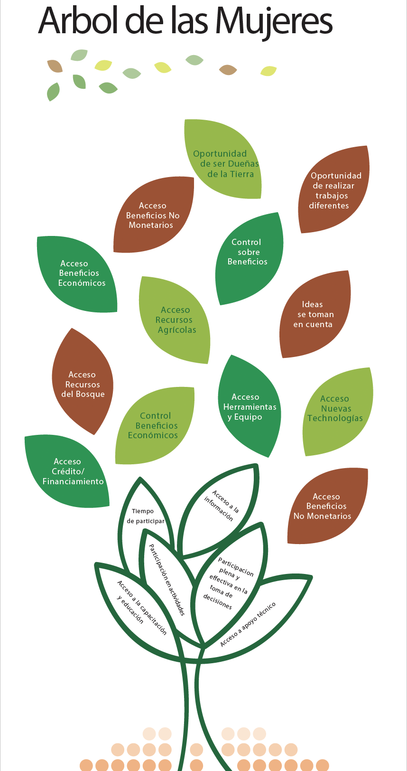
  - Before the session the facilitator will print or draw a tree that includes different leaves that describe issues where women and men face inequalities.
The inequalities leaves could include: Rights to own land, Opportunity to acquire land, Control over profits, Opportunity to do different jobs related to biodiversity, Voice and Influence in decision making, Access to non-cash benefits, Access to new technologies, Access to economic benefits, Access to natural resources, Access to credit/financing, Access to tools and equipment, Access to information, Full and effective participation in decision-making, Access to technical support, Access to training and education, Time to Participate, Full and effective participation in activities
  - Participants will be given colored papers (post its) Women and men will receive different colors (this allows the facilitator to disaggregate the data) (5 min)
  - Participants will be asked to vote on the three main inequalities they experience, found on the inequality tree (10 min)
  - Each participant will then be asked to write down what actions should be taken to address these barriers and share them in plenary (45 min)

Session 4. I have a dream of a better future: gender differentiated local biodiversity conservation and sustainable use priorities (60 min)

- Each participant will receive a blank piece a paper.
- The facilitator can start the dynamic by mentioning that since it is after lunch they are going to take a “quick nap” and ask participants to close their eyes.
- The facilitator will then start telling participants that while they are napping, they should dream of a green future where their community’s biodiversity is properly conserved and sustainably used. The facilitator will give examples of activities he/she sees in the dream. It is key that the dream highlights biodiversity conservation or sustainable use activities that are priorities for the country (for example, I dreamed that the mangroves cover all coastal areas, or that I was able to see the same butterflies I saw when I was young, I saw communities protecting genetic diversity of seeds, etc etc). (10 min)
- After the facilitator shares their dream, it will ask participants to start dreaming on their own.
- The facilitator will then ask participants to open their eyes and write what activities they saw in their own dreams (10 min)
- The facilitator will then ask for a volunteer and ask him/her to share what activities it dreamed about.
- After each activity the volunteer shares the facilitator will write in a flip chart. It will them ask participants if anyone else had a similar dream. The facilitator will draw a square for each man that dreamed of a similar activity and a circle for each woman that dreamed of a similar activity. (10 min)
- It will continue asking for volunteers until all participants have shared the “activities they dreamt” (30 min)

Session 5. Planting the right seeds: gender-responsive nature-based solutions (75 min)

- The facilitator will cut papers of two different colors; these papers are the "seeds."
- The facilitator will ask participants to name a nature-based solution they would like to implement but haven't been able to. The facilitator will write the activity on one of the papers and give each participant a "seed." The men's "seeds" will be in one color, and the women's will be in a different color. (10 min)
- Participants will be asked to form working groups based on similar "seeds." When forming groups, it's important to collect the individual seeds to document the gender-differentiated preferences. (5min)
- Each group will be given cards in two colors: blue (opportunities) and yellow (challenges), along with markers. The facilitator will explain that the yellow papers represent drought and blue papers represents water.
- Participants will be asked to write down why the seeds aren't growing on the yellow cards representing challenges and what they need for the seeds to grow on the blue cards representing opportunities they like to see. (30 min)
- Participants will then share this information with the other groups in plenary. (25 min)
- To conclude the activity, each participant will be asked individually which "drop of water" or opportunity is most important to them as individuals. The card prioritized by each participant will be marked with a colored sticker; it is important to use different colors for men and women. (5 min)

