

Gender and NBSAP BRIDGE Help Desk
Gender and Biodiversity Situational Analysis Template

What is a gender and biodiversity situational analysis?

A gender situational analysis is the first step in designing a gender-responsive or transformative policy or strategy. It can help countries to:
- Recognize both women and men as environmental stewards and key agents of change needed to achieve biodiversity goals.
- Ensure that the voices, ideas, concerns and experiences of women and men are considered as integral aspects of design, implementation, monitoring and evaluation of the policy or strategy.
- Assess the differentiated impacts on women and men of any action or intervention associated with the policy or strategy and seek to mitigate any possible negative impacts.
- Identify how the benefits, responsibilities and costs associated with the policy or strategy are distributed between and among men and women.

Gender & Biodiversity Analysis: Suggested content
- Gender-differentiated use of biological resources and ecosystem services on which communities depend and the benefits derived from these resources and services.
- Differentiated roles, knowledge, needs and contributions of women and men in relation to the conservation and sustainable use of biodiversity, including:
  - Differentiated environmental stewardship and agency of men and women.
  - Strategic environmental and sustainable development interests of women and men.
  - Women's needs and preferences in terms of their participation and the sharing of benefits, costs and responsibilities.
- Gender-differentiated impacts of environmental degradation, pollution, loss of biodiversity or climate change.
- Gender considerations relevant to the NBSAP, including:
  - Main gender inequalities prevalent in the biodiversity sectors relevant to the NBSAP.
  - Main cultural, institutional, and social barriers that prevent stakeholders, particularly women, from participating fully and effectively in all phases of the update and implementation of the NBSAP.
  - Gender-differentiated risks, costs, impacts and opportunities associated with the NBSAP.
  - Baseline of sex-disaggregated information relevant to the NBSAP.

How to develop a gender and biodiversity situational analysis?

6 suggested steps to develop gender and biodiversity situational analysis
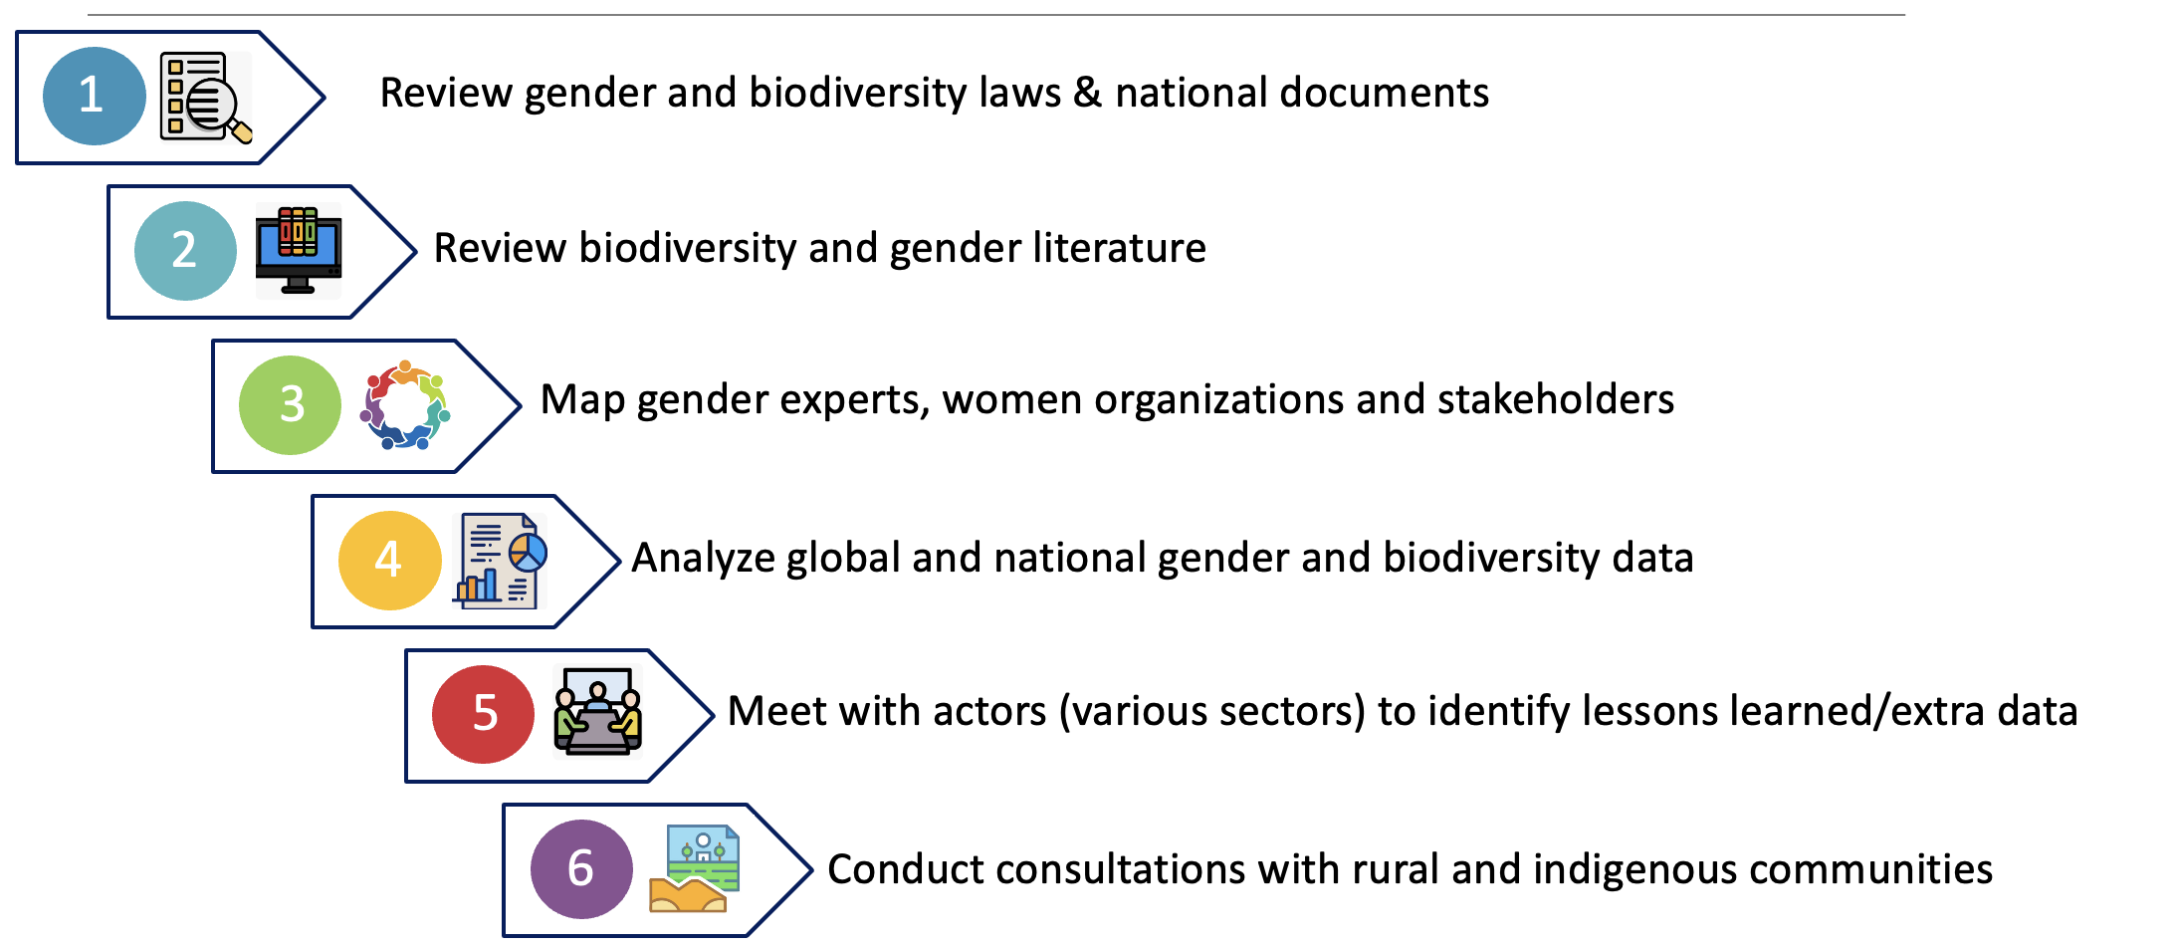

What could be the structure of gender and biodiversity situational analysis?


This document offers an optional template for a gender and biodiversity situational analysis, which follows the below sample table of contents.

Sample Table of Contents
1. Introduction
2. Methodology
3. Policy Analysis
4. Institutional Analysis
5. Inventory of national and local actors with gender
and biodiversity expertise
6. National Data Analysis
7. Local Data Analysis
8. Case Studies

For each one of the sections this guide will provide:

Brief description of the content that could be included in the section (yellow box)
Example of text or tables that could be used to systematize the information obtained by the country teams countries (green box)
Suggested steps to obtain the information for the section (blue box)

1. Introduction

This section could include a brief description of the situation analysis and what information it includes. The introduction could mention who developed the analysis, for whom and briefly describe what can/could it be used for.

Example of an introduction

Gender equality is a critical dimension of biodiversity conservation and sustainable use in [Country]. Different gender groups interact with biodiversity in different ways, shaped by socially defined roles, unequal access to land and natural resources, distinct livelihood strategies, and differentiated decision-making power within households, communities, and institutions.

This Gender and Biodiversity Situational Analysis for [COUNTRY] includes an analysis of the normative, institutional, available, literature and social framework related to gender relevant to the NBSAP and an analysis of the country's current situation in terms of biodiversity with a diversity of information on case studies, inequalities, opportunities, challenges and lessons learned. The analysis aims to identify key gender gaps and opportunities to strengthen equitable participation and benefit-sharing, and to inform the design and implementation of biodiversity policies and programmes that are both effective and socially just.

The information is the basis for developing the Gender and Biodiversity Roadmap, and will determine the actions, indicators and partnerships required in [COUNTRY]. This first stage is essential, since it allows the data, experiences, strengths and gaps that the country has in terms of gender and biodiversity. This process also allows us to identify the lessons learned that could be considered when proposing any gender-responsive action, target or goal for the NBSAP

To carry out the Gender Situational Analysis, the following activities were carried out:
- Review of major environmental laws and national documents relevant to gender and biodiversity.
- Mapping of gender experts, organizations and representatives of women's mechanisms.
- Mapping of interested associations and women (paying special attention to indigenous and local community women and those who have been involved in biodiversity conservation and sustainable use).
- Desk review of biodiversity related sectors (forestry, agriculture, terrestrial, costal and marine ecosystem management and conservation), land tenure and socio-economic gaps.
- Meetings with actors from various sectors (government, civil society, private sector) to identify lessons learned or extra data that have not been previously identified.
- Field visits to carry out consultation or focus groups with groups or associations of women from local communities.

Suggested Steps to develop the introduction
- Include a brief description of the relevance of the situation analysis for the country
- Provide a summary of the activities conducted as part of the situational analysis

2. Methodology

The methodology section provides a detailed description of all the activities conducted to design, collect and analyze the data.

In this section, the country should provide comprehensive information on all activities implemented. This should include, where relevant, the total number of policies reviewed; the national and international data sources used; the number of interviews conducted; and the number of focus groups or consultations held. The country should also report the total number of participants consulted, disaggregated by sex and social group (e.g., Indigenous Peoples, local communities, youth). In addition, details should be provided on the number of national workshops organized and the number of participants who attended, disaggregated by sex, social group (e.g., Indigenous Peoples, local communities, youth), and sector represented (e.g., government, civil society organizations, local communities).

Example of the brief description of the activity and summary of the methodology used to develop the activity

Activity 1. Review of major environmental laws and national documents relevant to NBSAP and & 7NR.
Methodology: The analysis of the regulatory framework identified environmental legislation and plans/strategies relevant to the NBSAP that promote gender equality. The analysis is based on an initial search for keywords including gender, women, equity and equality and was complemented by identifying sections that promote social equity. The analysis reviewed XX number of policies and XX strategies relevant to the NBSAP

Activity 2. Field visits to carry out consultation or focus groups with groups or associations of women from local communities
Methodology: To obtain local data, XX of communities were visited to conduct consultations. The consultations were conducted using a focus group discuss format. In total XX of participants were consulted, (XX women, XX men, XX indigenous women, XX indigenous men)
Tips to develop the methodology section:
- Define a clear methodology before conducting the activities
- Systematically document all the activities, data sources and processes

3. Policy Analysis

This section describes the relevant gender and biodiversity policy framework including:
- Summary of the gender policy commitments that can be translated into actions that can be included in the NBSAP
- Summary of global gender commitments that can be related to the NBSAP
- A timeline of national policies that shows the evolution of gender commitments
- List of gender goals and actions included in sectoral policies
- A final paragraph on how the information is relevant to the current NBSAP

Example of a table that correlates the National Gender Equality Policy framework with the NBSAP
Article | Relevance NBSAP

Example of timeline of National Biodiversity Policy framework that shows the evolution of gender commitments

Figure XX. Gender timeline of biodiversity-related policies
1998 ➔ | Biodiversity Law ➔ | * Includes as a General Principle. | ➔ Gender  Neutral
2015➔ | National Biodiversity Policy➔ | * Recognizes that rising inequality and the persistence of  conditions of poverty for women heads of household | ➔ Gender  Sensitive
2016➔ | National Biodiversity Strategy ➔ | *The ENB2 was developed under Human Rights and Gender Approach | ➔ Gender  Responsive

Example of a table that summarizes gender goals and actions included in sectoral policies

Table X . Gender actions identified in the Biodiversity Related Sectoral Strategies
Agriculture and food security
Terrestrial ecosystems
Marine and Costal Ecosystems

Suggested steps to conduct a policy analysis:
- Analyze the gender policy framework to identify key environmental mandates
- Identify key gender mandates and policy synergies included in the biodiversity policy framework
4. Institutional Analysis
This section presents a rapid assessment of the gender capacities of institutions relevant to the NBSAP, including national government institutions, non‑governmental organizations, and other key stakeholders. Recognizing that these actors have varying capacities to address gender and biodiversity, the section provides a brief diagnostic of institutional gender capacity. This assessment considers whether institutions have gender policies; designated gender experts or personnel; gender‑sensitive staff (i.e., personnel who are aware of gender issues and take these into account in their work); have received training on gender and biodiversity; and/or have implemented gender‑responsive biodiversity projects.

The rapid assessment may use a simple categorization system in which institutions receive a ✔ if they meet the gender criteria, a ✔✖ if they have made progress toward meeting the criteria, and a ✖ if they have not implemented any activities related to the criteria. For each criterion it can then include a brief description.

Example of institutional rapid assessment

Government Institutions
Name of the Institution
Gender Policy: ✔ The country has the Gender Equity and Environment Strategy
Gender and Environment Experts: ✔✖ The Secretariat has a gender focal point; however, its time has to be divided into several responsibilities.
Gender-Sensitive Staff: ✔ The staff is gender-sensitive and the secretary has a gender unit.
Capacity Building on Gender and the Environment: ✔✖ Staff have received several trainings from INAM.
Gender-Sensitive or Gender-Responsive Projects: ✔ The School for Equality and Empowerment of Rural Women has been implemented.

NGOs or CSOs Partners
Name of the Organization
Gender Policy: ✔✖
Gender and Environment Experts: ✔✖
Gender-sensitive staff: ✖✔  
Capacity Building on Gender and the Environment: ✔✖  
Gender-Sensitive or Gender-Responsive Projects: ✔✖
Suggested steps to conduct an institutional analysis
- Conduct conducting interviews with the relevant actors to understand each organization’s capacities and responsibilities on gender and biodiversity.
- Carry out a rapid assessment of the gender capacities of the institutions relevant to the NBSAP
5. Inventory of national and local actors with gender and biodiversity expertise

The section includes a list of actors who have expertise on gender and biodiversity and who can contribute to supporting the integration of gender in NBSAPs and the gender responsive implementation of the NBSAPs and/or local nature-based solutions, including:
- Women's groups/collectives that work on gender and biodiversity (or environmental issues)
- Platforms that support women working on biodiversity or environmental issues
- Gender experts with experience conducting a gender analysis for environmental sectors
- Gender experts or gender units in institutions involved in the NBSAP
- Civil organizations, academia, and international cooperation that work on gender and the environment

Example of inventory of national gender and biodiversity expertise

Women's Groups working on biodiversity issues
- Name of Women’s Group. Brief Description of their work on environment/biodiversity

Support Platforms for Women or Women’s Groups
- Name of Platform. Brief Description of how they support women’s group

National Gender and Biodiversity Experts
- Name of Expert. Brief Description of their expertise

Gender units in institutions involved in the NBSAP
- Name of Institution and its unit. Brief Description of expertise and areas of work

Civil organizations, academia, and international cooperation that work on gender and the environment
- Name of Institution and its unit. Brief Description of expertise and areas of work

Tips to conduct a relevant actor mapping
- Identify gender experts who have experience on gender in various environmental sectors
- Carry out mapping of women's groups/collectives and civil organizations, academia, other institutions and international cooperation that work on gender and the environment
- Identify gender experts or gender units in institutions involved in the NBSAP

5. National Data Analysis

This section consists of a desk review to summarize national gender data relevant to the NBSAPs and diversity sectors and connect existing gender and biodiversity data, including on the following themes detailed in the tables below:
- Gender-differentiated use, roles, knowledge, and needs of women and men in relation to the conservation and sustainable use of biodiversity,
- Gender differentiated impacts of biodiversity loss,
- Gender inequalities prevalent in biodiversity sectors,
- Gender-differentiated contributions to conservation and nature-based solutions.

Gender data may come from the following sources, among others:
- Projects supported by vertical funds (GEF, GCF, GBFF)
- Strategies and National Reports related to MEAs
- National statistical data relevant to the biodiversity sectors

Example of data on gender differentiated use, roles, knowledge, and needs related to biological resources

Productive Activities and Land Use

Conservation and Sustainable Management of Resources
Productive Ecosystems
Terrestrial Ecosystems (forests, scrublands, grasslands)
Aquaculture
Marine Ecosystems
Costal Ecosystems

Example of data on gender differentiated impacts of biodiversity loss

Land Degradation and changes in ecosystem composition

Species decline and extinction

Food insecurity, Health, Water Management and Care Responsibilities

Climate Change Amplification

Example of data on prevalent gender inequalities relevant to biodiversity sectors

Labor and Socio-Economic Conditions
Workforce
Care responsibilities time use
Education

Land Tenure

Gender Stereotypes and Power Relations

Example of gender differentiated contributions to conservation and nature-based solutions.

Indigenous and Local Women contributing to conservation, sustainable management of biological resources, restoration, protection of genetic diversity, invasive alien species reduction, sustainable agriculture, pollution reduction, climate change impacts minimization, green spaces or urban planning enhancement, sustainable consumption
Land Ecosystems
Marine and Coastal Ecosystems

Indigenous and Local Women implementing Nature Based Solutions
Land Ecosystems
Marine and Coastal Ecosystems

Professional women to conservation, sustainable management of biological resources, restoration, protection of genetic diversity, invasive alien species reduction, sustainable agriculture, pollution reduction, climate change impacts minimization, green spaces or urban planning enhancement, sustainable consumption
Park rangers
Fire fighters
Sustainable Agriculture Extension service providers
Scientists focus on Genetic Diversity, Access and Benefits Sharing

Suggested Steps to conduct a national data analysis
- Identify data in national and international sources
- Conduct an analysis of national data on prevelent gender inequalities relevant to the biodiversity sectors
- Identify data specialists to correlate gender data with biodiversity data and generate innovative analysis and indicators
- Combine or analyze existing national biodiversity and gender data in novel and creative ways

6. Local Data Analysis

Collecting and analyzing data on the experiences of grassroots women and men, as well as representatives and organizations of Indigenous Peoples and Local Communities (IP&LCs), can complement national data on gender and biodiversity.

The data in this section can focus on:
- Gender-differentiated use, roles, knowledge, and needs of women and men in relation to the conservation and sustainable use of biodiversity,
- Gender differentiated impacts of biodiversity loss,
- Gender inequalities prevalent in biodiversity sectors,
- Gender-differentiated local contributions to conservation and nature-based solutions.
- Potential conservation priorities or gender-responsive nature-based solutions that can be developed at the local level

Such data can be obtained through interviews, group discussions, online consultations, workshops, and more, with IP&LCs in all their diversity. It is recommended to separate women and men during this exercise and to ask each group about their own experiences. Annex 1 includes a list of questions that could be asked during the consultations.

The qualitative data can be analyzed by gender and summarized in tables that allow a comparison among the different communities consulted.

Note: This section can be developed or complemented in a later stage once the CCTs have developed the consultations. For example, Country Core Teams could initially present information obtained in previous local consultations conducted by the country and complement this information with the data obtained during the stakeholder consultations that will be developed under the NBSAP AP Gender Project.
Example of a table to summarize gender-differentiated roles

Table X. Differentiated gender roles in biodiversity conservation and sustainable use. Source: Focus groups

Community XX
 | Men | Women
Remarks

Example of a table to summarize gender-differentiated access and decision-making power over natural resources

Table X. Differentiated access and decision-making power over natural resources. Source: Focus groups

Community XX
 | Men | Women
Remarks

Example of a table to summarize gender differentiated impacts of biodiversity loss

Table X. Gender differentiated impacts of biodiversity loss. Source: Focus groups

Community XX
 | Men | Women
Remarks

Example of a table to summarize prevalent gender inequalities

Table XX. Prevalent inequalities in biodiversity sectors. The numbers in each box represent the number of women who selected the inequalities as their main issues. Source: Focus groups

 | Community | Community | Community
Rights to own land
Opportunity to acquire land
Control over profits
Opportunity to do different jobs related to biodiversity
Voice and Influence in decision making
Access to non-cash benefits
Access to new technologies
Access to economic benefits
Access to natural resources
Access to credit/financing
Access to tools and equipment
Access to information
Full and effective participation in decision-making
Access to technical support
Access to training and education
Time to Participate
Full and effective participation in activities

Example of a table to summarize gender differentiated contributions to the Conservation and Sustainable Management of Resources

Table X. Activities of Conservation and Sustainable Management of Biodiversity carried out by women. Source: Focus groups

Community | Women's Conservation and Sustainable Resource Management Activities

Community | Men's Conservation and Sustainable Resource Management Activities

Example of a table to summarize gender differentiated conservation priorities

Table X. Activities that women/men are interested in carrying out to conserve and sustainably use biodiversity. Source: Focus groups
 | Community 1 | Community 2 | Community 3 | Community 4
Reforestation | * | * | *
Sustainable Tourism | * | * | *
Home Gardens |  | * |  | *
Nurseries |  |  |  | *
Fisheries | * |  |  | *

Example of a table to summarize potential gender-responsive nature-based solutions that can be developed at the local level

Table xx. Nature-based solutions proposed by women/men that could be developed at the local and challenges and opportunities related to their implementation. Source: Focus groups

Community
Activities | Challenges | Opportunities
Tourism
Conservation

Suggested steps to conduct consultations with rural and indigenous communities
- Consider different methodologies for obtaining data at different levels (interviews, focus groups, online consultations, workshops)
- Ask the right questions and look for answers through different methodologies
- Conduct focus groups or local consultations to obtain recent qualitative data
- Conduct an analysis of local data that reflects the reality of women and men in all their diversity, as well as their needs, preferences and priorities in the various sectors

7. Case Studies

Case studies with concrete examples of the gender-biodiversity relationship can help bring the situational gender analysis to life. Case studies can capture initiatives of IP&LC women and women professionals contributing to conservation, sustainable management of biological resources, restoration, protection of genetic diversity, invasive alien species reduction, sustainable agriculture, pollution reduction, climate change impacts minimization, green spaces or urban planning enhancement, sustainable consumption.

Each case study should briefly describe the name of the initiative; the area of the country where it is being implemented; the environmental characteristics of the area, including the ecosystems or species affected by the initiative; and the socio‑economic characteristics of the area of implementation. The case study should also outline the activities implemented, particularly those that constitute nature‑based solutions or contribute to biodiversity conservation or sustainable use and include a description of the women or women’s groups involved and their role in environmental stewardship.

Example of a table to summarize case studies

1.Case Study: XXX

Name of the Initiative:
Region/Area in the Country:
Environmental Landscape (ecosystems and species impacted):
Socio-Economic Landscape:
Nature Based Solutions or Biodiversity Conservation or Sustainable Use Activities:
Women or Women's Groups Environmental Stewardship:

Suggested Steps to systematize case studies
- Define a template for the systematization case studies
- Search for global publications that might have case studies from the country
- Place a call for gender and biodiversity case studies and invite government institutions, CSOs and women’s groups to share examples
- Organize meetings with different sectors to conduct interviews, participatory workshops, and collect data

Annex 1. Diagnostic Guide on Gender and Environment

The following set of questions were developed by UNDP and provide guidance to policy makers, policy or programme officials, or implementers to Identify key gender considerations in various environmental issues. The questions are divided in the following dimensions

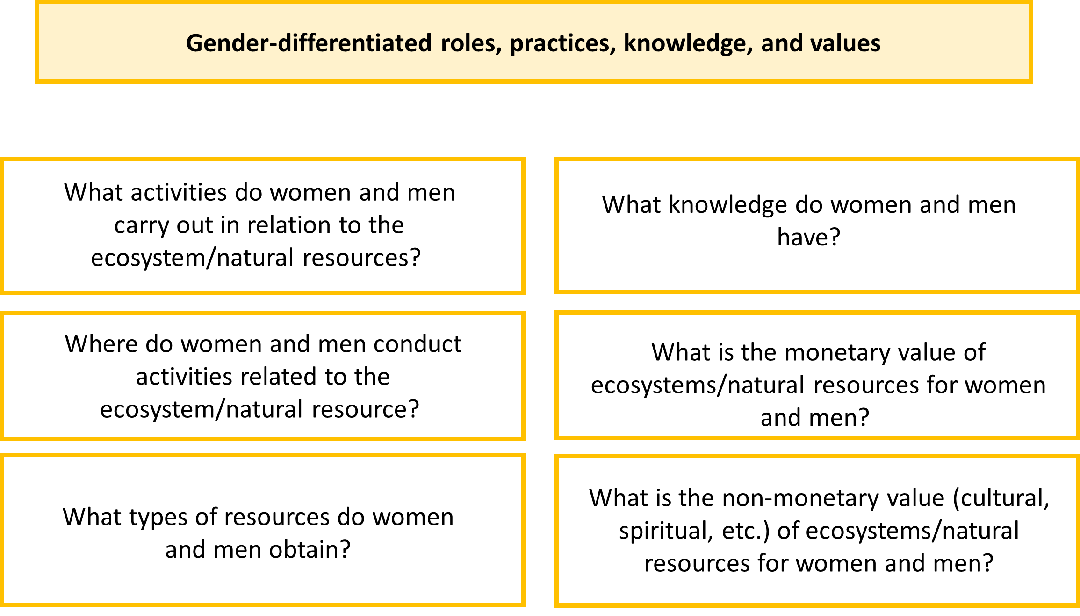
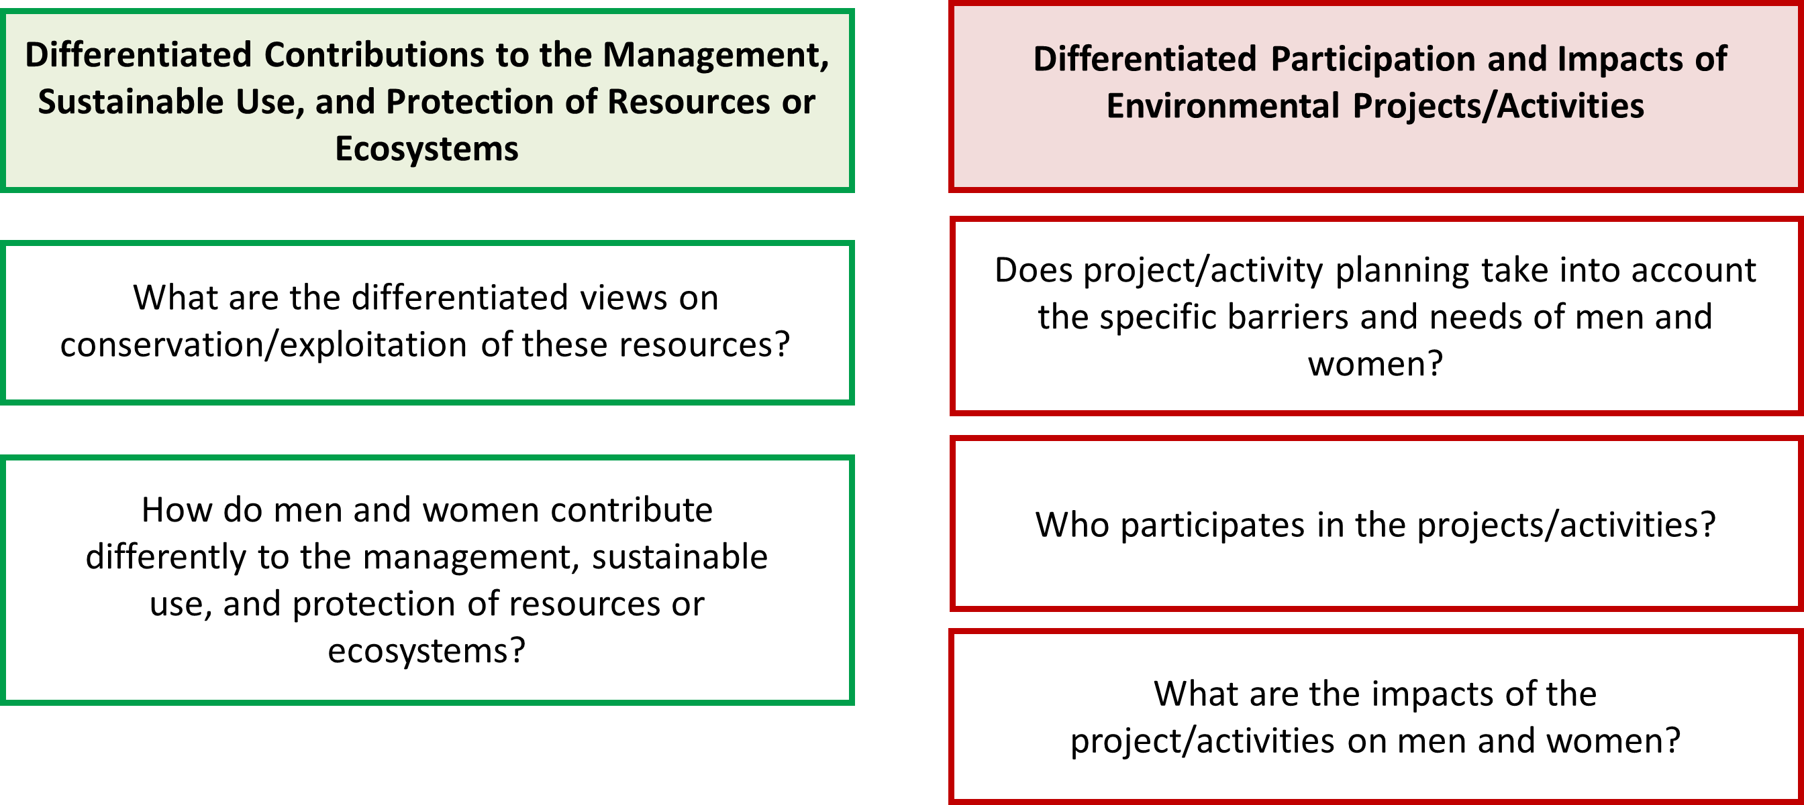
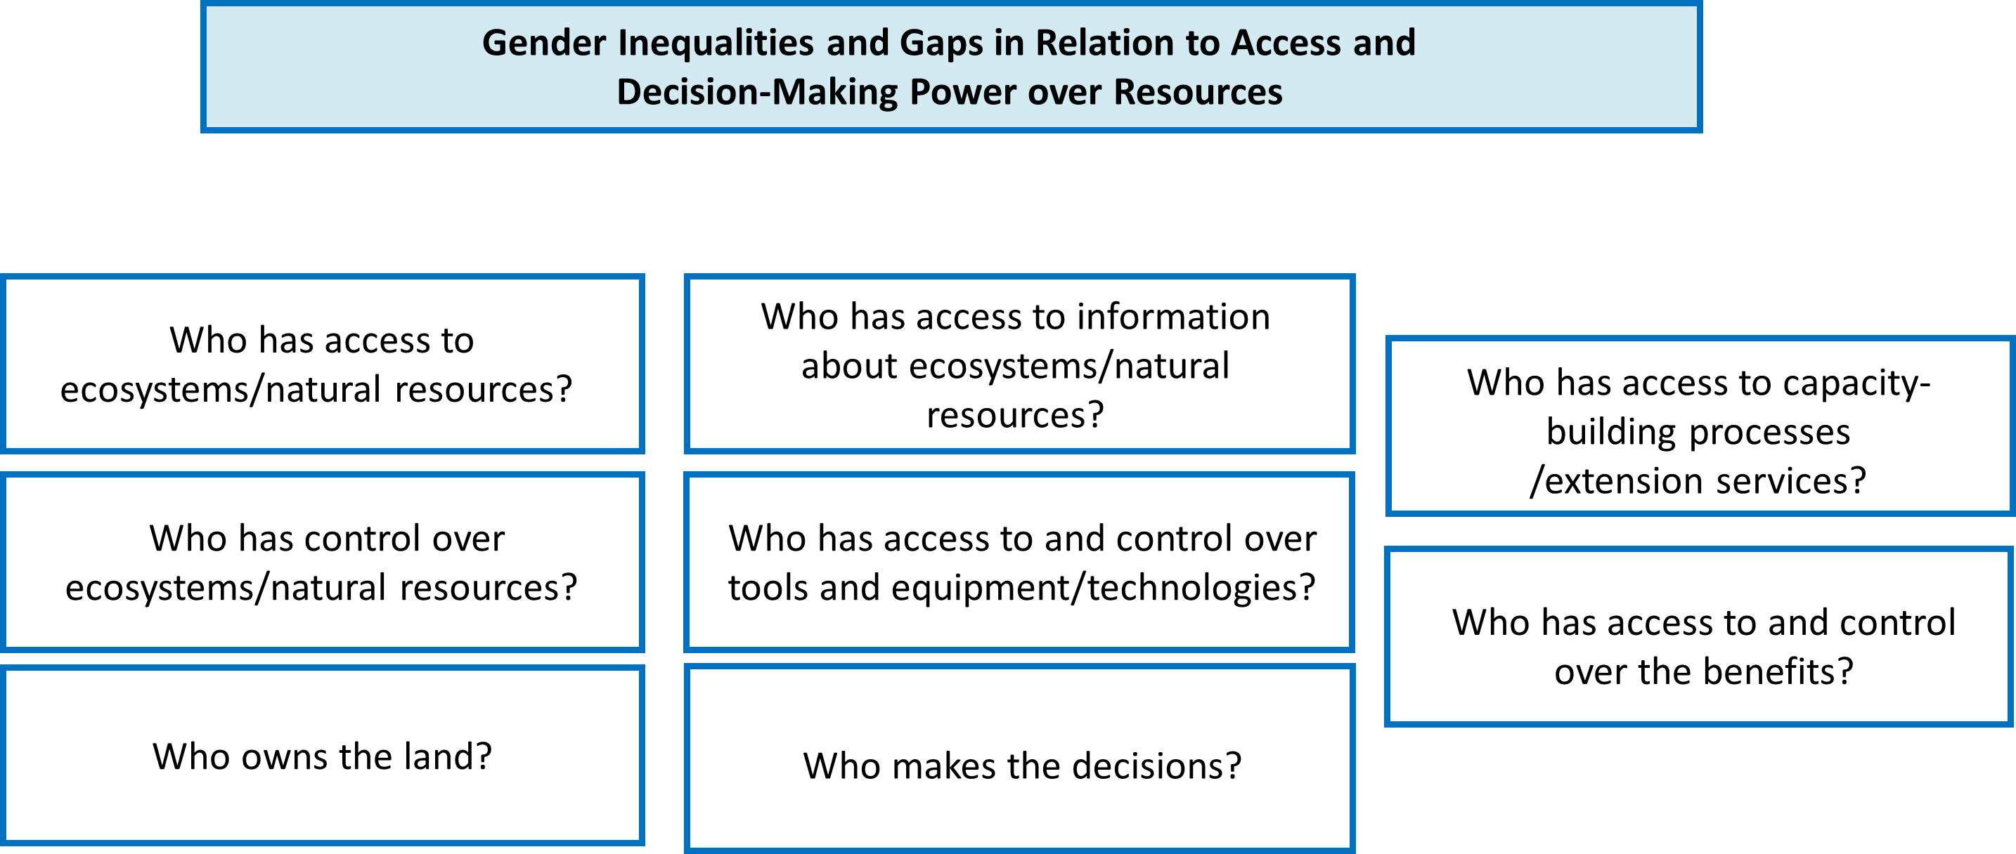

General recommendations for using the guide:
- It is recommended that the questions in the guide be completed in a sequential process that respects the order of the proposed topics. It is key to first obtain information on gender-differentiated rights, practices, knowledge and values and Gender Inequalities and Gaps in relation to Access to and Control of Resources and then to discuss differentiated contributions to the management, sustainable use and protection of resources or ecosystems, since this information on basis is essential to understand the differentiated participation and impacts of environmental projects/activities.
- In those communities where asking these questions is challenging, it is suggested that people seek further guidance or support from local experts to adapt and ask the questions.
- When making the diagnoses, it is recommended that the facilitators adapt the questions and incorporate concepts or terms that are commonly used by the people involved in the diagnosis.
- The questions included in the guide can be incorporated into various participatory methodologies such as interactive maps, interviews, focus groups or individual or group dynamics.

Roles, practices, knowledge and values differentiated by gender

Question | Thematic | Sample Questions
What activities do women and men carry out in relation to the ecosystem/natural resource? | Water | - What activities do women and men carry out in relation to water management?  - What activities do women and men carry out in relation to water carrying?  - What activities do women and men carry out in relation to water supply?  - Are the activities carried out by women/men formal or informal?
 | Seas and Coasts | - What activities do women and men carry out in the seas and coasts?  - What activities do women and men carry out in seafood value chains?  - Are the activities carried out by women/men formal or informal?
 | Biodiversity | - What activities do women and men who depend on biodiversity do?  - Do women and men interact with different species?  - Are the activities carried out by women/men formal or informal?
 | Forests | - What activities do women and men do in forests?  - What activities do women and men carry out in forest products value chains?  - Are the activities carried out by women/men formal or informal?
 | Climate change | - What activities do women and men who are affected by climate change do?  - Are the activities that are affected by climate change that women/men carry out formal or informal?
 | Waste/Waste Management | - What activities do women and men carry out in relation to waste management?  - Are the activities carried out by women/men formal or informal?
Where do women and men carry out activities in relation to the ecosystem/natural resource? | Water | - Where do women and men get their water?  - How do they use the water that women and men carry house/family crops/productive crops?
 | Seas and Coasts | - Where do women and men carry out activities in relation to the seas and coasts?  - Where do women and men who take advantage of marine resources carry out productive activities?
 | Biodiversity | - Where do women and men get natural resources?  - Where do women and men who take advantage of natural resources carry out productive activities?  - Are there places or ecosystems where women and men interact with specific biological species?
 | Forests | - Where do women and men carry out activities in relation to forests?  - Where do women and men who take advantage of forest resources carry out productive activities?
 | Climate change | - Where do women and men carry out activities that are affected by climate change?
 | Waste/Waste Management | - Where do women and men carry out activities in relation to waste management?  - Where do the women and men who take advantage of waste, reuse and/or recycle carry out productive activities?
What kind of resources do women and men get? | Water | - Why do women and men use water?
What kind of resources do women and men get? | Seas and Coasts | - What kind of resources do women and men obtain from the seas or coasts?  - Are these resources used for productive/domestic/other activities?
What kind of resources do women and men get? | Biodiversity | - What species or resources are used by women and men?  - What species or resources are used for productive/domestic/other activities?
What kind of resources do women and men get? | Forests | - What kind of resources do women and men get from forests?  - Are these resources used for productive/domestic/other activities?
What kind of resources do women and men get? | Climate change | - Which species or natural resources that are used by women and men are negatively impacted by climate change?  - Which species or natural resources that are used by women and men are essential to ensure their resilience to climate impacts?
What kind of resources do women and men get? | Waste/Waste Management | - What type of waste is collected by women and men?  - What kind of waste is processed by women and men?
What knowledge do women and men have? | Water | - What kind of differentiated knowledge do women and men have in relation to water management?  - What kind of differentiated knowledge do women and men have in relation to sanitation?
What knowledge do women and men have? | Seas and Coasts | - What kind of differentiated knowledge do women and men have in relation to the seas and coasts?  - What kind of differentiated knowledge do women and men have in relation to the sustainable use of marine/coastal resources?  - What kind of differentiated practices do women and men have in relation to the sustainable use of marine/coastal resources?
What knowledge do women and men have? | Biodiversity | - What kind of differentiated knowledge do women and men have in relation to biodiversity?  - What kind of differentiated knowledge do women and men have in relation to the sustainable use of biodiversity?  - What kind of differentiated practices do women and men have in relation to the sustainable use of biodiversity?
What knowledge do women and men have? | Forests | - What kind of differentiated knowledge do women and men have in relation to forests?  - What kind of differentiated knowledge do women and men have in relation to the sustainable use of forest resources?  - What kind of differentiated practices do women and men have in relation to the sustainable use of marine/coastal resources?
What knowledge do women and men have? | Climate change | - What kind of differentiated knowledge do women and men have in relation to climate change?  - What kind of differentiated knowledge do women and men have in relation to the impacts of climate change?  - What kind of differentiated knowledge do women and men have in relation to climate change mitigation or adaptation?  - What kind of differentiated practices do women and men have to adapt to the impacts of climate change?
What knowledge do women and men have? | Waste/Waste Management | - What kind of differentiated knowledge do women and men have in relation to waste management?  - What kind of differentiated practices do women and men have in relation to waste management?
What is the monetary value to women and men of ecosystems/natural resources? | Water | - Does water management generate economic income for women and men?  - Does obtaining clean water require an economic investment for women and men?
 | Seas and Coasts | - Does the sustainable use of marine resources generate economic income for women and men?
 | Biodiversity | - Does the sustainable use of genetic resources generate economic income for women and men?
 | Forests | - Does the sustainable use of forest resources generate economic income for women and men?
 | Climate change | - What impacts does climate change have on the economic income of women and men?
 | Waste Management | - Does waste management generate economic income for women and men?
What is the non-monetary value (cultural, spiritual, etc.) for women and men of ecosystems/natural resources? | Water | - What is the non-monetary value (cultural, spiritual, etc.) associated with water use for women and men?
 | Seas and Coasts | - What is the non-monetary value (cultural, spiritual, etc.) of the products that women and men obtain from the seas and coasts?
 | Biodiversity | - What is the non-monetary value (cultural, spiritual, etc.) of species that are sustainably used by women and men or of species with which they share the environment?
 | Forests | - What is the non-monetary value (cultural, spiritual, etc.) ofthe forest and/or the products obtained by the women and men of the forest?
 | Climate change | - What is the non-monetary impact (cultural, spiritual, etc.) that climate change has on women and men?
 | Waste/Waste Management | - What is the non-monetary impact (cultural, spiritual, etc.) on women and men of getting involved in waste management?
Gender Inequalities and Gaps in Relation to Access to and Control of Resources

Who has access to ecosystems/natural resources? | Water | - Do women and men have access to water?  - Do women and men have equal access to water?  - Are there any restrictions that prevent women or men from accessing water?
Who has access to ecosystems/natural resources? | Seas and Coasts | - Do women and men have access to marine resources?  - Do women and men have equal access to marine resources?  - Do women and men have equal access to marine ecosystems?  - Are there any restrictions that prevent women or men from accessing marine resources?
Who has access to ecosystems/natural resources? | Biodiversity | - Do women and men have access to natural resources/species?  - Do women and men have equal access to natural resources/species?  - Do women and men have equal access to ecosystems where natural resources/species are located?  - Are there any restrictions that prevent women or men from accessing natural resources/species?
Who has access to ecosystems/natural resources? | Forests | - Do women and men have access to forests?  - Do women and men have equal access to forest resources?  - Do women and men have equal access to forest ecosystems?  - Are there any restrictions that prevent women or men from accessing forest resources?
Who has access to ecosystems/natural resources? | Climate change | - Does climate change limit access to important natural resources for women and men?  - Does climate change promote inequalities in access to natural resources important for women and men?
Who has access to ecosystems/natural resources? | Waste/Waste Management | - Are women and men exposed to waste?  - Do women and men have the same access to waste as a means of livelihood?  - Are there any restrictions that prevent women or men from accessing waste?  - Is exposure to waste and/or hazardous waste the same for men and women?  - Do women and men have equal access to protective equipment during waste management?
Who has control of ecosystems/natural resources? | Water | - Do women and men have control over water?  - Do women and men have equal control over water?  - Are there any restrictions that prevent women or men from having control of the water?
Who has control of ecosystems/natural resources? | Seas and Coasts | - Do women and men have control of marine resources?  - Do women and men have equal control over marine resources?  - Do women and men have equal control over marine ecosystems?  - Are there any restrictions that prevent women or men from having control over marine resources?
Who has control of ecosystems/natural resources? | Biodiversity | - Do women and men have control of natural resources/species?  - Do women and men have equal control over natural resources/species?  - Do women and men have equal control over the ecosystems where natural resources/species are located?  - Are there any restrictions that prevent women or men from having control over natural resources/species?
Who has control of ecosystems/natural resources? | Forests | - Do women and men have control over forests?  - Do women and men have equal control over forest resources?  - Do women and men have equal control over forest ecosystems?  - Are there any restrictions that prevent women or men from having control over forest resources?
Who has control of ecosystems/natural resources? | Climate change | - Does climate change limit control over natural resources important to women and men?  - Does climate change promote inequalities in control over natural resources important to women and men?
Who has control of ecosystems/natural resources? | Waste/Waste Management | - Do women and men have control over waste?  - Do women and men have equal control over waste?  - Are there any restrictions that prevent women or men from having control over waste?
Who owns the land? | Water | - Do women and men own the land where the water sources are located?  - Is the number of women owners different from the number of men who own the land where the water sources are located?
Who owns the land? | Seas and Coasts | - Do women and men own or possess land on shore and beach land with access to marine ecosystems?  - Do women and men have rights of access to marine resources in their communities?  - Is the number of women owners different from the number of men who own the land where marine ecosystems are located?
Who owns the land? | Biodiversity | - Do women and men own the land where the natural resources/species are located?  - Is the number of women owners different from the number of men who own the lands where the natural resources/species are located?
Who owns the land? | Forests | - Do women and men own the land where forest ecosystems are located?  - Is the number of women owners different from the number of men who own the land where forest ecosystems are located?
Who owns the land? | Climate change | - Does climate change affect women's and men's land tenure?
Who owns the land? | Waste/Waste Management | - Do women and men own the land where waste management activities are carried out?  - Is the number of women owners different from the number of men who own the land where waste management activities are carried out?
Who has access to information on ecosystems/natural resources? | Water | - Do women and men have access to appropriate information about water?  - Do women and men have equal access to appropriate information about water?  - Are there any restrictions that prevent women or men from accessing appropriate water information?
 | Seas and Coasts | - Do women and men have access to appropriate information on marine resources?  - Do women and men have equal access to appropriate information on marine resources?  - Do women and men have equal access to appropriate information about marine ecosystems?  - Are there any restrictions that prevent women or men from accessing appropriate information on marine resources?
 | Biodiversity | - Do women and men have access to appropriate information on existing biodiversity?  - Do women and men have equal access to appropriate information about existing biodiversity?  - Do women and men have equal access to appropriate information about the ecosystems where natural resources/species are located?  - Are there any restrictions that prevent women or men from accessing appropriate information about natural resources/species?
 | Forests | - Do women and men have access to appropriate information about forests?  - Do women and men have equal access to appropriate information on forest resources?  - Do women and men have equal access to appropriate information about forest ecosystems?  - Are there any restrictions that prevent women or men from accessing appropriate information on forest resources?
 | Climate change | - Do women and men have access to appropriate information on climate change?  - Do women and men have equal access to appropriate information on climate change?  - Do women and men have equal access to appropriate information on climate change?  - Are there any restrictions that prevent women or men from accessing appropriate information about climate change?
 | Waste/Waste Management | - Do women and men have access to appropriate information on waste management, especially hazardous waste?  - Do women and men have equal access to appropriate information on waste management?  - Are there any restrictions that prevent women or men from accessing appropriate information on waste management?
Who has access to capacity building/extension processes? | Water | - Do women and men have access to capacity-building/extension processes that allow them to improve water management?  - Do women and men have equal access to capacity-building/extension processes that allow them to improve water management?  - Are there any restrictions that prevent women or men from accessing or participating in capacity-building/extension processes that allow them to improve water management?
Who has access to capacity building/extension processes? | Seas and Coasts | - Do women and men have access to capacity-building/extension processes that enable them to improve the sustainable use of marine resources?  - Do women and men have equal access to capacity-building/extension processes that enable them to improve the sustainable use of marine resources?  - Are there any restrictions that prevent women or men from accessing or participating in capacity building/extension processes that allow them to improve the sustainable use of marine resources?
Who has access to capacity building/extension processes? | Biodiversity | - Do women and men have access to capacity-building/extension processes that allow them to improve the sustainable use of biodiversity?  - Do women and men have equal access to capacity-building/extension processes that allow them to improve the sustainable use of biodiversity?  - Are there any restrictions that prevent women or men from accessing or participating in capacity building/extension processes that allow them to improve the sustainable use of biodiversity?
Who has access to capacity building/extension processes? | Forests | - Do women and men have access to capacity-building/extension processes that allow them to improve the sustainable use of forest resources?  - Do women and men have equal access to capacity-building/extension processes that enable them to improve the sustainable use of forest resources?  - Are there any restrictions that prevent women or men from accessing or participating in capacity-building/extension processes that allow them to improve the sustainable use of forest resources?
Who has access to capacity building/extension processes? | Climate change | - Do women and men have access to capacity-building/extension processes that allow them to increase their resilience to climate change or enhance their contributions to greenhouse gas reduction?  - Do women and men have equal access to capacity-building/extension processes that allow them to increase their resilience to climate change or enhance their contributions to the reduction of greenhouse gases?  - Are there any restrictions that prevent women or men from accessing or participating in capacity-building/extension processes that allow them to increase their resilience to climate change or enhance their contributions to the reduction of greenhouse gases?
Who has access to capacity building/extension processes? | Waste/Waste Management | - Do women and men have access to capacity-building/extension processes that allow them to improve waste management?  - Do women and men have equal access to capacity building/extension processes that allow them to improve waste management?  - Are there any restrictions that prevent women or men from accessing or participating in capacity building/extension processes that allow them to improve waste management?
Who has access to and control over the tools and equipment/technologies? | Water | - Do women and men have equal access to tools, equipment or technologies that allow them to improve water management?  - Do women and men have equal control over the tools, equipment or technologies that allow them to improve water management?  - Are there any restrictions that prevent women or men from accessing or controlling tools, equipment, or technologies that allow them to improve water management?
 | Seas and Coasts | - Do women and men have equal access to tools, equipment or technologies that enable them to improve the sustainable use of marine resources?  - Do women and men have equal control over the tools, equipment or technologies that enable them to improve the sustainable use of marine resources?  - Are there any restrictions that prevent women or men from accessing or controlling tools, equipment or technologies that allow them to improve the sustainable use of marine resources?
 | Biodiversity | - Do women and men have equal access to tools, equipment or technologies that allow them to improve the sustainable use of biodiversity?  - Do women and men have equal control over the tools, equipment or technologies that allow them to improve the sustainable use of biodiversity?  - Are there any restrictions that prevent women or men from accessing or controlling tools, equipment or technologies that allow them to improve the sustainable use of biodiversity?
 | Forests | - Do women and men have equal access to tools, equipment or technologies that enable them to improve the sustainable use of forest resources?  - Do women and men have equal control over the tools, equipment or technologies that enable them to improve the sustainable use of forest resources?  - Are there any restrictions that prevent women or men from accessing or controlling tools, equipment or technologies that allow them to improve the sustainable use of forest resources?
 | Climate change | - Do women and men have equal access to tools, equipment or technologies that allow them to increase their resilience to climate change or enhance their contributions to reducing greenhouse gases?  - Do women and men have equal control over the tools, equipment or technologies that allow them to increase their resilience to climate change or enhance their contributions to reducing greenhouse gases?  - Are there any restrictions that prevent women or men from accessing or controlling tools, equipment or technologies that allow them to increase their resilience to climate change or enhance their contributions to reducing greenhouse gases?
 | Waste Management | - Do women and men have equal access to tools, equipment or technologies that allow them to improve waste management?  - Do women and men have equal control over the tools, equipment, or technologies that allow them to improve waste management?  - Are there any restrictions that prevent women or men from accessing or controlling tools, equipment or technologies that allow them to improve waste management?
Who makes the decisions? | Water | - Can women and men participate in decision-making processes on sustainable water use and activities to improve water management or protect water sources? Are they equally invited?  - Are there any restrictions that prevent women or men from participating in decision-making about sustainable water use and activities to improve water management or protect water sources?  - Are the ideas, needs or preferences of women and men equally taken into account and valued during decision-making processes on sustainable water use and activities to improve water management or protect water sources?  - Who participates in the rural aqueduct management boards where decisions related to water management are made in local communities?  - Who participates in the watershed committees?
Who makes the decisions? | Seas and Coasts | - Can women and men participate in decision-making processes on the sustainable use and protection of marine resources and activities in the seas and coasts? Are they equally invited?  - Are there any restrictions that prevent women or men from participating in decision-making on the sustainable use of marine resources and the activities that are carried out to improve the protection or conservation of the seas and coasts?  - Are the ideas, needs or preferences of women and men equally taken into account and valued during decision-making processes on the sustainable use of marine resources and activities undertaken to improve the protection or conservation of marine resources?  - Who sits on the boards of directors of community associations where decisions are made related to the sustainable use of marine resources and activities undertaken to improve the protection or conservation of seas and coasts?
Who makes the decisions? | Biodiversity | - Can women and men participate in decision-making processes on the sustainable use and protection of biodiversity and activities in diverse natural ecosystems? Are they equally invited?  - Are there any restrictions that prevent women or men from participating in decision-making about the sustainable use of biodiversity and the activities that are carried out to improve the protection or conservation of biodiversity?  - During decision-making processes on the sustainable use of natural resources and activities undertaken to improve the protection or conservation of biodiversity, are the ideas, needs or preferences of women and men equally taken into account and valued?  - Who participates on the boards of directors of local associations where decisions are made related to the sustainable use of biodiversity and the activities that are carried out to improve the protection or conservation of biodiversity?
Who makes the decisions? | Forests | - Can women and men participate in decision-making processes on the sustainable use and protection of forest resources and activities in forests? Are they equally invited?  - Are there any restrictions that prevent women or men from participating in decision-making about the sustainable use of forest resources and the activities that are carried out to improve the protection or conservation of forests?  - Are the ideas, needs or preferences of women and men equally taken into account and valued during decision-making processes on the sustainable use of forest resources and activities undertaken to improve the protection or conservation of forests?  - Who sits on the boards of local associations where decisions are made related to the sustainable use of forest resources and activities undertaken to improve forest protection or conservation?
Who makes the decisions? | Climate change | - Can women and men participate in decision-making processes on adaptation and mitigation actions? Are they equally invited?  - Are there any restrictions that prevent women or men from participating in decision-making on adaptation and mitigation actions?  - Are women's and men's ideas, needs or preferences equally taken into account and valued during decision-making processes on adaptation and mitigation actions?  - Who sits on the boards of local associations where decisions are made on adaptation and mitigation actions?
Who makes the decisions? | Waste/Waste Management | - Can women and men participate in decision-making processes on sustainable water use and activities to improve waste management? Are they equally invited?  - Are there any restrictions that prevent women or men from participating in decision-making on activities to improve waste management?  - Are the ideas, needs or preferences of women and men equally taken into account and valued during decision-making processes on activities to improve waste management?  - Who sits on the boards of local associations where waste management decisions are made?
Who has access to and control over benefits? | Water | - Who has control over the money generated by activities associated with water management?  - Who has access to and control over money/credit to improve water management?  - Who gets non-monetary benefits associated with water management? Are these benefits associated with productive activities or caregiving/domestic activities?
Who has access to and control over benefits? | Seas and Coasts | - Who has control over the money generated by activities associated with the use of marine resources?  - Who has access to and control over money/credit to improve the sustainable use of marine resources?  - Who gets non-monetary benefits associated with the use of marine resources? Are these benefits associated with productive activities or caregiving/domestic activities?
Who has access to and control over benefits? | Biodiversity | - Who has control over the money generated by activities associated with the use of biodiversity?  - Who has access to and control over money/credit to enhance the sustainable use of biodiversity?  - Who gets non-monetary benefits associated with the use of biodiversity? Are these benefits associated with productive activities or caregiving/domestic activities?
Who has access to and control over benefits? | Forests | - Who has control over the money generated by activities associated with the use of forest resources?  - Who has access to and control over money/credit to improve the sustainable use of forest resources?  - Who derives non-monetary benefits associated with the use of forest resources? Are these benefits associated with productive activities or caregiving/domestic activities?
Who has access to and control over benefits? | Climate change | - Who has control over the money generated by adaptation and mitigation actions?  - Who has access to and control over the money/credit to carry out adaptation and mitigation actions?  - Who gets non-monetary benefits associated with adaptation and mitigation actions?  - Are these benefits associated with productive activities or caregiving/domestic activities?
Who has access to and control over benefits? | Waste Management | - Who has control over the money generated by activities associated with waste management?  - Who has access to and control over money/credit to improve waste management?  - Who gets the non-monetary benefits associated with waste management? Are these benefits associated with productive activities or caregiving/domestic activities?
Differentiated contributions to the management, sustainable use and protection of resources or ecosystems

What differentiated vision of conservation/exploitation of these resources? | Water | - Do women and men have a different vision of the conservation/exploitation of water resources?  - Do women and men have different priorities in relation to the conservation/exploitation of water resources?
 | Seas and Coasts | - Do women and men have a different vision of the conservation/exploitation of marine resources?  - Do women and men have different priorities in relation to the conservation/exploitation of marine resources?
 | Biodiversity | - Do women and men have a different vision of the conservation/exploitation of biodiversity?  - Do women and men have different priorities in relation to the conservation/exploitation of biodiversity?
 | Forests | - Do women and men have a different vision of the conservation/exploitation of forest resources?  - Do women and men have different priorities in relation to the conservation/exploitation of forest resources?
 | Climate change | - Do women and men have a different view on mitigation and adaptation actions?  - Do women and men have different priorities on mitigation and adaptation actions?
 | Waste/Waste Management | - Do women and men have a different vision about waste management and/or recycling?  - Do women and men have different priorities in relation to waste management and/or recycling?
How do men and women contribute differently to the management, sustainable use and protection of resources or ecosystems? | Water | - What is the differentiated contribution of men and women to water management?  - What is the differentiated contribution of men and women to the protection of water sources?  - What are the different responsibilities of men and women in relation to efforts to improve water management and the protection of water sources?  - Do women and men receive equal recognition for their contributions to water management and the protection of water sources?
 | Seas and Coasts | - What is the differentiated contribution of men and women to the conservation and protection of seas and coasts?  - What is the differentiated contribution of men and women to the sustainable use and management of marine resources?  - What are the different responsibilities of men and women in relation to efforts to improve the conservation of seas and coasts and the sustainable use of marine resources?  - Do women and men receive equal recognition for their contributions to the conservation of seas and coasts and the sustainable use of marine resources?
 | Biodiversity | - What is the differentiated contribution of men and women to the conservation and protection of biodiversity?  - What is the differentiated contribution of men and women to the sustainable use and management of biodiversity?  - What are the different responsibilities of men and women in relation to efforts to improve biodiversity conservation and the sustainable use of natural resources?  - Do women and men receive equal recognition for their contributions to biodiversity conservation and the sustainable use of natural resources?
 | Forests | - What is the differentiated contribution of men and women to forest conservation and protection?  - What is the differentiated contribution of men and women to the sustainable use and management of forest resources?  - What are the different responsibilities of men and women in relation to efforts to improve forest conservation and the sustainable use of forest resources?  - Do women and men receive equal recognition for their contributions to forest conservation and the sustainable use of forest resources?
 | Climate change | - What is the differentiated contribution of men and women to mitigation or adaptation actions?  - What differentiated responsibilities do men and women have for mitigation or adaptation actions?  - Do women and men receive equal recognition for their contributions to mitigation or adaptation actions?
 | Waste/Waste Management | - What is the differentiated contribution of men and women to waste management and/or recycling?  - What are the different responsibilities of men and women in relation to activities to improve waste management (final disposal, recycling)?  - Do women and men receive equal recognition for their contributions to waste management or recycling?
Differentiated participation and impacts of environmental projects/activities

Does project /activity planning take into account the constraints and needs of men and women? | Water | - Are the ideas, needs or preferences of women and men equally taken into account and valued during the design processes and planning of water management projects/activities?  - Are the constraints experienced by women and men taken into account during the design processes and planning of water management projects/activities?
 | Seas and Coasts | - Are the ideas, needs or preferences of women and men equally taken into account and valued during the design and planning processes of marine ecosystem projects/activities?  - Do the design and planning processes of marine ecosystem projects/activities take into account the constraints experienced by women and men?
 | Biodiversity | - Are the ideas, needs or preferences of women and men equally taken into account and valued during the design and planning processes of projects/activities related to the conservation or sustainable use of biodiversity?  - During the design and planning processes of projects/activities related to the conservation or sustainable use of biodiversity, are the constraints experienced by women and men taken into account?
 | Forests | - Are the ideas, needs or preferences of women and men equally taken into account and valued during the design and planning processes of forestry projects/activities?  - Do the design and planning processes of forestry projects/activities take into account the constraints experienced by women and men?
 | Climate change | - Are the ideas, needs or preferences of women and men equally taken into account and valued during the design and planning processes in mitigation or adaptation projects/activities?  - Are the constraints experienced by women and men taken into account during the design and planning processes in mitigation or adaptation projects/activities?
 | Waste Management | - Are the ideas, needs or preferences of women and men equally taken into account and valued during the design processes and planning of waste management projects/activities?  - Are the constraints experienced by women and men taken into account during the design processes and planning of waste management projects/activities?
Who is involved in the projects/activities? | Water | - Can women and men participate in water management projects/activities? Are they equally invited?  - Are there any restrictions that prevent women or men from participating in water management projects/activities?  - Do men and women have time to participate in water management projects/activities?  - Are the ideas, needs or preferences of women and men equally taken into account and valued during the implementation processes of water management projects/activities?
Who is involved in the projects/activities? | Seas and Coasts | - Can women and men participate in projects/activities related to marine ecosystems? Are they equally invited?  - Are there any restrictions that prevent women or men from participating in projects/activities related to marine ecosystems?  - Do men and women have time to participate in projects/activities related to marine ecosystems?  - During the implementation processes of projects/activities related to marine ecosystems, are the ideas, needs or preferences of women and men equally taken into account and valued?
Who is involved in the projects/activities? | Biodiversity | - Can women and men participate in projects/activities related to the conservation or sustainable use of biodiversity? Are they equally invited?  - Are there any restrictions that prevent women or men from participating in projects/activities related to the conservation or sustainable use of biodiversity?  - Do men and women have time to participate in projects/activities related to the conservation or sustainable use of biodiversity?  - During the implementation processes of projects /activities related to the conservation or sustainable use of biodiversity, are the ideas, needs or preferences of women and men equally taken into account and valued?
Who is involved in the projects/activities? | Forests | - Can women and men participate in forestry projects/activities? Are they equally invited?  - Are there any restrictions that prevent women or men from participating in forestry projects/activities ?  - Do men and women have time to participate in forestry projects?  - During the implementation processes of forestry projects/activities , are the ideas, needs or preferences of women and men equally taken into account and valued?
Who is involved in the projects/activities? | Climate change | - Can women and men participate in mitigation or adaptation projects/activities? Are they equally invited?  - Are there any restrictions that prevent women or men from participating in mitigation or adaptation projects/activities?  - Do men and women have time to participate in mitigation or adaptation projects/activities?  - Are the ideas, needs or preferences of women and men equally taken into account and valued during the implementation processes in mitigation or adaptation projects/activities?
Who is involved in the projects/activities? | Waste Management | - Can women and men participate in waste management projects/activities? Are they equally invited?  - Are there any restrictions that prevent women or men from participating in waste management projects?  - Do men and women have time to participate in waste management projects/activities?  - Are the ideas, needs or preferences of women and men equally taken into account and valued during the processes of design and implementation of waste management projects/activities?
What are the impacts of the project/activities on men and women? | Water | - What are the positive impacts of water management projects/activities on women and men?  - What are the negative impacts of water management projects/activities on women and men?  - Who benefits from water management projects/activities? Is the distribution of benefits equitable between men and women?  - Who bears the costs of water management projects/activities? Is the distribution of costs equitable between men and women?  - How do water management projects/activities impact care and domestic responsibilities? Is the impact similar for women and men?  - How do water management projects/activities impact productive responsibilities? Is the impact similar for women and men?
 | Seas and Coasts | - What are the positive impacts of marine ecosystem projects/activities on women and men?  - What are the negative impacts of marine ecosystem projects/activities on women and men?  - Who benefits from marine ecosystem projects/activities ? Is the distribution of benefits equitable between men and women?  - Who bears the costs of marine ecosystem-related projects/activities ? Is the distribution of costs equitable between men and women?  - How do projects/activities related to marine ecosystems impact care and domestic responsibilities? Is the impact similar for women and men?  - How do projects/activities related to marine ecosystems impact productive responsibilities? Is the impact similar for women and men?
 | Biodiversity | - What are the positive impacts of projects/activities related to the conservation or sustainable use of biodiversity on women and men?  - What are the negative impacts of projects/activities related to the conservation or sustainable use of biodiversity on women and men?  - Who benefits from projects/activities related to the conservation or sustainable use of biodiversity? Is the distribution of benefits equitable between men and women?  - Who bears the costs of projects/activities related to the conservation or sustainable use of biodiversity? Is the distribution of costs equitable between men and women?  - How do projects/activities related to the conservation or sustainable use of biodiversity impact care and domestic responsibilities? Is the impact similar for women and men?  - How do projects/activities related to the conservation or sustainable use of biodiversity impact productive responsibilities? Is the impact similar for women and men?
 | Forests | - What are the positive impacts of forestry projects/activities on women and men?  - What are the negative impacts of forestry projects/activities on women and men?  - Who benefits from forestry projects/activities? Is the distribution of benefits equitable between men and women?  - Who bears the costs of forestry projects? Is the distribution of costs equitable between men and women?  - How do forestry projects/activities impact care and domestic responsibilities? Is the impact similar for women and men?  - How do forestry projects/activities impact ? Is the impact similar for women and men?
 | Climate change | - What are the positive impacts of mitigation or adaptation projects/activities on women and men?  - What are the negative impacts of mitigation or adaptation projects/activities on women and men?  - Who benefits from mitigation or adaptation projects/activities? Is the distribution of benefits equitable between men and women?  - Who bears the costs of mitigation or adaptation projects/activities? Is the distribution of costs equitable between men and women?  - How do mitigation or adaptation projects/activities impact care and domestic responsibilities? Is the impact similar for women and men?  - How do mitigation or adaptation projects/activities impact? Is the impact similar for women and men?
 | Waste Management | - What are the positive impacts of waste management projects/activities on women and men?  - What are the negative impacts of waste management projects/activities on women and men?  - Who benefits from waste management projects/activities? Is the distribution of benefits equitable between men and women?  - Who bears the costs of waste management projects/activities? Is the distribution of costs equitable between men and women?  - How do waste management projects/activities impact care and domestic responsibilities? Is the impact similar for women and men?  - How do water waste management projects/activities impact productive responsibilities? Is the impact similar for women and men?

