P4EG Annex V
City Examples for Inspiration
Case Studies Compendium

The examples are divided into thematic sections. Please contact your M4EG Secretariat Focal Point for more information.

Contents
ECONOMIC DEVELOPMENT & ENTREPRENEURSHIP 4
Urban Transformation in Stepanavan – Armenia 5
Private Sector Development and Technical Vocational Education and Training (PSD TVET) Programme – Armenia 6
Azerbaijan Employment Support Project – Azerbaijan 7
“Open Door” Days in Vocational Education and Training Centers in Ganja – Azerbaijan 8
Economic Development of Oni Municipality via Business Clusters – Georgia 10
Regional Development Project II in Imereti Region – Georgia 11
Mestia Tourism and Entrepreneur Development – Georgia 12
Creating Better Life-Long Learning Opportunities through Local Partnerships – Georgia 13
Learn, Exercise, Achieve, Receive, Network for Employment (LEARN for Employment) – Georgia 14
Startup City Cahul – Moldova 15
Towards a more entrepreneurial Derry~Londonderry – United Kingdom 17
Land Registration and Property Valuation Project – Moldova 19
Partnership for the Baryczy Valley - Poland 20
Applying City Marketing for Sustainable Development in Small Cities – Ukraine 22
GREEN TRANSITION & ENERGY EFFICIENCY 24
Assisted Natural Forest Regeneration on Degraded Lands – Albania 25
A Green Blueprint for Adaptation and Rural Growth in Lori and Syunik - Armenia 26
Fostering Biomass Production for Sustainable Heating in Georgia 28
Green Guria: Supporting Local Democracy and Rural Development for Inclusive and Resilient Green Growth - Georgia 29
Programme for Energy Efficiency in Public Buildings – Georgia 31
Small Hydropower Plant in Akhmeta, Georgia 32
Belvedere SPA - Landfill Energy Plant – Italy 34
Empowering Moldova's Energy Security 35
Chisinau River Bic Rehabilitation and Flood Protection – Moldova 36
Oban Local Energy Plan – Scotland 37
Redefining Procurement Conditions - Landcom Sydney 38
Revitalizing Energy Efficiency in a Ukrainian Multifamily Apartment Building 40
PARTICIPATORY PLANNING 42
Unleashing Stepanavan’s Potential: A Dynamic Playbook for Social Innovation 43
Futureproofing North Macedonia Through Strategic Foresight 46
Ethnography Unlocks Circular Economy Insights: A Case Study from Pasig City, Philippines 48
Tallinn, Estonia—A Model for Citizen-Centric Urban Planning 50
TECHNOLOGY & URBAN MOBILITY 52
Bakuriani Municipal Services Project – Georgia 53
The Gyumri Technology Centre – Armenia 54
Log-in Georgia, Georgia 56
TEKWILL Hub Spaces – Moldova 57
CASE STUDY 2: Green Cities Framework – Balti Trolleybus – Moldova 59

ECONOMIC DEVELOPMENT

& ENTREPRENEURSHIP

Urban Transformation in Stepanavan – Armenia
Stepanavan, a small resort town in Armenia, initially known for its diverse offerings, sought avenues for further economic development and is now part of the City Experiment Fund, a portfolio initiative which applies systems thinking to urban transformation. After comprehensive stakeholder consultations, two critical issues were identified: youth emigration and unemployment.
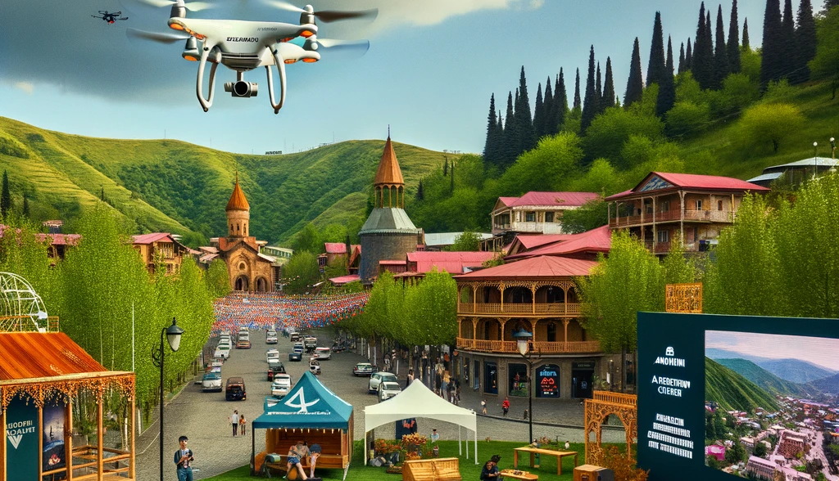A vibrant AI generated view of Stepanavan, Armenia, reflecting the town’s anticipated urban transformation initiatives.

Portfolio Approach:
- Enhancing Learning and Job Opportunities:
- Focused on enabling local youth with alternative learning and job prospects.
- Introduced remote learning and work options, aligning with the post-COVID trend.
- Creating Entertainment Opportunities:
- Recognized the importance of leisure for the youth after work.
- Established an open-air movie & discussion club, revived traditional festivals, and promoted sports.
- Digital Visibility:
- Showcased Stepanavan as not just a tranquil retreat but an ideal residence for remote workers.
- Elevated Stepanavan's presence on the digital map through various interventions.
- Medical Professional Internships:
- Conducted an experimental internship program to attract needed medical professionals to Stepanavan.
- Aviation Cluster Initiative:
- Pioneered an ambitious plan to rejuvenate the declining aviation industry.
- Created an aviation cluster, encompassing education, business, and infrastructure.
- Established the Aviation and IT Learning Center to educate youth on UAV operations for agriculture, forest protection, and disaster risk reduction.
- Network of Change-Makers:
- Fostered a community of change-makers and innovators, assuming dynamic management of the portfolio.
This comprehensive approach tackled emigration and unemployment issues while positioning Stepanavan for sustainable growth.
Source: UNDP – Systems lens into the cities: can we be “on time”?

Private Sector Development and Technical Vocational Education and Training (PSD TVET) Programme – Armenia
Overview:
The PSD TVET Programme operates across the South Caucasus, encompassing Armenia, Azerbaijan, and Georgia. It is designed to enhance conditions for sustainable economic development, particularly in rural areas. The program focuses on three key areas: private sector development, bolstering technical and vocational education and training (VET), and regional development.
Introduction of Dual-Organized VET System:
Inspired by the German model but tailored to local VET advancements and private sector structure, Armenia has adopted a dual-organized VET system. This entails a collaboration framework between public and private sectors, conducting skills analyses in targeted sectors, and identifying training needs. The methodology ensures the quality and recognition of trained personnel by the private sector.
GIZ Support Initiatives:
GIZ supports the institutional establishment of qualifications in VET colleges and the organization of work-based learning in private companies. This encompasses capacity development measures for VET teachers and in-company instructors in the private sector.
Advantages of Dual VET System:
The dual VET system involves learning in two settings: a VET school and a private company. Given the increasing digitalization and technological advancements, providing individuals, especially the youth, with in-demand skills is crucial for securing decent employment. Work-based learning, a core component of dual-organized VET, equips individuals with essential skills and practical experience, making them more resilient to job market fluctuations.
Noteworthy Results:
- 96% curriculum fulfilment
- 87% of students reported improved performance
- 90% satisfaction among teachers and instructors with the content and work environment
- 37% of students secured employment post-program
Short-Term Dual VET Courses:
The program also introduced short-term dual VET courses, lasting 4-5 months, catering to the needs of private sector companies. These courses swiftly address specific skill gaps and demands for certain positions.
Source: GIZ – Dual Education – Guaranteed Employment!

Azerbaijan Employment Support Project – Azerbaijan

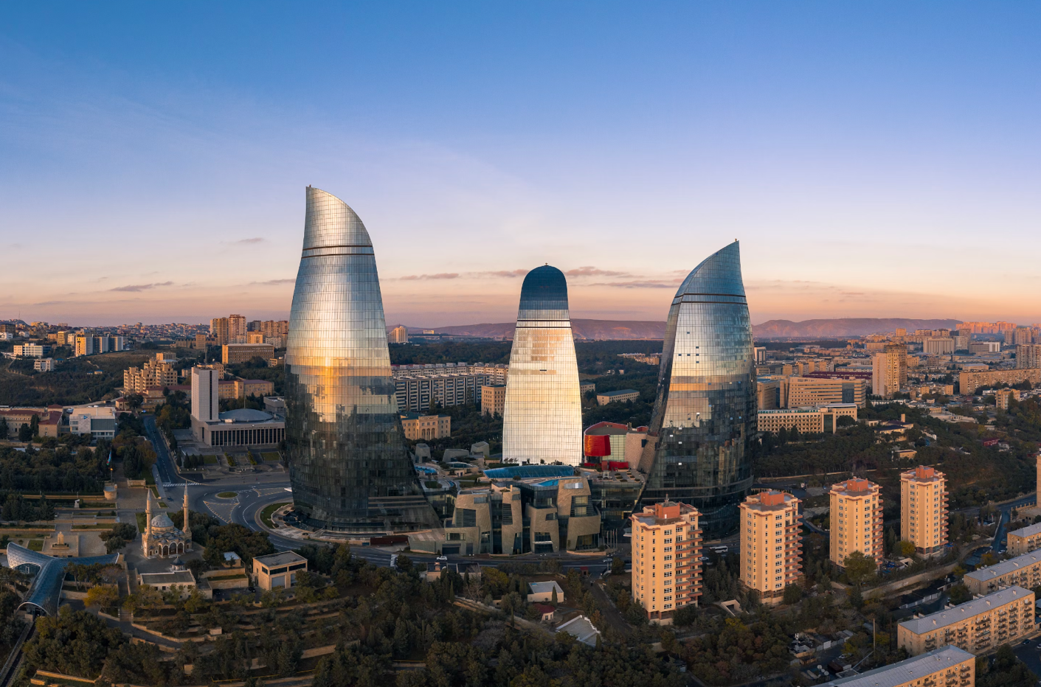Image: Baku, Unsplash
Total Funding: $100,000,000 (Loan from IBRD, a World Bank subsidiary)
Description: Aims to assist vulnerable populations in Azerbaijan in gaining employment and income. Focuses on promoting self-employment opportunities, particularly for women, youth, individuals with low education levels, and internally displaced persons. Enhances the national Self-Employment Program by supporting startups, expanding beneficiaries, and improving program governance.
Duration: Five years
Impact: Addresses disparities between rural and urban areas, income groups, and genders in Azerbaijan.
Source: World Bank Project Page

“Open Door” Days in Vocational Education and Training Centers in Ganja – Azerbaijan
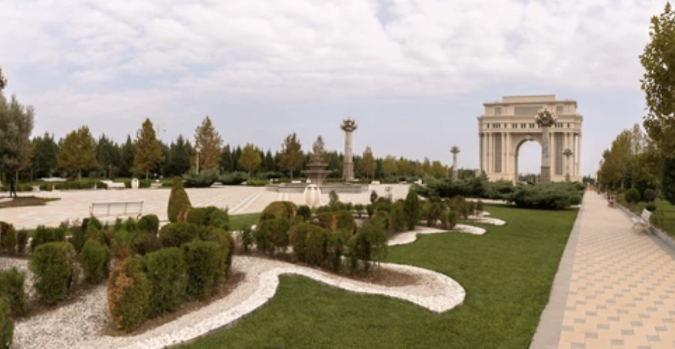
Image: Ganja, Shutterstock

Project Description:
The Ganja State Vocational Centre for Trade and Services, along with the Ganja State Vocational Centre on Industry and Technologies, organized an "open door" initiative in collaboration with the European Union (EU), the United Nations Development Programme (UNDP), and the State Agency on Vocational Education (SAVE). This initiative welcomed senior students from Ganja, parents, teachers, and private sector representatives.
Key Activities:
- Participants were given the opportunity to explore the various facilities of the centers and learn about the available services and admission procedures.
- Information was provided about upcoming high technical vocational education programs, which will be introduced for the first time in both VET centers in Ganja. Graduates from these programs will have the opportunity to enter universities without the need for admission exams.

Project Background and Goals:
The event was part of the "VET for the Future: Development of VET Providers’ Excellence in Azerbaijan" project, funded by the EU and implemented by UNDP in partnership with the State Agency on Vocational Education.
The main objective of the project is to assist the Government of Azerbaijan in enhancing the quality of vocational education and training by modernizing institutions to deliver competence-based training that aligns with the demands of the labor market.
About the Vocational Education Center:
The Vocational Education Center in Ganja offers a range of vocational education programs aimed at preparing students for employment in sectors like agriculture, construction, and information technology. Students can opt for short-term certificate programs or longer-term diploma programs based on their career aspirations.
Apart from classroom instruction, the center emphasizes hands-on training through workshops and internships with local businesses. This practical experience equips students with the necessary skills for success in the workforce.
In summary, the Vocational Education Center in Ganja serves as a model for how Azerbaijani municipalities are working to provide citizens with the education and training needed to thrive in the modern economy.
Source: UNDP Azerbaijan
VET for the Future Project Document

Economic Development of Oni Municipality via Business Clusters – Georgia
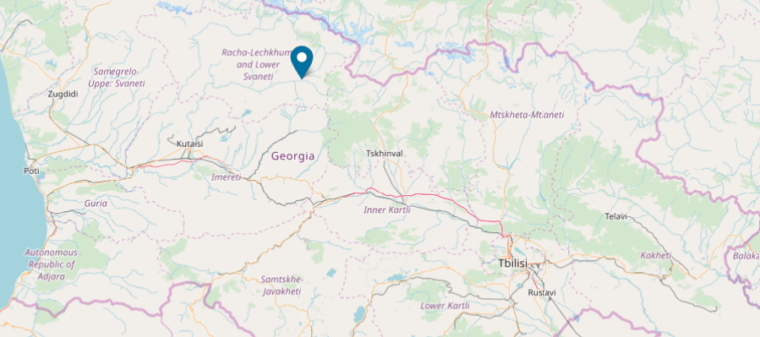
Image: Project map, EU4Georgia

Budget: €350,291
EU Contribution (EU4Georgia): €315,262
Description: Aims to enhance Oni Municipality's economic competitiveness through business cluster creation, attracting investors. Anticipated outcomes include improved conditions for Micro Small and Medium Enterprises (MSMEs), boosting employment and investments.
Objectives:
- Establish two clusters with ≥15 MSME members each.
- Strengthen cluster management, implement pilot projects with sub-grants.
- Enhance visibility for potential investors.

Expected Results:
- Increased MSME competitiveness and investment growth.
- Better socio-economic conditions in Oni, evident in thriving MSMEs, higher employment, and increased investments.
Source: European Union, EU4Georgia Project Page

Regional Development Project II in Imereti Region – Georgia
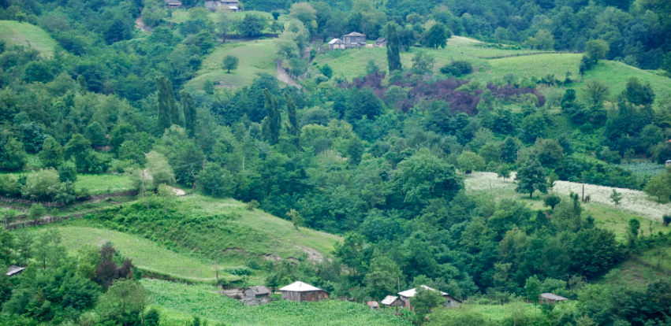
Image: Georgia Travel

Finance: USD 9,000,000 from the World Bank
Project Description: The project encompasses two key components:
- Urban regeneration and tourism circuit development in Tskaltubo.
- Institutional development.
This initiative builds on existing efforts, focusing on completing and rehabilitating municipal and tourism infrastructure, with an emphasis on preserving cultural heritage sites in the Imereti Region. The aim is to ensure the sustainability of prior investments made under the Regional Development Project. Additionally, the project addresses financial gaps caused by currency depreciation and cost overruns due to necessary additional work on cultural heritage sites.
Mercy Tembon, World Bank Regional Director for the South Caucasus, highlights the main beneficiaries as the residents of Imereti, who will gain access to improved public infrastructure and revitalized cultural heritage sites. The project's broader goal is to encourage private investments, foster public-private partnerships, boost local business activity, and develop regional tourism circuits. The anticipated outcomes include enhanced quality of life and increased employment opportunities in the region.
Rosanna Nitti, Task Team Leader for the Regional Development Projects, emphasizes the project's integrated approach to tourism development, spanning infrastructure, urban renewal, cultural heritage restoration, skill-building, and creating an attractive environment for private sector investments. The initiative is poised to facilitate the integration of the Imereti region into the larger Georgian and regional tourism landscape.
Source: World Bank – Second Regional Development Project Additional Financing in Georgia

Mestia Tourism and Entrepreneur Development – Georgia


Image: Mestia, Shutterstock
Mestia has been actively promoting entrepreneurship and innovation by offering training and technical assistance to local entrepreneurs. The aim is to help them grow their businesses and draw more tourists to the area.
Through this project, local entrepreneurs have undergone training in crucial areas like business planning, marketing, and customer service. Additionally, they have been given access to financing through microcredit schemes and other financial support programs.
The outcome has been the establishment of numerous new businesses in the region, including guesthouses, restaurants, and adventure tourism companies. These enterprises have not only created employment opportunities but also generated income for the local population. Additionally, they have played a significant role in highlighting the distinctive cultural and natural heritage of Svaneti.
The government agency Enterprise Georgia has been supporting Mestia in the development of eco and agrotourism. They are working to raise quality standards and have introduced the “Micro and Small Business Support program” to diversify regional goods and services. Furthermore, the village is actively engaged in implementing the country’s plan to develop co-working and co-living spaces for remote expatriate workers.
Source: UN World Tourism Organization

Creating Better Life-Long Learning Opportunities through Local Partnerships – Georgia
Project Description:
The project "Creating Better Life-Long Learning Opportunities through Local Partnerships" aims to enhance the quality and accessibility of skills provision for life-long learning and improve employment opportunities for youth and vulnerable groups in six target regions of Georgia (Guria, Racha-Lechkhumi, Imereti, Kakheti, Tbilisi, and Adjara). The goal is to institutionalize and replicate successful models and approaches across the country. The project is implemented with the financial support of the European Union's "Skills for Jobs" Programme, in partnership with the Ministry of Education and Science of Georgia (MoES), and involves collaboration with the private sector (especially in the HORECA, healthcare, personal services, and other sectors) as well as educational institutions such as schools, colleges, and training centers.
Specific Objective:
Strengthening employability for both men and women in urban and rural areas by increasing access to high-quality services.
Expected Results:
- Strengthened accessibility to skills development for youth, women, men, and vulnerable groups in selected regions through the introduction of new types of formal and non-formal education-related service provision.
- Improved quality of skills development through the enhancement of institutional and human capacity among service providers.
- Enhanced employability of youth through the development of key competences, including digital and entrepreneurial competence.
This project is designed to address the skills gap and improve opportunities for lifelong learning, with a particular focus on supporting vulnerable groups and ensuring that both urban and rural areas benefit from these initiatives.
Source: EU4Georgia

Learn, Exercise, Achieve, Receive, Network for Employment (LEARN for Employment) – Georgia

Image: Unsplash

EU Contribution: € 670,000
Project Description:
The LEARN for Employment! project addresses the challenge of labor market imbalances in the tourism and maritime sectors in Georgia. It aims to establish an effective transition model from education to employment in these industries, with the overarching goal of boosting employment rates, fostering social integration, and reducing poverty and vulnerability.
Project Objectives and Pillars:
- Addressing Key Challenges:
- Inaccessibility of relevant skills matching services
- Insufficient capacity of vocational education and training providers
- Limited availability of career orientation and consultation services for job seekers
- Provision of Work-Based Learning and Life-Long Learning skills with a focus on youth
- Lack of coordination and Public-Private Partnerships (PPP)
- Development of Labor Market Infrastructure:
- Research and development of labor market infrastructure to align with the demands of the maritime and tourism sectors.
Expected Results:
- In six regions of Georgia, improved continuous career consultation, planning, and employment services will be available. At least 3,240 beneficiaries will have the skills and knowledge to apply for jobs in the open labor market.
- The infrastructure of the maritime and tourism labor market will be developed, and intermediary services will be adjusted to meet the demands of these sectors.
- At least eight state and private VET service providers, six state and private employment service providers, and 180 potential employers will enhance their capacity in formal, informal, and non-formal training, as well as the provision of apprenticeships.
- At least 720 beneficiaries will participate in VET, on-the-job training, and internship programs. A minimum of 360 of them will secure employment.
Success Stories:
- Beneficiary 1 (Carpenter from Guria): Finding a job in Guria was challenging, but with the assistance of the Guria "Career Guidance and Employment Service Center," he successfully secured a position at a furniture workshop.
- Beneficiary 2 (Credit Officer from Guria): After losing his job, he sought help from the "Career Guidance and Employment Service Center." They prepared an individual plan based on his needs and skills, ultimately leading him to secure a position at "Credo Bank."
Source: EU4Georgia

Startup City Cahul – Moldova

Image: Startupcitycahul.md
Total Budget: €6,800,000
EU Contribution: €6,800,000
Project Description:
Launched in June 2020, this four-year project aims to unleash and bolster the potential of the digital economy, enhance regional competitiveness, and improve the business and investment environment in the Cahul region through:
- Nurturing partnerships for innovation and entrepreneurship between the private sector, public sector, and educational institutions in the Cahul region.
- Promoting technology, problem-solving, and creative solutions in learning, making STEM (Science, Technology, Engineering, and Mathematics) subjects more attractive to individuals of all genders and ages.
- Facilitating the emergence of startups in innovative sectors, enhancing their capacity, and preparing them for investment.
Key Outputs:
- Establishment of a Regional Innovation and Technology Centre in Cahul ('EU4Innovation Centre').
- Development of STEM activities integrated into the educational system, as well as extracurricular activities at the Centre.
- Creation of a seed funding and acceleration program for digital and innovative startups and entrepreneurs.
- Reinforcing their capacity building and readiness for investment.
Expected Results:
- The 'EU4Innovation Centre' in Cahul is established, fully functional, and operating according to specified requirements.
- More young people, particularly girls and women, are attracted to start a career in the ICT sector.
- Enabling conditions for startups in innovative sectors to emerge and grow are established.
Sources: Startup City Cahul
EU4Moldova

Towards a more entrepreneurial Derry - Londonderry – United

Kingdom
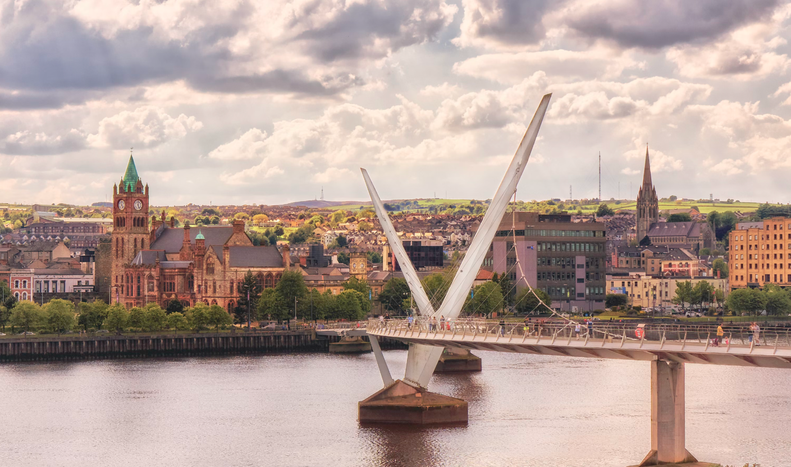
Image: Londonderry, Unsplash

The OECD worked closely with Derry-Londonderry to develop a comprehensive plan, known as the One Plan, aimed at achieving inclusive growth for this city in Northern Ireland. Initial assessments revealed areas of weakness in business creation, entrepreneurial culture, and SME support. The private sector in the city seemed to be underperforming, and the rates of GDP growth were low. Additionally, there was a shortage of business leadership organizations, indicating a lack of influence within city and regional institutions. Derry-Londonderry also had relatively few private employers, with many jobs linked closely to public spending trends. The local economic and political leaders were encouraged to foster a more pro-business culture within the city.
The lack of entrepreneurial activity in Derry~Londonderry was attributed to several factors:
- A history of conflict, which often created an unfavorable environment for entrepreneurs to thrive.
- A dearth of a shared vision or project for the city, which could discourage entrepreneurs by undermining confidence in the city and region's assets.
- A political culture that wasn't as supportive of the private sector and entrepreneurs as it could be.
- Limited examples of local entrepreneurs succeeding and generating jobs and wealth for the city.
- Few financial tools tailored to support local entrepreneurs in Derry~Londonderry.
- The absence of an established "entrepreneurial ecosystem" in the city.
- Self-employment was not seen as a starting point for growing entrepreneurial activity in Derry~Londonderry.

The proposed local strategy to encourage entrepreneurship in Derry~Londonderry comprised six key components:
- Promoting entrepreneurship: This involved creating a central access point for entrepreneurs, garnering support for entrepreneurship from public leaders, and fostering a culture of entrepreneurship within existing institutions.
- Celebrating entrepreneurship: This entailed identifying local entrepreneurs and publicly celebrating their successes, as well as establishing an entrepreneurial ecosystem. An "entrepreneur day" with awards was suggested as a means of recognizing entrepreneurs.
- Coaching and training new entrepreneurs: This included providing essential business creation information and support, matching training with entrepreneurial needs, and offering business plan coaching.
- Incubating entrepreneurs: This involved providing affordable spaces for entrepreneurs, along with support in skills development, networking, and accessing markets.
- Connecting entrepreneurs; and
- Funding entrepreneurs: This component focused on micro-credit schemes and SME loan guarantee schemes backed by local business incubators.
Source: OECD – Delivering Local Development in Derry~Londonderry, Northern Ireland.

Land Registration and Property Valuation Project – Moldova
Total Project Cost: US$ 35,000,000
Finance Summary: US$ 35,000,000 from the International Bank for Reconstruction and Development (IBRD) – World Bank entity
Project Description:
The Land Registration and Property Valuation Project in Moldova is designed with the objective of enhancing the quality and transparency of the land administration and property valuation systems in the country.
Project Components:
- First Property Registration:
This component is aimed at supporting the initial registration of both public and private land in Moldova. It also seeks to bolster the accuracy and reliability of records that already exist in the land register.
Subcomponents:
- Systematic registration of private land, including the implementation of public displays, awareness campaigns, and a grievance mechanism.
- Systematic registration of public land.
- Enhancement of the quality and dependability of the cadastre data.
- Property Valuation:
This aspect focuses on expanding mass valuation to encompass properties not presently covered. It also involves selected revaluation of properties to enhance market transparency and maintain the currency and usability of the property valuation system.
- Land Administration System Strengthening:
This component is geared towards fortifying the land sector in Moldova through policy dialogue facilitation. It includes a review of the existing institutional and regulatory frameworks, with proposed enhancements where applicable. It also advocates for the streamlining of business processes and modernization of cadastre services through the application of Information and Communication Technology (ICT). Additionally, it supports the development of the National Spatial Data Infrastructure (NSDI).
Activities:
- Development of land sector and land sector sustainability policies, covering governance, organizational systems, roles of different process participants, notaries, private sector, registration, and valuation processes.
- Strengthening ICT capacities.
- Reinforcing the National Spatial Data Infrastructure, involving the preparation of a business plan, expansion of the geoportal, and capacity-building initiatives for agencies responsible for core reference datasets.
Capacity Building and Project Management:
This component aims to enhance the capacities of stakeholder agencies and institutions. It ensures the smooth implementation of project activities and provides support for project sustainability.
Source: World Bank - Land Registration and Property Valuation Project

Partnership for the Baryczy Valley - Poland
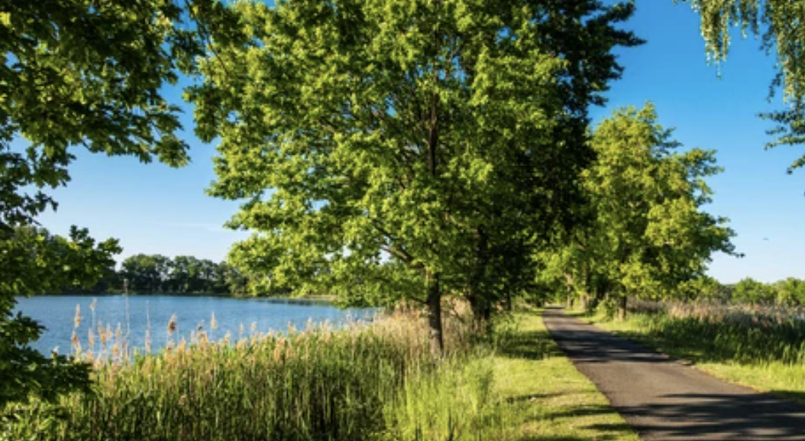
Image: Sutterstock
Overview:
- Initiative: Partnerstwo Dla Doliny Baryczy (PDDB)
- Established: 2008
- Location: Barycz River Valley (eight communes)
- Participants: Public institutions, enterprises, NGOs, and individuals.
Objective:
Strengthen economic potential, increase tourism appeal, and boost local business competitiveness through community activation, entrepreneurship promotion, sustainable development, and environmental education.
Unique Features:
- Barycz Valley is renowned for its protected landscape park, extensive European fishponds, unique bird habitats, and significant carp farming.
- PDDB manages the quality assurance system: "The Barycz Valley Recommends."
Achievements (2018):
- Training: 93 sessions for 1484 individuals on topics like grant programs, business planning, and application processes.
- Consultations: 856 hours assisting 103 grant applicants.
- Educational Grants: Supported NGOs with 257 training sessions for 7554 participants, mainly teachers and students.
- Subsidies: Granted PLN 2.413 million to 17 local enterprises from the Rural Development Program (2014–2020).
- Fisheries Support: Assisted 21 entities with PLN 3.389 million for development, competitiveness, and environmental initiatives from Fisheries and Sea Operational Program (2014–2020).
- Business Incubator: Allocated PLN 0.5 million for establishment in 2021 using funds from Rural Development Program (2014–2020).
- Event Support: Co-financed "Carp Days" promotion with PLN 43,000, aiding 51 exhibitors.
- Quality Mark: Granted "Dolina Baryczy Poleca" rights for 57 products and 101 services by local entrepreneurs.
- Promotion: Co-financed promotional materials, including movies, leaflets, and maps, totaling PLN 86,000.
Focus:
The partnership emphasizes sustainable tourism, aligning with global eco-tourism and gastronomy trends, to bring shared regional value. Activities include promotional events, educational campaigns, and community support.
Sources: GIZ Programme - Case Studies on innovation and clusters from around the world
Dolina Baryczy website
Nasza Barycz website

Applying City Marketing for Sustainable Development in Small Cities – Ukraine

Image: Unsplash

Overview:
Comparison of six small cities in the Kharkiv region emphasizes the competitive advantages unique to each, crucial for driving sustainable local development. Lozova, Chuguiv, and Kupyansk serve as successful models of city marketing implementation, showcasing positive developmental trends. Meanwhile, three other cities, though possessing distinct merits, lag behind due to a lack of city marketing strategies. These cities now stand to benefit from adopting these concepts to address current stakeholder needs and foster local sustainable development.
Key Insights:
The presented scientific paper underscores the value of city marketing for small cities, with a focus on case studies from Ukraine's Kharkiv region. City marketing endeavors to shape opinions, intentions, and behaviors of external entities toward the area. It aims to enhance the overall attractiveness and prestige of the territory, centering on its resources.
Principles of Territorial Marketing:
- Promoting the territory as a hub for knowledge-based projects.
- Forecasting the economic needs, current situation, and potential of the territory.
- Delivering effective solutions to economic challenges at various levels.
- Prioritizing long-term sustainable development.
- Influencing the formation of needs and behaviors in the investment market.
Key Factors Influencing Attractiveness:
- Real development and prosperity levels in the region.
- Image projection.
- Reputation.
Source: 2nd International Conference "Green Cities - Green Logistics for Greener Cities", 2-3 March 2016, Szczecin, Poland - Applying city marketing as a tool to support sustainable development in small cities: case study in Ukraine

GREEN TRANSITION

& ENERGY EFFICIENCY

Assisted Natural Forest Regeneration on Degraded Lands – Albania

Image: Unsplash

Context:
In Albania, land degradation is a pressing concern, primarily stemming from overgrazing and deforestation for firewood. These practices have hindered the natural rejuvenation of the landscape, leading to increased erosion. Many of these barren, unproductive lands have been abandoned by communities.
Nature-Based Intervention:
To combat this degradation and erosion, a comprehensive regeneration approach was adopted. This involved implementing protective measures against grazing to encourage natural regrowth. Additionally, supplementary planting was undertaken to enhance species diversity and expedite soil stabilization, especially in heavily eroded areas. Finally, active silvicultural management techniques were applied to augment biomass density in the restored area.
Effectiveness:
- Climate Change: The project encompassed large-scale reforestation and the restoration of degraded landscapes. Forestry techniques were employed to boost biomass in the newly forming forests, likely leading to increased carbon sequestration.
- Ecosystem Health: The regeneration efforts significantly improved habitat quality and connectivity, along with an overall rise in above-ground biomass. Reduced erosion and soil degradation also resulted in improved water quality in nearby areas due to diminished runoff.
- Socioeconomic Outcomes: This project targeted some of the most economically challenged regions in the country. It provided vital, sustainable revenue streams directly to impoverished rural communities. By managing the forest and facilitating regeneration, short- and medium-term employment opportunities were created. The project also aspires to have the landscape support the production and sale of small timber, firewood, nuts, fruits, and medicinal products.
Source: Nature-Based Solutions Initiative – Case Study Platform - Assisted Natural Forest Regeneration on Degraded Lands

A Green Blueprint for Adaptation and Rural Growth in Lori and Syunik - Armenia
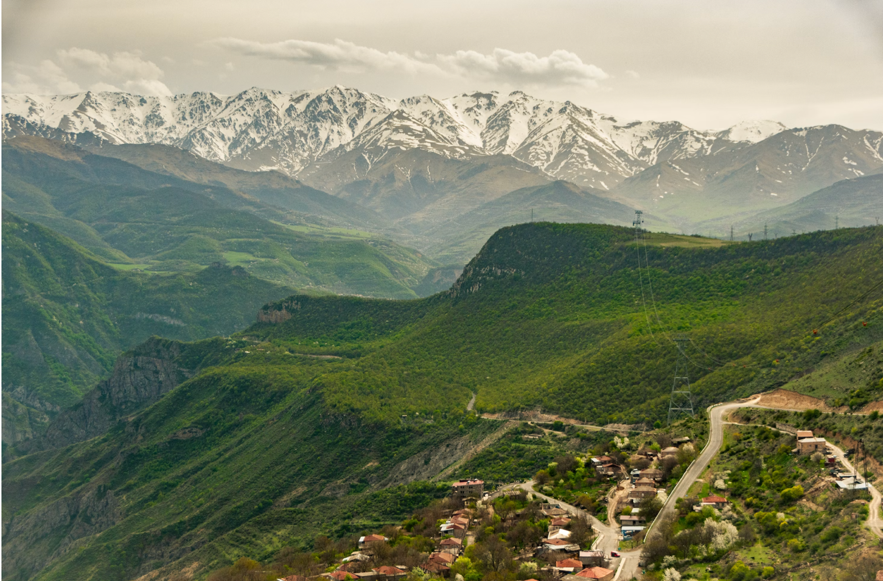Image of Syunik: Unsplash

Executive Summary
Attribute | Details
Initiative Name | Landmark Initiative for Forest Management in Armenia
Total Budget | $US 18.7M
Primary Financing Source | Green Climate Fund (GCF)
GCF Financing Percentage | 53%
Co-financing Rate | 46.5%
Target Regions | Lori and Syunik
Core Objectives | Enhance forest management and promote energy-efficient practices
Innovation Highlight | Armenia's first forestry-focused funding proposal
Transforming Challenges into Opportunities
Armenia, a nation renowned for its stunning landscapes, faces a pressing challenge: its forests and rural communities are critically vulnerable to climate change. But here's the game-changer—the country is poised to turn vulnerability into strength with an innovative project, blending both adaptation and mitigation strategies.
A Dual Approach: Adaptation and Mitigation
By concentrating on the critical forest-energy nexus, this groundbreaking initiative sets its sights on two pivotal arenas:
- Empowering Communities: Through forest concessions and better fuelwood management, local communities will become the true guardians of their natural resources.
- Energy Efficiency: Elevating the adoption of energy-efficient appliances in rural households and the private sector, taking the pressure off Armenia's delicate ecosystems.
A Model for the Future
This isn't just a project; it's a pilot, a template, a trailblazer. With its innovative approaches, Armenia is crafting a resilient, green, and inclusive model, one that can guide the entire nation towards a more sustainable future.
Financial Backing for a Greener Tomorrow
With over half of the budget backed by the Green Climate Fund and a significant co-financing rate, Armenia is leveraging international partnerships to achieve these transformative goals.
By turning theory into action, Armenia is not just adapting; it's evolving, showing the world what a community-focused, energy-smart future can look like.
Source: Green Climate Fund - Armenia

Fostering Biomass Production for Sustainable Heating in Georgia
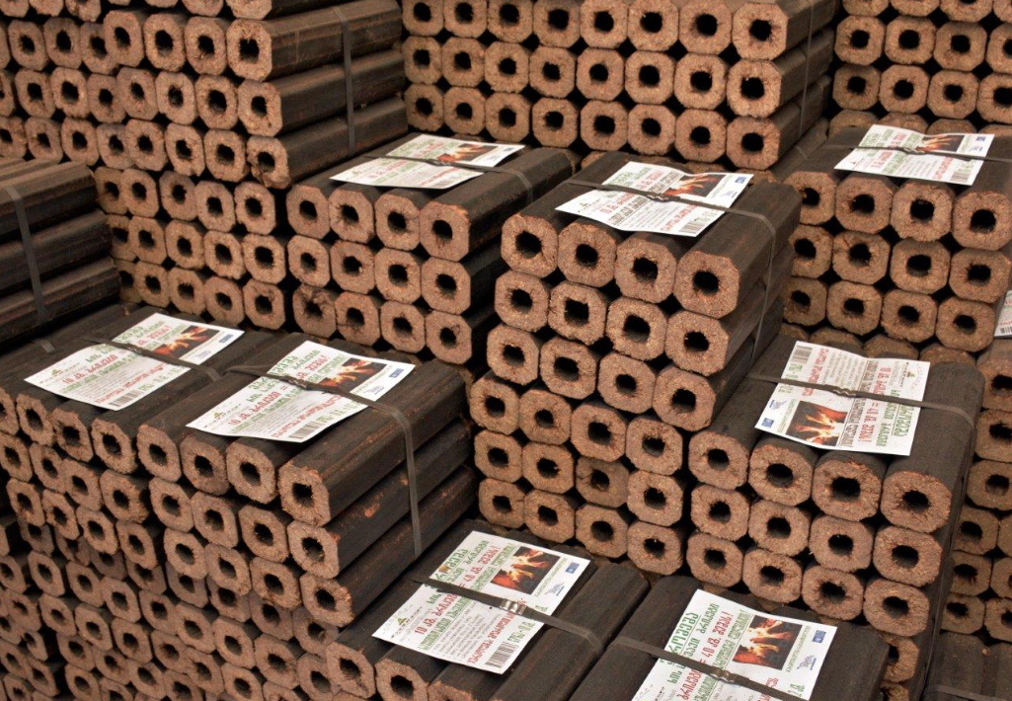Image: Biomass briquettes made from vineshoots. Photo: Vladimer Valishvili/UNDP

Project Overview:
In a strategic collaboration, the United Nations Development Programme (UNDP) partnered with Georgia to champion the production and utilization of biomass. This renewable energy source, derived from organic matter like wood, plants, and household waste, held the promise of revolutionizing the municipal sector. Under the project titled "The Promotion of Biomass Production and Utilization in Georgia," funded by the Global Environment Facility (GEF) and UNDP, a holistic approach was adopted to reduce dependence on fossil fuels and curb GHG emissions.
Key Objectives:
- Sustainable Heating Solutions: The primary goal was to establish a sustainable system for meeting the heating needs of the municipal services sector through the production of upgraded biomass fuels.
- Institutional Framework: A robust biomass financing mechanism and an investment grant mechanism were put in place to ensure the longevity and effectiveness of the initiative.
Implementation and Impact:
Within this initiative, a state-of-the-art briquette-producing facility was established in the Akhmeta Municipality. Operated under the aegis of the Greens Movement of Georgia / Friends of the Earth – Georgia, this facility now produces approximately 30 tons of energy-efficient briquettes. The fruits of this endeavor have already reached the community, with 5,500 kg of briquettes distributed to kindergartens in Zemo Alvani and Kvemo Alvani villages, along with additional allocations to schools in Zemo Keda and Arboshiki.
Outcomes:
- Reduced dependence on fossil fuels for heating municipal services.
- Mitigated GHG emissions, contributing to a greener, more sustainable environment.
- Creation of a replicable model for biomass production and utilization.
Source: UNDP – Promoting Biomass Production and Use in Georgia

Green Guria: Supporting Local Democracy and Rural Development for Inclusive and Resilient Green Growth - Georgia
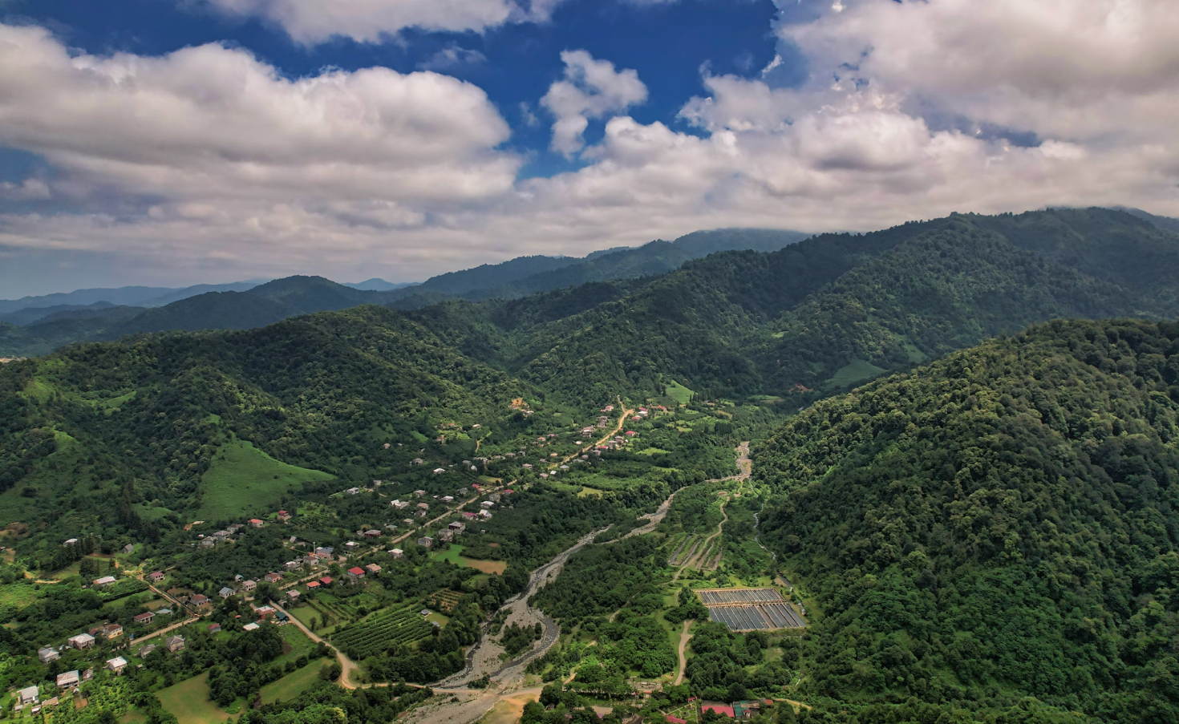Image: Guria, Unsplash

Total Budget: €2,222,376
EU Contribution: €2,000,000
Project Description:
The Green Guria project, implemented by CENN in Georgia's Guria region, specifically focuses on Ozurgeti, Lanchkuti, and Chokhatauri Municipality. Collaborating with partners like the Young Pedagogues' Union, the Institute of Democracy, and Keda LAG, the initiative aims to enhance the living conditions and socio-economic environment of vulnerable rural communities. This is achieved through bolstering civic participation, promoting inclusive rural development, and fostering green growth. The project strives to build climate-resilient and green communities in Guria, diversify rural opportunities, encourage competitive economic and agricultural practices, and engage various groups in participatory planning.
Specific Objective:
The project's overarching goal is to diminish poverty, enhance the socio-economic environment, and improve living conditions in vulnerable rural communities within disadvantaged areas of Georgia. This is accomplished by strengthening civic engagement, facilitating inclusive rural development, and promoting green growth. The specific objective is to forge robust, climate-resilient, and green communities in Guria, achieved by diversifying rural opportunities, promoting competitive economic, agricultural, and environmental practices, and involving civil society, vulnerable groups, women, and youth in participatory planning.
Expected Results:
- Enhanced participatory bottom-up mechanisms for sustainable rural and territorial development.
- Improved policy dialogue and participatory implementation of rural development approaches.
- Cultivation of a greener and diversified rural economy, with expanded areas under climate-smart forest and land management.
- Empowered rural population and improved access to public services and infrastructure.
Source: EU4Georgia - GREEN Guria

Programme for Energy Efficiency in Public Buildings – Georgia
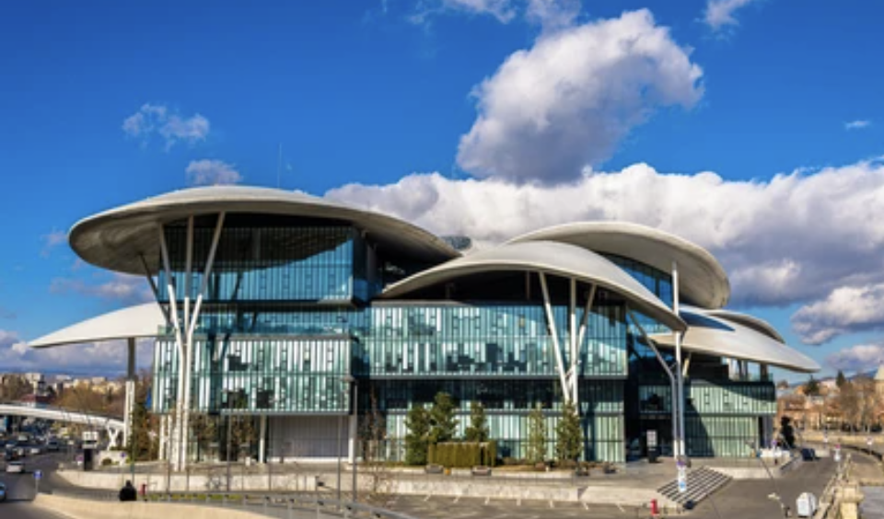Image: Tbilisi, Shutterstock

EU Contribution: €12,650,000
Implementation Period: 17.12.2019 - 31.12.2029
Project Description:
This initiative focuses on upgrading and renovating the energy efficiency of public buildings, predominantly schools, across the entirety of Georgia. The program is an integral part of the EU's broader initiative to enhance the energy sector in Georgia, particularly within the framework of the Georgian Energy Sector Reform (GESR). It plays a pivotal role in introducing new energy efficiency standards, performance benchmarks, and fostering the market for energy efficiency in buildings. The program comprises an investment component co-funded by the EBRD and KfW, along with a complementary technical assistance package to facilitate implementation.
Objectives:
- Boost the market for Energy Efficiency (EE) in buildings by contributing to an enhanced value chain for EE materials and technologies, and by supporting capacity development in the private sector, including construction companies.
- Optimize energy consumption in targeted buildings, leading to a reduction in CO2 emissions. The renovation measures will also contribute to extending the lifespan of buildings, and enhance health, safety, comfort, and educational conditions.
Expected Results:
- Strengthened government leadership in the field of energy efficiency, along with increased awareness of its benefits.
- Reduced energy consumption in targeted buildings, typically in the range of 20% to 40%, resulting in significant reductions in CO2 emissions.
- Establishment of a new market for energy efficiency materials and services in Georgia's building sector.
- Enhanced financial sustainability for the central government and municipalities through lower energy costs.
- Improved comfort levels, hygiene, and sanitary standards in buildings, thereby enhancing the learning and working environment.
Source: EU4Georgia

Small Hydropower Plant in Akhmeta, Georgia
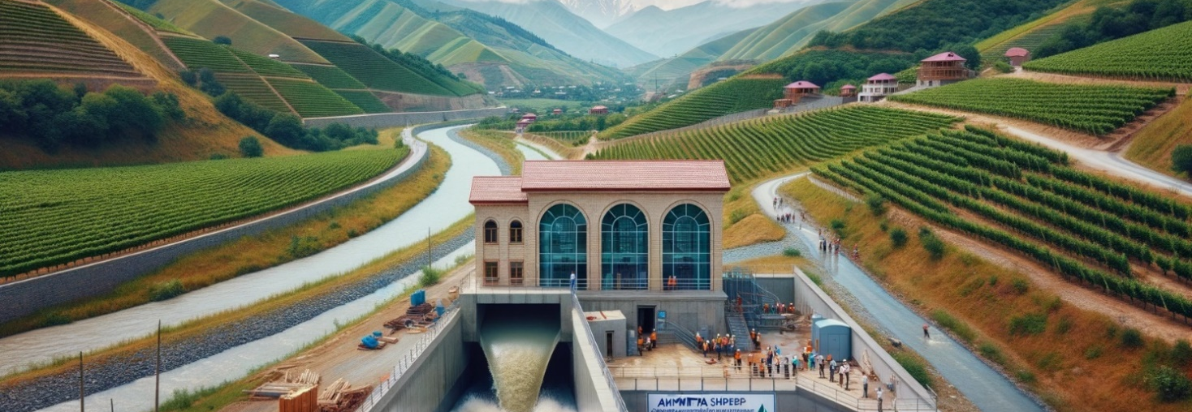An AI-generated image capturing the essence of the Small Hydropower Plant located in Akhmeta, Georgia.

Budget:
- Total: US$ 10,000,000
- Financing: US$ 7,000,000 allocated for project financing and construction through the Risk Sharing Framework (RSF) co-financing instrument, in partnership with the European Bank for Reconstruction and Development (EBRD) and local banks.
Location & Features:
- Situated in Kakheti, eastern Georgia's renowned wine region.
- Annual generation: 50 GWh of clean energy.
- Annual CO2 emissions reduction: 15,000 tons.
- Unique aspect: Relies on a longstanding irrigation network amidst vineyards, ensuring consistent energy production independent of the basin's hydrology.
Financing Model:
- Utilizes EBRD’s Risk Sharing Framework (RSF) where EBRD shares risk of sub-loans made by partner banks.
- This efficient model enabled the project's financing in ways unattainable by local banks or direct foreign investments.
Environmental & Economic Benefits:
- Aligns with UN SDGs, specifically SDG 7 (access to modern energy) and SDG 13 (combatting climate change).
- Strategically located in a modified water system with minimal biodiversity concerns, avoiding water or social conflicts.
- The project developers ensured community engagement, leading to universal local support.
- Generates additional revenues for irrigation network maintenance, benefiting local farmers in this famed wine region.
- Created jobs in construction and plant operation, with an anticipated upgrade in local hydropower skills and significant technology knowledge transfer.
Source: LIU, D., LIU, H., WANG, X., and Kremere, E., eds. (2019). World Small Hydropower Development Report 2019: Case Studies. United Nations Industrial Development Organization; International Center on Hydro Power.

Belvedere SPA - Landfill Energy Plant – Italy
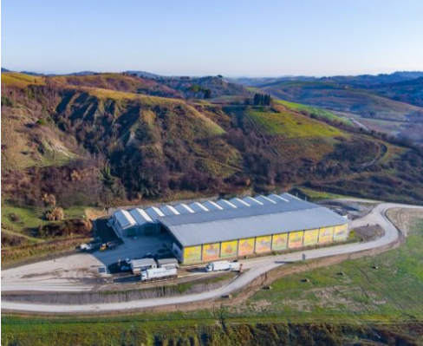
Image: Belvedere Spa, belvedere.peccioli.net

Project Background:
Two decades ago, Peccioli, a small Tuscan city with a population of 5,000 near Pisa, faced a pivotal decision from the regional government. The proposal involved centralizing waste from 40 municipalities, including Florence, in Peccioli's municipal landfill. In response, the mayor saw an opportunity for local development. Citizens were assured that the landfill would not pose pollution risks, and significant investments were promised for expanding, sanitizing, and creating biogas through co-generation for electricity generation (to be supplied to the National Electricity Company) and a teleheating system for providing hot water to residents.
Positive Outcomes:
The profits generated from the landfill and electricity production empowered the municipality to make substantial investments in schools, parking facilities, local infrastructure, and social services. This led to a marked improvement in the overall quality of life in the community. The mayor assumed a role akin to a collective entrepreneur, championing the local community's interests and providing leadership that is often lacking in local authorities.
Long-term Impact:
Over the course of two decades, this endeavor has yielded over EUR 250 million in revenue and facilitated the creation of 300 jobs, both directly and indirectly. From 1990 to 1997, Peccioli Municipality directly managed the landfill. Since 1997, landfill management has been entrusted to BELVEDERE SpA, a company established through a Public Private Partnership. Presently, the company boasts assets exceeding EUR 40 million.
Sources: Belvedere Spa - Project Website
OECD Local Economic and Employment Development (LEED) Papers – Case Study Section

Empowering Moldova's Energy Security
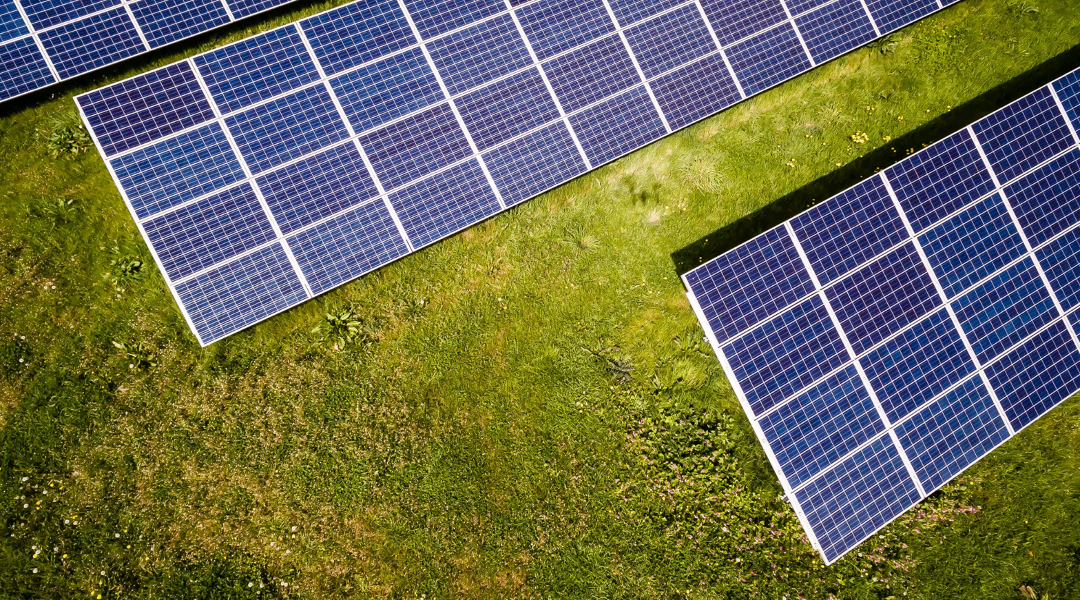Image: Solar panels, Unsplash

Project Overview:
Skyvolt SRL, a forward-looking enterprise established in 2017, undertook an ambitious venture to bolster Moldova's energy security. With a total budget of €800,000, Skyvolt set out to construct and operate a 1 MWel solar photovoltaic system in Sîngerei, a region in northern Moldova.
Key Objectives:
- Clean Energy Generation: The project aimed to generate an estimated 1.2 GWh of clean electricity annually, a substantial addition to the national grid.
- Environmental Impact: Anticipated savings of approximately 585 tons of CO2eq per year were projected, aligning with Moldova's commitment to reduce greenhouse gas emissions by 70% by 2030.
Notable Outcomes:
- Equivalent to powering 900 Moldovan households or meeting the energy needs of 2,000 individuals.
- Enhanced energy balance and security for the nation.
- A positive step towards a greener and more resilient energy mix.
Source: EBRD – Green Economy Financing Facility

Chisinau River Bic Rehabilitation and Flood Protection – Moldova
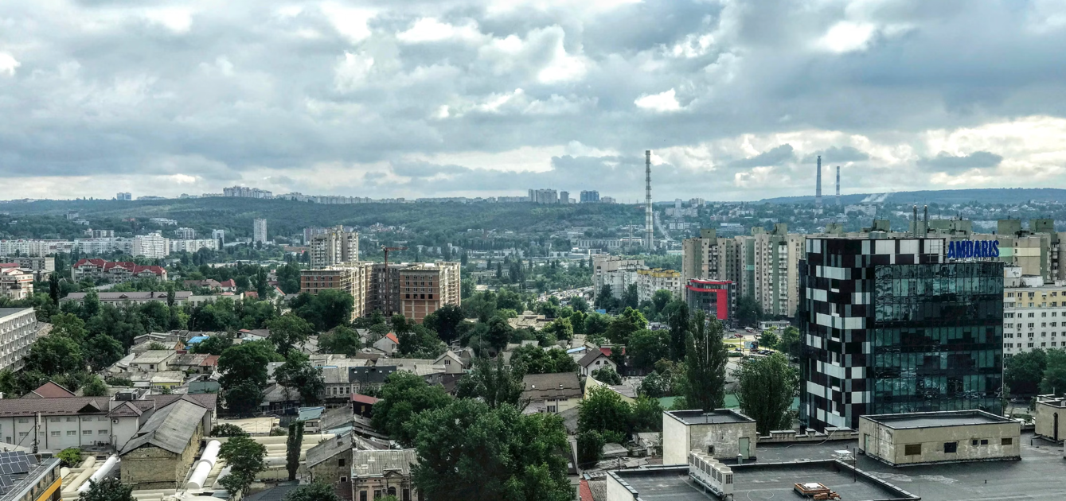
Image: Chisinau, Unsplash
Project Overview:
The Chisinau River Bic Rehabilitation and Flood Protection project in Moldova is a critical initiative with a total budget of €20 million. The financing consortium includes €8 million from the European Bank for Reconstruction and Development (EBRD), €8 million from the European Investment Bank (EIB), and an investment grant of up to EUR 4.0 million from the Green Climate Fund (GCF).
Project Description:
This project addresses the pressing need to safeguard people, properties, and commerce from the detrimental impacts of severe flooding, which are anticipated to exacerbate due to the effects of climate change. The interventions encompass a multifaceted approach, including the restoration of existing storm drains, trials of sustainable urban drainage solutions, installation of flap valves, and re-grading of river sections to bolster capacity.
Key Objectives:
- Flood Risk Mitigation: Implementation of measures to mitigate the risk of River Bic flooding, protecting the well-being and assets of approximately 2,100 individuals.
- Regeneration and Restoration: Revitalize the River Bic, transforming it into an appealing asset for the city and the broader region. The project seeks to not only halt further degradation but also rejuvenate the natural environment.
- Economic and Societal Impact: Foster sociability, stimulate economic revival, and enhance the city centre's attractiveness, positively influencing the lives of around 100,000 residents, workers, and visitors.
Anticipated Benefits:
- Improved Quality of Life: Enhanced outdoor experiences along the river Bic, leading to an enriched quality of life for the community.
- Economic Revival: The revitalization efforts are poised to spur economic activity, potentially becoming a magnet for businesses and residents alike.
- Health and Wellbeing: The project's success will contribute to the health and wellbeing of the population by reducing flood-related risks and improving overall water quality.
Source: EBRD – Green Cities Framework - Chisinau River Bic Rehabilitation and Flood Protection

Oban Local Energy Plan – Scotland
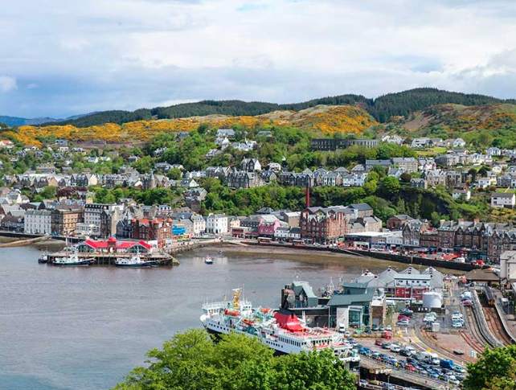
Image from ALI Energy
Project Description:
Oban, Scotland, has developed a Local Energy Plan to assess its current and future energy requirements encompassing power, heat, and transportation. The plan aims to identify priority areas for action to promote sustainable growth. Additionally, the planning process allowed the community to engage with its energy needs, offering immediate and long-term planning opportunities.
Challenges Addressed:
- High levels of fuel poverty, indicate households struggling to afford adequate heating given their income.
- Inefficient energy consumption in housing.
- Limited local capacity for green energy generation.
- Heavy reliance on private cars for transportation.
Proposed Actions:
- Implement residential programs for fabric improvements and insulation. Seek support, advice, and available funding for ongoing improvement works.
- Encourage the development of solar photovoltaic (PV) installations on existing properties through feasibility studies and community involvement models.
- Promote the adoption of electric vehicles by raising awareness of existing grant and loan schemes. Explore funding options for capital investment and cost-effective leasing models.
- Develop an Active Travel Plan, focusing on traffic management, flow reduction, safer cycling routes, and promoting e-bike usage with associated charging points.
- For more detailed information and additional actions, refer to the full document.
Source: Oban Local Energy Plan Summary (July 2018)

Redefining Procurement Conditions - Landcom Sydney

Image: Landcom
Landcom, a government-owned land and property developer in Sydney, Australia, has taken significant steps in redefining procurement conditions to prioritize innovation, environmental sustainability, social value, and support for local companies over simply seeking the lowest-cost solutions.
Landcom's primary mission is to increase the housing supply, enhance affordability, and protect the environment in the Greater Metropolitan Region of New South Wales. Over the past decade, sustainability has become a core principle guiding its planning, operations, and collaborations with both public and private sectors.
Despite the requirement to operate according to commercial principles, Landcom plays a key role in advancing the government's land development and environmental policies. This position has enabled Landcom to disseminate sustainability guidelines, design principles, demonstration projects, policies, and practices throughout the development and construction industries. This has led to the emergence of new specialized roles in sustainability within firms and the growth of training and skills related to sustainability in traditional construction occupations.
For instance, Landcom has implemented principles such as water-sensitive urban design, sustainable stormwater management, standards for reducing water and energy consumption, and practices for reusing and recycling construction materials. Additionally, they focus on managing native vegetation and riparian corridors. These principles are mandated in tender processes for Landcom projects and are included as requirements in awarded contracts.
Through these efforts, Landcom serves as a bridge between the government's social, environmental, and economic goals and the commercial objectives of the private sector. This approach not only drives sustainable development but also fosters a culture of innovation and environmental responsibility in the construction and development industries.
Source: Sustainable Places Strategy

Revitalizing Energy Efficiency in a Ukrainian Multifamily Apartment Building
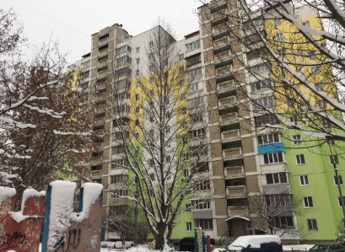
Image: Ukraine, EBRD
Project Overview:
Aviator 17, a Homeowners’ Association (HOA) in Ukraine, undertook a transformative initiative to enhance energy efficiency in their aging multifamily apartment building. The primary concern was the persistent issue of low temperatures within apartments during the heating season. Recognizing the need for change, Aviator 17 sought financing through the European Bank for Reconstruction and Development's (EBRD) IQ Energy Programme.
Key Objectives:
- Facade Insulation: The initial phase focused on partially insulating the building's facade walls, laying the foundation for a comprehensive insulation project.
- Energy Efficiency Financing: Aviator 17 secured a loan of UAH 1,688,874 (equivalent to €51,600) through the EBRD's IQ Energy Programme, enabling the execution of the project.
- Technical Support: The IQ Energy team provided critical support, including feasibility analysis, technical expertise, and financial planning to ensure the project's success.
Implementation and Impact:
With the financial backing and technical guidance from EBRD's IQ Energy Programme, Aviator 17 partnered with local supplier VELIANT BUD for the facade insulation project. The IQ Energy team played a pivotal role in verifying the quality of the insulation after installation.
Outcomes:
- Significant Energy Savings: The project resulted in an estimated 23% reduction in energy consumption, leading to substantial savings on monthly heating bills for residents.
- Enhanced Building Aesthetics: The project not only improved energy efficiency but also gave the building a modern and attractive appearance, ensuring its longevity for years to come.
Source: EBRD – Green Economy Financing Facility - Multifamily Apartment Building Energy Efficiency

PARTICIPATORY

PLANNING

Unleashing Stepanavan’s Potential: A Dynamic Playbook for Social Innovation
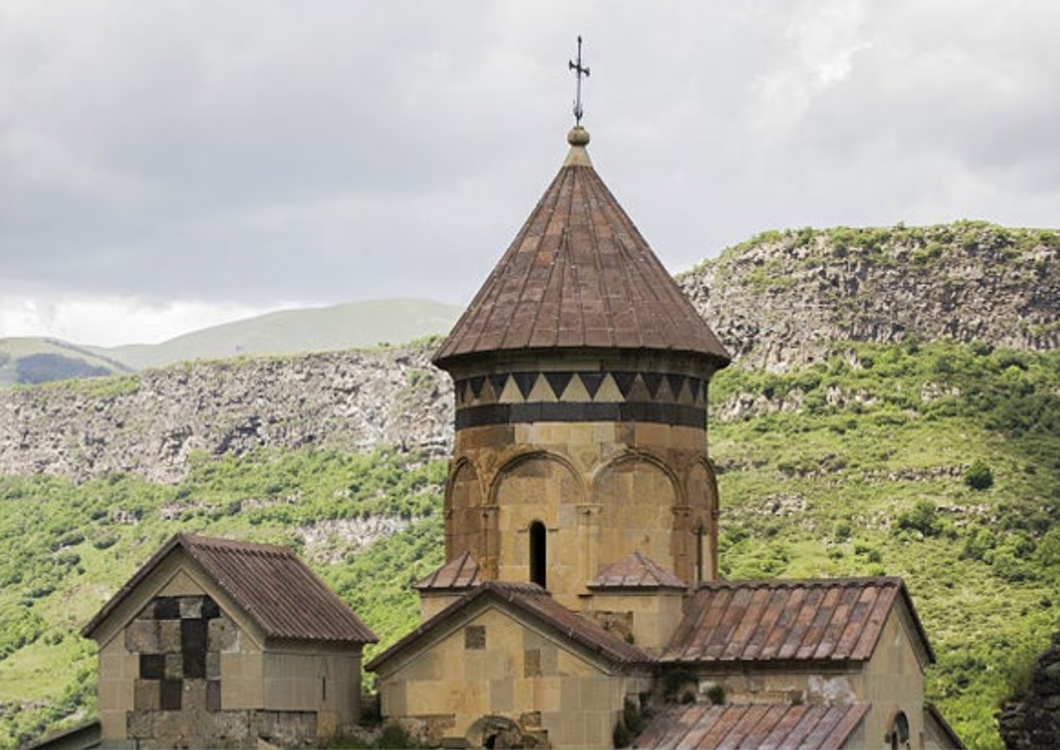
Image: Stepanavan, UNDP City Snapshots
Who's Behind It: Agirre Center's Social Genius
Imagine a think-tank that's not content with just thinking. Hailing from Spain's Basque Country, the Agirre Center is a hub where entrepreneurs, scholars, and policymakers unite to solve real-world problems. They specialize in three power moves: insightful research, spreading know-how, and taking their solutions globally.
The Game Plan: Building Bridges for Big Impact
In comes the Social Innovation Platform, a masterfully crafted strategy that connects different groups under a unified plan. It’s like building a multi-lane highway where every car, no matter its size or speed, is headed in the same direction.
Five Cities, One Goal: Systemic Change
In 2021, five cities from Europe to Central Asia—including Stepanavan, Armenia—decided to pilot these platforms. Their aim? Drive large-scale impact that can be felt across their entire community.
Collab with UNDP Armenia: Listening First, Acting Second
Together with UNDP Armenia, the Stepanavan team went on a listening tour. They gathered stories, struggles, and dreams from the local community. And what did they find? Stepanavan isn't just another sleepy town—it's a hidden gem, waiting to shine.
Strategic Action Points: Choose Your Adventure
Next, the team got tactical, pinpointing key areas where change could make the biggest impact. They rolled up their sleeves in July and August 2021 and kicked off a series of trials and projects.
From Data to Stories: The Plot Thickens
This wasn't a one-off experiment. It was a saga of workshops and discussions that delved deeper into the town's hidden narratives, evolving the mission from a "rest stop" to a "life destination."
Eight Positions, Infinite Possibilities
The project branched into eight distinct yet connected strategies, each backed by a flurry of options. From rebranding the town to creating youth-focused opportunities, the interventions were as varied as they were interconnected.
Co-Creation Spaces: Where Ideas Come Alive
Finally, think of Stepanavan's platform as a garden where each flower is a unique project or idea. These flowers are nurtured in specialized greenhouses—each focusing on a different issue like housing or alternative finance—and together, they make up a thriving ecosystem.
By focusing on community input and multi-stakeholder collaboration, Stepanavan is now geared to redefine itself, attracting the best talent and resources to foster a vibrant, inclusive community. It's not just change; it's transformation.
Sources: UNDP - Systems lens into the cities: can we be “on time”
Agirre Centre – Social Innovation Platform in Stepanavan

Citizen Engagement in Co-implementation of Actions in Camden – London, United Kingdom
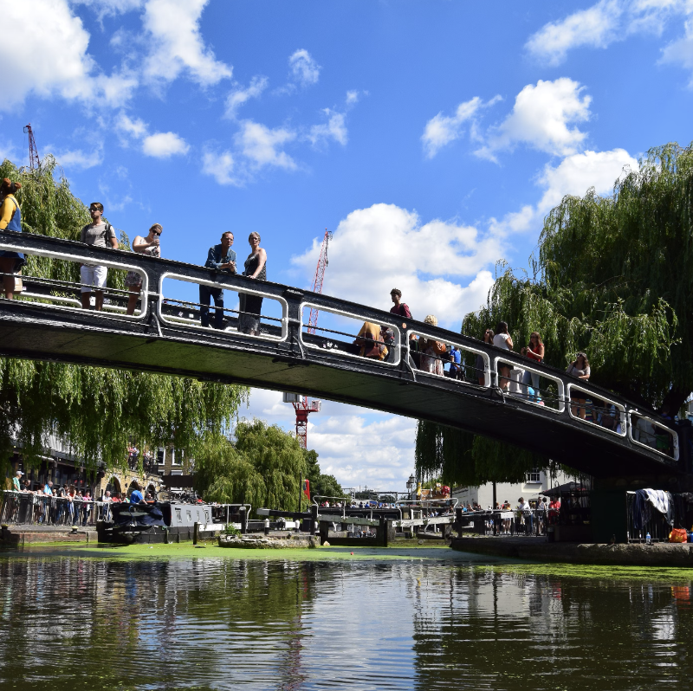
Image: Camden Park, Unsplash
Extract from the report "Inclusive and Sustainable British Columbia – A Mission-oriented Approach to a Renewed Economy" by Mariana Mazzucato:
"Citizen engagement should not be a one-off event that only takes place when missions are being designed. Instead, it is vital that ongoing engagement takes place while mission-oriented policies are being implemented. The format within which co-implementation takes place in missions depends on the context of the mission. For instance, there could be dedicated bottom-up citizen initiatives in some mission areas. These could take the form of accelerators, providing support to small-scale initiatives through suitable grants, and stimulated by prizes and other types of rewards and incentives, as has happened in the London Borough of Camden in the UK (where the decisions about who receives funding are made by a panel of Camden citizens).”
Source: Institute for Innovation and Public Purpose – Inclusive and Sustainable British Columbia – A Mission-oriented Approach to a Renewed Economy

Futureproofing North Macedonia Through Strategic Foresight

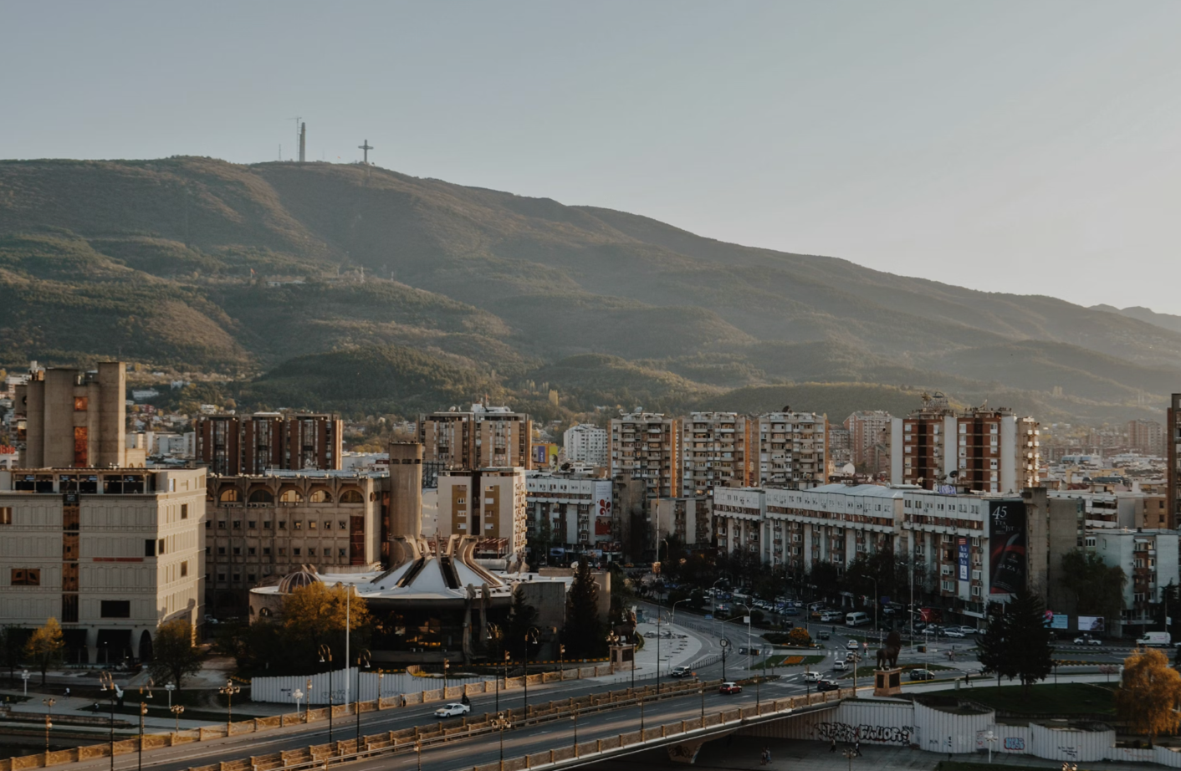
Image: Skopje, Unsplash

Overview:
The United Nations Development Programme (UNDP), in coordination with the North Macedonia Resident Coordinator's Office (RCO) and funded by UK GGF, has engaged in a collaborative venture with Dark Matter Labs. The aim is to assist the Government of North Macedonia in formulating its National Development Strategy (NDS) for the years 2021-2041.
Objective Alignment
The project aligns with both the 2030 Agenda for Sustainable Development and the specific developmental and strategic priorities of North Macedonia. It aims to provide an actionable roadmap for the nation's transition over the next two decades.
Methodological Approach
The strategy leverages strategic foresight methodologies to reimagine statecraft. It views the nation as an integrated system capable of responding to multifaceted challenges, ranging from climate change to global pandemics.
Media Engagement
The process and methodology have been outlined in a detailed video, which serves as an informational resource. The video elaborates on how nations can adapt and build resilience to deal with the long-term and interconnected global challenges.
Key Takeaways
- Innovative methodologies provide a framework for an adaptive and resilient national strategy.
- Collaboration between multiple stakeholders ensures a comprehensive and aligned approach.
- The initiative sets a precedent for how to engage in long-term planning that accounts for global uncertainties.
Further Information
For an in-depth explanation of the methodology and objectives of the project, watch the video.
The project exemplifies how strategic foresight can be incorporated into national planning, providing a blueprint for sustainable development that is responsive to future uncertainties.
Sources: UNDP – UNDP North Macedonia: A new way forward

Ethnography Unlocks Circular Economy Insights: A Case Study from Pasig City, Philippines

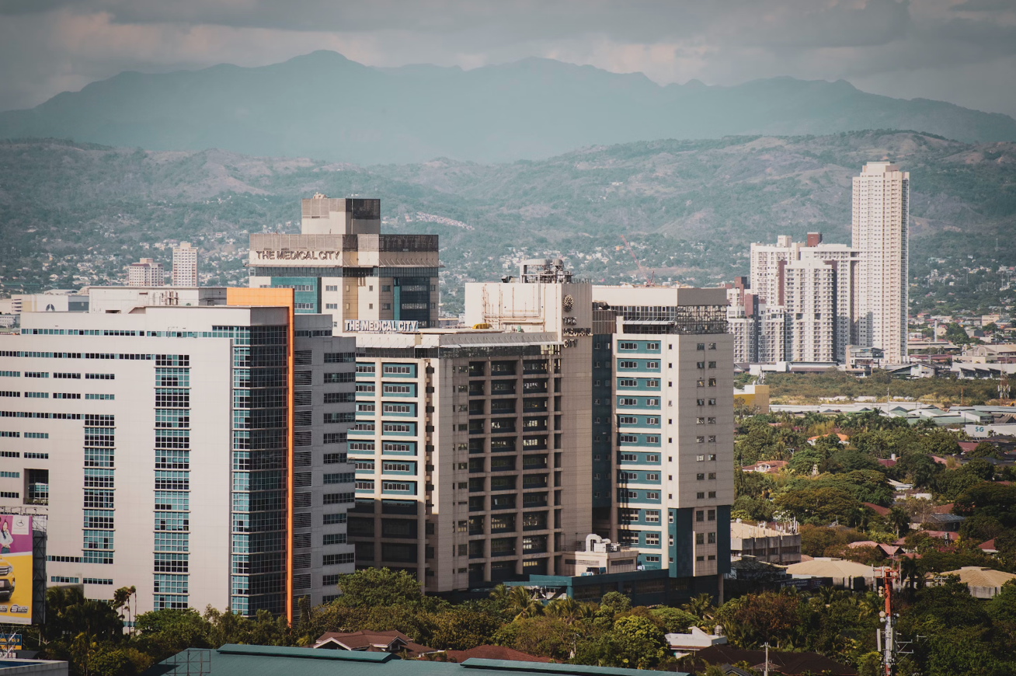
Image: Pasig, Unsplash

Attribute | Details
Project Lead | UNDP Philippines
Timeline | November 2020
Research Team | Members of UNDP Philippines Accelerator Lab and Climate Change Unit
Key Stakeholders Engaged | Waste Management Actors, Households, Policymakers, NGOs, Businesses, Students
Methodology | Rapid Ethnographic Research
Research Duration | One month for planning, three weeks for fieldwork
Interview Duration | 60-90 minutes each
Total Interviewees | 23
Key Focus Areas | Waste perception, circular economy, sustainable practices, barriers, future opportunities
Outcome | Creation of seven personas with accompanying user stories
Ground-Breaking Ethnographic Approach
Forget conventional research; UNDP Philippines has turned the spotlight on real, lived experiences to tackle waste management in Pasig City. By employing a rapid ethnographic approach, the project plunged into the social and behavioral nuances of waste, unearthing actionable insights.
Methodology Meticulously Crafted
Before hitting the ground, the team meticulously planned every detail, from who to interview to what questions would pierce the heart of the matter. All this was captured in a comprehensive Ethnographic Research Field Guide.
Rich Conversations, Richer Insights
Imagine sitting down with community members, policymakers, and even students, diving into hour-long conversations about waste management and circular economy. This isn't your everyday survey; it's a deep, contextual understanding of the issues.
Personas that Tell a Story
The treasure trove of data didn't just gather dust. It was transformed into seven detailed personas, complete with user stories. These personas serve as a compass, guiding Pasig City toward sustainable change.
It’s Not Just Data; It’s Humanity
This project reminds us that numbers alone can't solve complex problems. By blending qualitative insights with quantitative data, Pasig City and UNDP Philippines are pioneering a balanced, empathic approach to the circular economy.
With this study, UNDP Philippines has set a benchmark in how in-depth, community-based insights can bring about a paradigm shift in tackling environmental challenges. It's ethnography in action, making a sustainable impact.
Source: System Change: A Guidebook to Adopting Portfolio Approaches
A rapid ethnographic research on circular economy in a Philippine urban setting

Tallinn, Estonia—A Model for Citizen-Centric Urban Planning
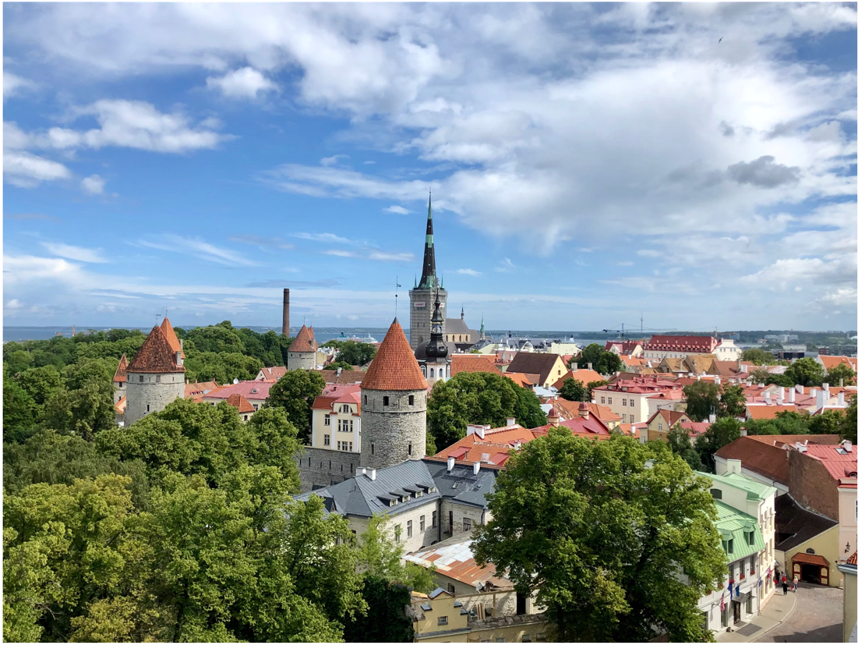
Image from Unsplash

Tallinn, the capital of Estonia, has set a benchmark in urban planning by involving citizens, local groups, and businesses in a participatory planning process.
The Inception: Smart City Project 2015
In 2015, the city embarked on a Smart City initiative to improve digital infrastructure. The key to its approach were interactive workshops led by urban planning and technology experts. Here, citizens engaged in activities like brainstorming and mapping, providing invaluable insights that were incorporated into strategic plans.
Scale of Engagement
Over 3,000 individuals and stakeholders participated, pinpointing focus areas like public transport, green spaces, and digital innovation. To be truly inclusive, online surveys were also used, attracting widespread participation through promotion on social media platforms.
The Evolution: Tallinn 2035
Year | Workshops | Method of Engagement | Key Focus Areas | Notable Targets
2015 | Workshops and Online Surveys | Workshops | Digital Infrastructure,  Public Transport,  Green Spaces,  Digital Innovation. | Citizen well-being through digital services
2018 | Tallinn 2035 | Workshops and Online Surveys | Sustainability,  Social Cohesion,  Economic Growth. | 40% reduction in emissions by 2030
Building on its past success, Tallinn developed its 2018 plan known as "Tallinn 2035." The planning process continued to be participatory, employing workshops and online surveys to refine its strategy. Significant milestones in the plan include a 40% reduction in carbon emissions by 2030 and the addition of 20,000 new jobs.
Conclusion
Tallinn’s participatory planning model is a case study in effective governance, showing that citizen involvement leads to more balanced, fair, and tailored solutions to urban challenges.
Sources: Tallinn Smart City
Tallinn 2035 Strategic Plan
Participatory Planning in Tallinn

TECHNOLOGY

& URBAN MOBILITY

Bakuriani Municipal Services Project – Georgia
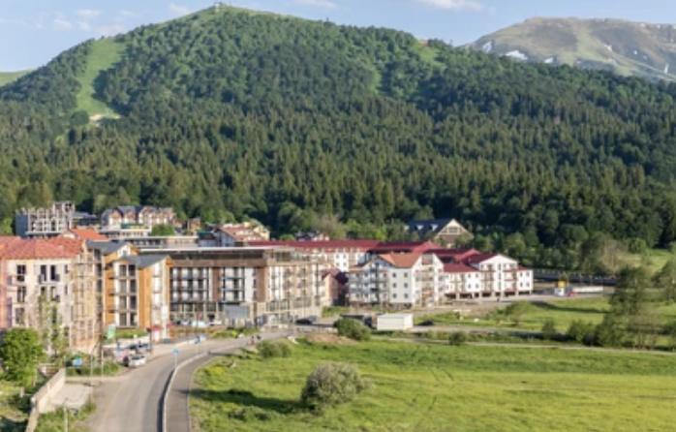
Image: Bakuriani, Shutterstock
Total Project Cost: €5,000,000
Finance Summary: €5,000,000 sovereign loan to Georgia
Project Description:
The Bakuriani Municipal Services Project involves extending a sovereign loan of up to EUR 5 million to Georgia, specifically for the benefit of Bakuriani. The funds will be used to expand the fleet of specialized vehicles and machinery, with the aim of enhancing the quality of municipal services. Additionally, the loan will be used to procure up to 10 units of buses. The overarching goal of the project is to contribute to the improvement of accessibility, mobility, safety, and efficiency of urban transportation for all user groups. It will also lead to enhanced solid waste management practices and improved air quality within the city.
Project Objectives:
- Improving Municipal Services and Safety Measures: The investment is set to elevate the quality of municipal services and implement safety measures in Bakuriani.
- Procuring Modern Buses: The project entails the acquisition of modern buses dedicated to passenger transportation.
- Acquiring Equipment for Solid Waste Management: Specialized equipment for solid waste management and other municipal operations will be procured.

Expected Impacts:
The Bakuriani Municipal Services Project is anticipated to achieve the following:
- Addressing Well-Governed and Inclusive Transition Objectives: This will be accomplished by supporting sector reforms and ensuring access to efficient transportation for the local population.
- Building Local Capacity: The program will provide training initiatives, thereby enhancing the skills and capabilities of the local workforce.
Source: EBRD - Bakuriani Municipal Services Project

The Gyumri Technology Centre – Armenia
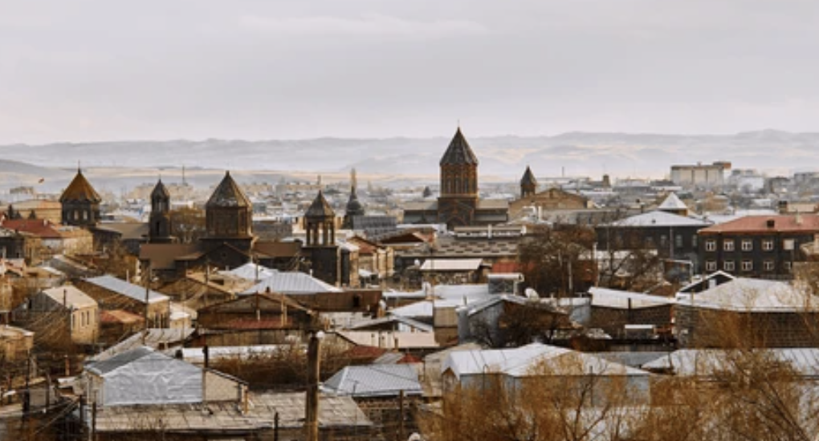
Image: Gyumri, Shutterstock

Foundation:
- Year: 2013
- Collaborators: Enterprise Incubator Foundation, Government of Armenia, World Bank
- Under Project: E-Society, Innovation and Competitiveness
Objective:
To stimulate the regional technology sector's growth and create job opportunities for the local populace.
Services & Offerings:
- Mentorship for tech startups and entrepreneurs
- Networking platforms
- Funding access
- Events like hackathons and workshops to foster innovation and teamwork
Facilities:
- Modern infrastructure including office spaces and conference rooms
- Houses numerous startups, tech enterprises, and a branch of the American University of Armenia
Local Moniker: "Technopark"
Role & Impact:
- Incubates innovative teams and startups
- Uses early-stage venture capital to transform business ideas into sustainable ventures
- Supports individuals, especially the unemployed with innovative concepts, to establish their businesses
- Hosts significant tenant companies such as D-Link, Instigate Design, Time Production, Cleantech Open, and Startup Club
Significance:
The center is pivotal to Armenia's growing tech industry, solidifying Gyumri's reputation as a regional innovation
and entrepreneurship nucleus.
Sources: World Bank
Gyumri Technology Centre

Log-in Georgia, Georgia

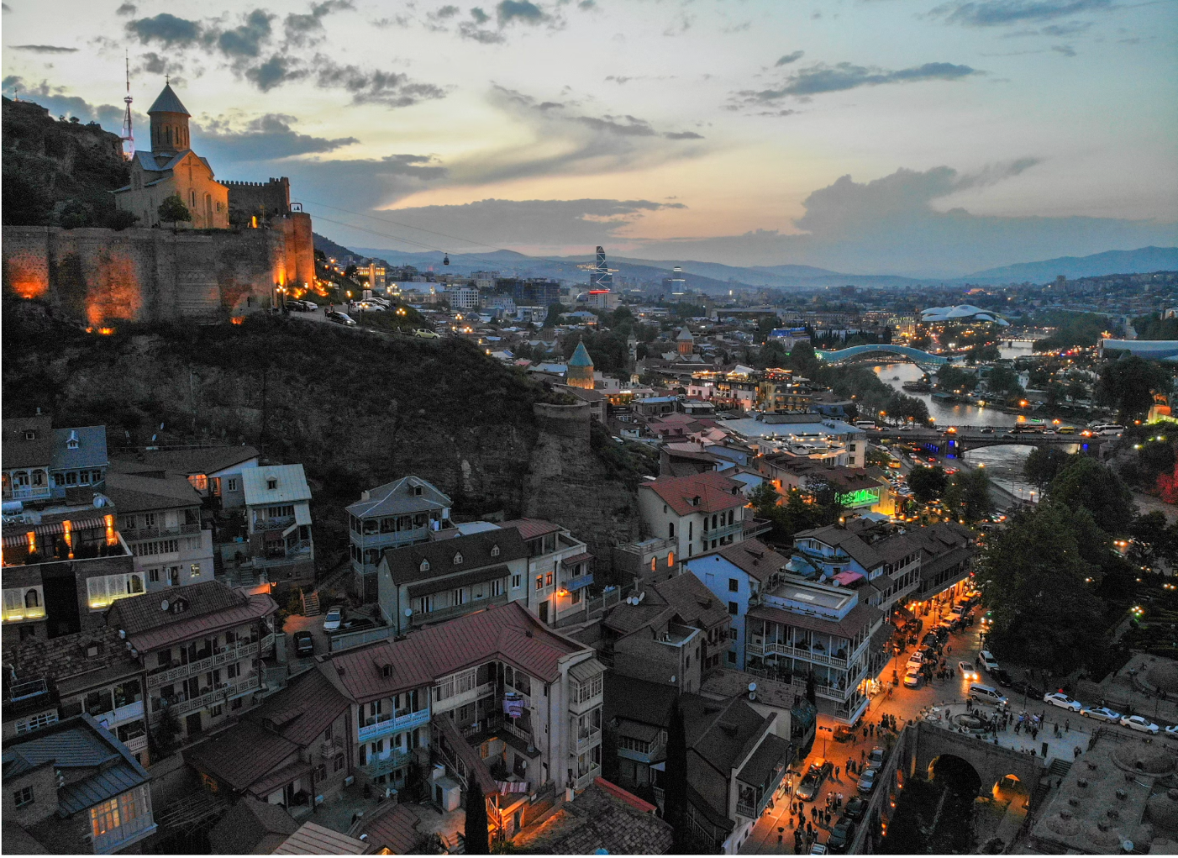Image of Tbilisi, Unsplash

World Bank Funding: €35,700,000
Project Description:
The Log-in Georgia Project is dedicated to bridging the digital divide in rural Georgia. Its primary objectives are to provide high-quality, affordable broadband internet to people, enterprises, and institutions in these areas, while also encouraging the utilization of digital services.
This initiative aligns with Georgia’s National Broadband Development Strategy for 2020-2025, and aims to connect around 1,000 villages, including those in mountainous regions, to reliable and affordable broadband service. The anticipated outcome is improved accessibility to quality broadband services for nearly 500,000 residents currently lacking such access.
Project Objectives:
The Log-in Georgia Project comprises three key components:
- Increasing Access to Affordable Broadband Internet: This component focuses on expanding the coverage of high-speed broadband internet services in rural settlements.
- Promoting the Use of Broadband-Enabled Digital Services: The project emphasizes the importance of training and capacity-building programs to enhance the use of digitally enabled services throughout the country. This includes fostering digital financial services, e-commerce, online e-government services, remote e-learning, and telemedicine.
- Attract investment to expand networks to rural areas, densify in urban areas, develop IT infrastructure, and improve quality of service.
Source: World Bank – Log-In Georgia Project Page

TEKWILL Hub Spaces – Moldova
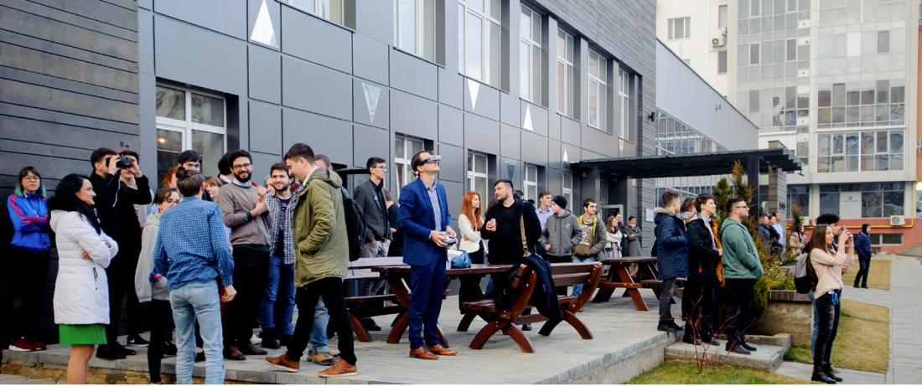Image: Tekwill

Overview:
- Nature: Public-private partnership
- Focus: Enhancing Moldova's Information and Communication Technology (ICT) sector development
- Supporters: USAID (United States Agency for International Development) and Sida (Swedish International Development Agency) representing the Government of Sweden.
- Collaborators: Moldovan Association of ICT Companies (ATIC) and the Technical University of Moldova.
Background: TEKWILL was birthed from the project "Development of Moldova ICT Excellence Center."
Innovation Centers:
- Presence: Multiple centers established across Moldova.
- Offerings: Comprehensive training and certification in programming, web design, cybersecurity, and entrepreneurship.
- Facilities: Equipped with advanced technologies such as 3D printers, robotics kits, and virtual reality systems.
Primary Objective:
- Skill Enhancement: Focus on cultivating IT skills to create quality jobs.
- Migration Deterrence: Aims to retain young talent within the country by offering attractive opportunities.
- Business Growth: Supports local startups and companies while enticing international IT firms to invest in Moldova.
Initiatives:
- Events: Organizes hackathons, startup competitions, and conferences to foster idea exchange and networking.
- Training: Since 2017, over 40,000 individuals have been trained.
- Sector Growth: Has spurred the growth of Moldova's ICT sector, with many startups and innovative projects stemming from TEKWILL centers.
Sources: Tekwill
USAID: Tech Start-up Ecosystem and Seed Fund in Moldova

Green Cities Framework – Balti Trolleybus – Moldova
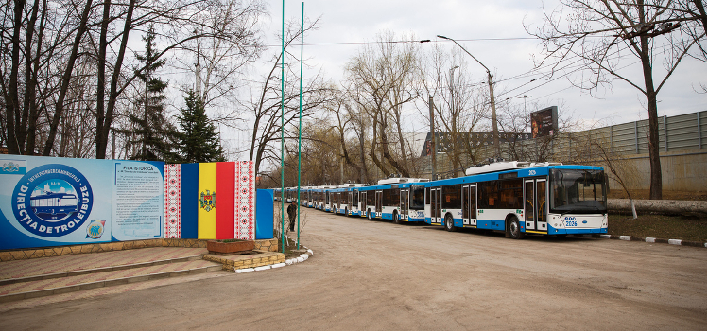Image from EBRD

Total Budget: €3,700,000
Finance Summary: €2,500,000 loan from EBRD and €1,200,000 grant co-financing from international donors.
Project Description:
The project aims to enhance and expand Balti's existing trolleybus network. It involves acquiring approximately 10 new low-floor trolleybuses equipped with autonomous course (opportunity charging batteries) to operate on extended routes. Additionally, the funding will be utilized for procuring technical maintenance vehicles and rehabilitating the aging power supply infrastructure.
Project Objectives:
The initiative promotes resource efficiency by introducing an energy-efficient trolleybus service and upgrading the antiquated power supply infrastructure. It is complemented by a technical cooperation package that encompasses project implementation support, devising a sustainable public transport plan, and formulating a Green City Action Plan (GCAP) for Balti.
The project is poised to yield significant environmental and public health advantages. This includes the modernization of the trolleybus fleet, which will contribute to improved air quality within the city. It will also enhance accessibility to services, job opportunities, and mobility for all user demographics, ultimately augmenting the overall quality, safety, and efficiency of urban transportation.
Source: EBRD Green Cities Framework - Project Page

