Pathway for Economic Growth (P4EG)
Annex I – P4EG TEMPLATE

Overview:
Main Section/Sub-section | Max. Length (pages) | Estimated Time for Development
Preface from Mayor | 1 | 1 day
1. Executive Summary | 1 | 3 days
2. Introduction to Plan | 1 | 3 days
3. Process of Local Economic Development Plan Development | 2 | 2 weeks
4. Review existing plans and global goals | 3 | 1 week
5. Local Economic Analysis | 15 | 2 months
6. Strategy making | 10 | 2 months
7. Action Plan and strategy implementation | 4 | 2 months
8. Monitoring Indicators and Mechanisms | 2 | 1 month

- Cover page
This title page to the Plan may be designed to give a sense of the Municipality and its attractiveness. The Plan may be given a “catchy title”. You may also wish to insert your Vision Statement from the plan on the title page to inform the reader of your core vision for your place. You can also add a picture or illustration of your municipality to illustrate the plan

Pathways for Economic Growth in [name of city/ municipality]

- Preface
The preface should be written and signed by the Mayor after agreement on the final version of the P4EG among the partners.

This text is a statement to citizens (the document should be made public) and to partners. It should also include a statement of intent to work to implement the Plan within the Mayors for Economic Growth (M4EG) initiative. The Preface by the Mayor should be about ½ page and must not exceed 1 page. Ideally, the section should be signed by the Mayor.

As the document is to be made public, the text below may be included following the Mayor’s signature pointing to the key contact regarding the P4EG.

“If you would like more information on this Plan, please contact:
Name:
Title:
Address:
Telephone:
Fax:
Email:
Website:”

- Alignment with national regulation
This section should provide clear statements on how the P4EG aligns with national regulation / and how national plans can be used to support the localized P4EG:

- Clearly set out how this P4EG document aligns with national regulations, especially regarding any planning regulations, decentralization policies and required processes for legal approval
- Show that it was developed within the legal framework (set out in the Constitution or national regulations)
- That it respects and is compliant with the general principles of policy development at the municipal level of your country (e.g. citizen participation, transparency, equal access to resources, gender equality etc.)
- How it will be inserted in the general local policy documents framework and how authors of the national plans can be engaged in implementing national policy principles at the local level

Suggested length: max 1 page

1. Executive Summary
The Executive Summary should be easy to read with no complex terms. It should briefly convey the overall content of the Plan, in case the reader does not read any of the rest of the report. In particular, it should include:

- Key Points from the Introduction
- Key conclusions of the SWOT analysis
- The Vision for the Municipality
- Key Objectives
- Main proposed actions
- Key conclusions from the financing section

As a good practice, the Executive summary should not exceed 1 - 1.5 pages.

- 2. Introduction to the P4EG
This section should provide clear statements to introduce the P4EG:

- That the municipality has signed up to Mayors for Economic Growth (including date)
- The rationale/motivation of the municipality to develop a Local Economic Development Plan in the form of a P4EG.
- How this Plan relates to any pre-existing or higher-level Plans elaborated according to the national regulations or within the framework of a donor project/program
- That it has been developed in partnership with private sector and civil society according to the Mayors for Economic Growth (M4EG) standards
- Part/amount of funding for implementing the Plan allocated from the municipal budget

In many cases, there will be pre-existing plans. People may ask: “Why do we need another Plan?”. It is important to note the following points when communicating the rationale for your Plan:
- The P4EG is developed with the aim to address specific economic challenges, encourage green economy development as a source of growth, considering macro-factors of change in local development to build its resilience (climate drivers, demographics, digitization, conflicts, energy transition) or further strengthen local economy through public-private dialogue and focusing on the role of place and community in driving economic development;
- It is not comprehensive and does not replace, or conflict with, existing plans. Rather, it is a complementary process to existing plans aiming to align with national and international standards for a more sustainable growth, including EU Green Deal objectives;
- It is recommended to state what the “status” of the Local Economic Development Plan is in terms of the usual country planning system (for example, it can simply be an additional, special-purpose document); and
- Other existing plans may not have involved the private sector or civil society organisations. The P4EG is to be developed in dialogue and close cooperation with the private sector and its implementation and monitoring will also involve them.

Suggested length: 1 page

3. Alignment to existing plans and initiatives (local and global, embedded in the P4EG, and identify global goals and targets for your city)
Before starting any analysis or writing your plan, the first step is to undertake a review of the existing urban, economic, environmental, and strategic plans, policies and targets to understand the wider context in which you are developing your plan. Several scales should be considered, from the higher-level national/international strategic visions (EU Green Deal, 2030 Agenda and SDGs etc.) to more localized plans, including neighbouring municipalities or the municipality’s own plans. An overview of the key plans can be found in the P4EG Overview and ULC Foundation Course.

As best as possible the objectives of these key plans should be engrained in the P4EG document.
Having reviewed the global development targets set out in the guidance above, list principles and targets that constitute the initial objectives for your municipality when developing this plan. Provide 5-10 objectives, among which at least 3 need to be linked to transition to a greener economy.
Example of template that can be used to highlight relevant existing national and local plans:
Name of plan, organisation name, relevant geography | Sector / Theme / Focus | Time scale | Main objectives relevant to the municipality | Implication for P4EG
Local / Regional / National | What is the main topic, sector of focus (global, green, climate, economy, digital etc.) | Time horizon of the document / strategy | List main relevant objectives identified for economic / environmental development or funding.  For each, specify whether they will be mandatory and at what time horizon.  Are these objectives funded by local / regional / national governments? How? Local budget / grants / loans / other | Identify how the P4EG might align with the policy objective.  What are the implications for local development?  E.g. if housing supply was identified in the previous column, alignment might be that the LEPD recognises the role of the municipality in supplying housing. You might want to draw on example priorities in the LEDP around housing – for example action to address poor quality housing by working with home builders, including grants to improve building quality

- 4. Local Situation Assessment
Here you insert the method used, data and findings from the assessment conducted. It is a synthesized version only (ideally max 10 pages). Please include reference to all 8 building blocks and data points collected. Please consult the Guidance Note, Annex IV on inspirational cases, and the P4EG Course modules under the ULC for more information.

This section could inter alia include:
- Stakeholder engagement activities undertaken
- Municipal/urban context, including population statistics,
- Local economy and business performance (and reference to tools used, e.g. Local Quotient; Shift-Share Analysis as example tools)
- Quality of infrastructure
- Sustainability, environmental and biodiversity resilience
- Quality of Place
- Education and skills
- Promoting new and innovative industries
- Municipal services
Recommend highlighting associated EU Green Deal objectives per area above.

The findings and conclusions from these exercises will lay the ground for the concrete actions proposed by the P4EG. Evidence presented here will justify your decisions to choose certain actions rather than others in the Action Plan.
Proposed/example overview of ‘assessment template’ that can be used for each area above:

Topic | Strengths, assets, opportunities | Challenges | Investment need / or strategic opportunities / and how could the opportunity link to | Who could take this opportunity forward / who could fund this / who could be a partner organisation
Location
Natural resources and assets
Climate
Physical assets (property, buildings, critical infrastructure)
Demography
Income
…

- 5. Strategy
In this part, your municipality’s strategy, development vision and main priorities are discussed.
Recommend referring to the SWOT analysis and findings, example below.

Strengths | Opportunities
- Economic assets (biggest sectors of employment)  - People assets (skills, population, sectors of community leaders)  - Transport assets  - Knowledge assets (schools, universities, major institutions)  - Cultural assets  - Economic history and context  - Concentration of business types and expertise  - Expertise in knowledge based economic sectors  - Accumulation of modern built environment assets  - Appeal to visitors (short and long term)  - Cachet and branding  - Reputation for quality of life  - Examples of collaboration between knowledge assets and actors | - Growing appetite to live, work, and play in high amenity higher density urban environments  - Potential talent pipeline  - Infrastructure investment from central government  - Potential to create specialised precincts/ agglomerations in brownfield sites with improved place management  - Existing knowledge and customer base to grow industries at interface of growth sectors knowledge/ fintech/ digital  - Infrastructure investment cycle and renewal means larger set of opportunities to manage growth  - Sites that have the ability to cater for change
Weaknesses | Threats
- Evidence of limited local government support for the business community  - Not yet excelling in economic metrics (job growth, business creation, building and development activity, low returns to education)  - Local infrastructure impacting on municipality life (time spent travelling, high car dependence)  - Low retention of skill and talented people  - Limited readiness for new urban technology (low internet use, low investment in tech infrastructure)  - Underdeveloped economic areas with pulling power for businesses, and poor sense of place acting as deterrent for investment  - Poor business brand identity, lacking in appeals to visitors and in employment | - Reputation declines among broad base skilled people, including family age, unaffordability, and deterioration of public realm  - Chronic affordability challenges, especially for families  - Perception of a “manufacturing municipality”: stuck in ageing economic offer  - Data analytics, workflow automation and AI disruptions to the industrial sectors  - Increased and unmanaged competition for business/jobs within broader municipality/region

Example vision (next 10-15 years):
To deliver a step-change for town/city XX by 2030. Building upon our proud industrial heritage, our vision is to create a forward-looking innovation and entrepreneurial centre in region X which helps to raise aspirations and skills, is supported by modern transport and digital infrastructure, and offers a diverse range of community and leisure uses.

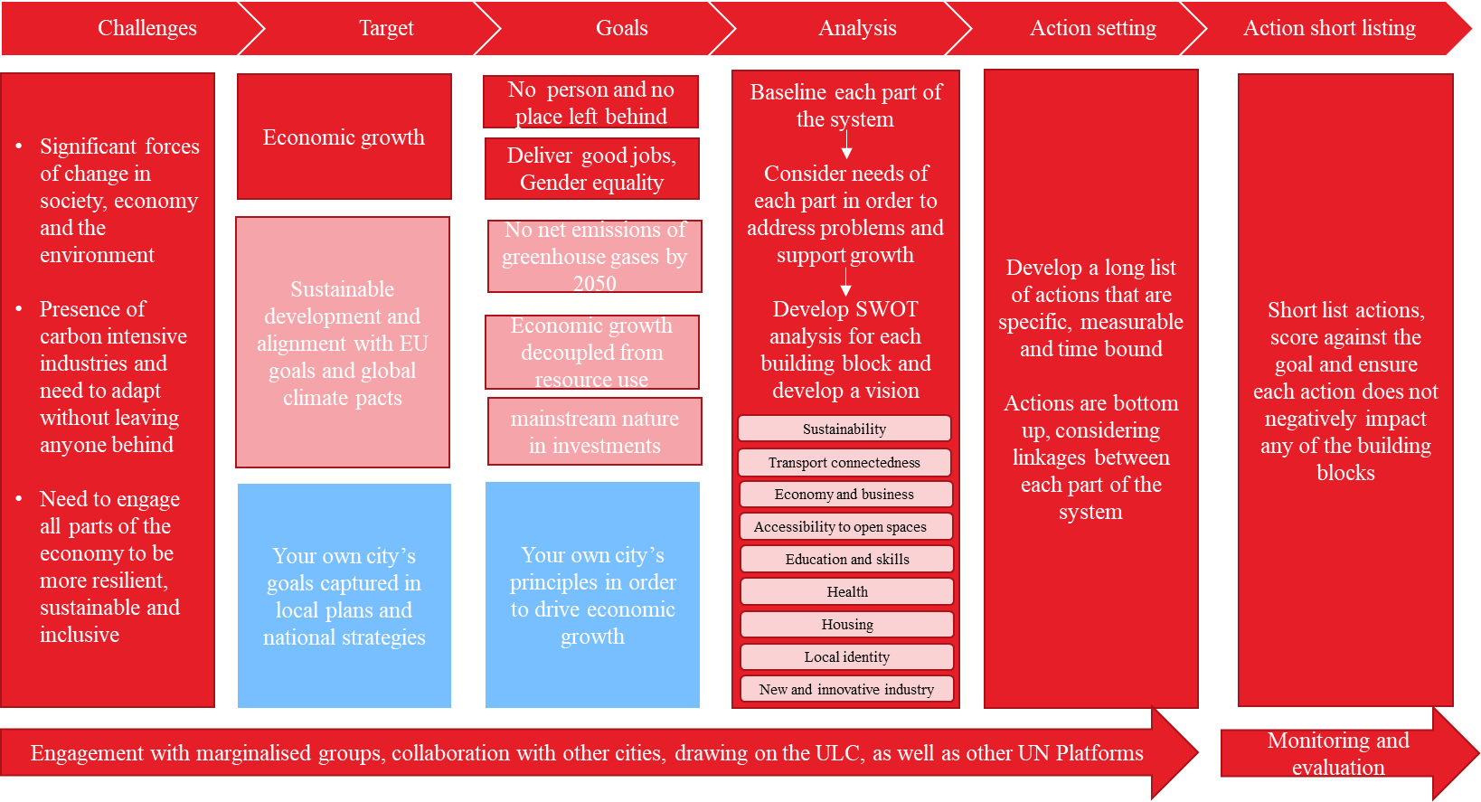
For the vision to be linked to general targets and goals defined and that responds to your challenges, the following approach is proposed:

Simplified example:

Example template for strategic goals, justification and alignment with international/national plans;

strategic goals  (examples only) | Brief justification of why each goal is a priority | Alignment with global/national/regional goals (EU Green Deal, SDGs etc.)
Promoting the development of organic viticulture and winemaking as a competitive industry | (Justification based on local context based on local assessment) | The EU Green Deal: Healthy and affordable food  SDG 8 - Decent work and economic growth  SDG 9 - Industry, innovation and infrastructure
Developing skills tailored to current and future economic needs and introducing innovative approaches |  | The EU Green Deal: on the future customized work places and skills training transition for the period  SDG 4 - quality education  SDG 9 - Industry, innovation and infrastructure
Green and smart urban renewal of the municipality |  | EU Green Deal: 1) Greener and smarter transport, 2) Renovated, energy-efficient buildings  SDG 11 - Sustainable cities and communities

6. Strategy Implementation & Action Plan

A detailed Action Plan is the most important part of the P4EG, with other parts just laying the ground and outlining the overall logic for the proposed interventions.

The Action Plan must ensure that actions are articulated both to general principles of economic sustainable economic growth and specific objectives to the municipality and be feasible.

Feasibility of actions is critical to the success of the implementation of LEDPs and their ability to successfully deliver local economic growth. To ensure that all actions included in the plan have been tested, it is proposed to create a mandatory process of evaluation for these actions once the P4EG is produced.

The process consists of 4 steps against which action will have to be assessed:

- Confirming the selected action’s relevance: justification of the proposed action, demonstrating how it provides strategic fit, responds to the municipality’s and society’s current issues.
- Expected impact of the action and metrics for measurement: identify the benefits to the society of the action, wider benefits of the action to society (health and wellbeing benefits, land value uplifts, accessibility to services, agglomeration benefits).
- Initial financial feasibility of the action: affordability of the action, how will it be funded, what expenditure and revenues are expected.
- Preparing the implementation of the action: how the municipality plans to procure and implement the action, how the action be managed once implemented, who will be responsible, and how it will be monitored.

Funding and Financing
For each action proposed in the plan, provide details of the funding and finance approach. A table template has been provided below to help if needed:

Actions | Estimated costs | Source of financing |  |  |  | Funding gaps | Remarks
Actions | Estimated costs | Local budget | National budgets | Business | Donors | Funding gaps | Remarks
Action 1
Action 2
Etc.
Total

Below is a simplified example template of goals and related activities:

P4EG Goals |  |  | P4EG Activities
Priority | Focus of municipality team | Lead (within municipality) | From existing budget | Need to mobilize | Estimated  budget | Estimated  timeline
#1 Advancement of organic viticulture and winemaking as a thriving and competitive sector in x municipality | Focus 1: increasing external awareness of the municipality's economic potential and promoting investment opportunities, especially in the viticulture and winemaking  Focus 2: Introducing digital and technological solutions for more effective and efficient wine production  Focus 3: … |  | - local and foreign tour operators compilation (of tourism nationally with the agency in coordination)  - detailed mapping of existing producers (emphasis on the cellars and of ‘wine on the way’) informative campaign, festivals participation by way of measurement  - investment Proposals/catalog development in Georgian and English | 1.1.4 Piloting of technologies (linking producers with grant opportunities from international and other organisations)

7. Monitoring, learning and evaluation
This section describes regularly monitor of all projects and measures. By regularly and methodically tracking all P4EG actions and their progress against your objectives and targets you can determine whether the plans are progressing as planned and contributing as expected to the established goals.
Successful monitoring requires two key components:
- Implementation monitoring plan to track the status and progress of the actions being implemented.
- Measuring the impact of the actions on the local area’s performance across each relevant building block.

The implementation and monitoring structure should be integrated into the P4EG and reviewed and approved by the municipality as part of the overall package. It should also be embedded within statutory planning processes with political oversight as relevant.

It might also be helpful to have here a governance structure or P4EG delivery vehicle illustrated, see example below (or this can form an annex or internal document as needed).

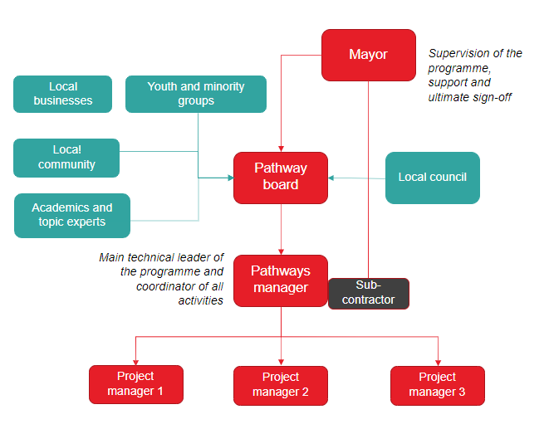

Example template for monitoring and learning/reflection capture
Priority 1: |  |  | xxxxxxxxxxxx |  |  | SDGs & the EU Green Deal: |  |  |  | xxxxxxxxxxxxx
Focus/task 1.1: |  |  | xxxxxxxxxxxxxxxxxxxxxxxxxxxxxxxx
Focus/Task result indicator 1.1.1: xxxxxxxx |  |  |  |  | baseline | target |  |  | source of confirmation
 |  |  |  |  |  | intermediate |  | final
 |  |  |  | year | 2023 | 2025 |  | 2027
 |  |  |  | indicator
Learning insights – what have we learned: knowledge, skills, feedback from residents and partners under this focus area? |  |  |  | [minimum quarterly anecdotal reflections from P4EG manager and core municipality team]
Activity |  | Activity result indicator |  | source of confirmation | Responsible agency | Partner agency | Performance deadline | Budget | source of funding
 |  |  |  |  |  |  |  |  | Municipality budget |  |  | other |  | Deficit
 |  |  |  |  |  |  |  |  | Amount |  | Code | Amount | Organization | Deficit
1.1.1 | xxxxxxx
Task 1.2:
Task result indicator 1.2.1: |  |  |  |  | baseline | target |  |  | source of confirmation
Activity |  | Activity result indicator |  | source of confirmation | Responsible agency | Partner agency | Performance deadline | Budget | source of funding
 |  |  |  |  |  |  |  |  | Municipality budget |  |  | other |  | Deficit
 |  |  |  |  |  |  |  |  | Amount |  | Code | Amount | Organization | Deficit
1.2.1 | xxxxxxx
Learning insights – what have we learned: knowledge, skills, feedback from residents and partners under this focus area? |  |  |  | [minimum quarterly anecdotal reflections from P4EG manager and core municipality team]

Also recommended:

8. Adaptative management

Any strategy or plan needs to be continuously updated. It is recommended that the P4EG Manager or Coordinator and relevant colleagues meet on a quarterly basis to discuss progress and whether any adaptation is required.

For example, unexpected events can change the P4EG implementation plan - an extreme weather event could mean that the local area needs to prioritise repairing critical infrastructure over a P4EG recommended investment. The Local Authority could delay implementing an action or decide to amend one. For example, instead of purchasing 100 electric buses to meet its air-quality and transport-sector targets, the city might only purchase 50 due to initial demand constraints.

The P4EG Manager or Coordinator should work with relevant departments and stakeholders within the local authority to ensure that any updates to the monitoring plans receive appropriate approvals. The path to meeting the P4EG vision is continuous; through periodically monitoring the progress of the P4EG and capturing learnings, the municipality can inform the public on what was accomplished and adjust their strategic goals and actions as needed.

Communication and outreach

It is essential that you can keep engaging with stakeholders, including private sector, civil society and academia as relevant after the plan’s publication. Especially the civil society may provide you with critical thinking regarding actions, implementation or raising issues that might be integrated into a revised vision of the plan.

Clearly set out key actions of communication you are considering, timelines and budget allocated for such actions. E.g. public launch event, provide open access to the document on the website of the municipality, annual report on progress or publish updates of the P4EG on the website, use Mayors Twitter account as needed to share progress or changes, investor and private sector events, job fairs etc.

