P4EG
Annex IV – Example P4EG
[the below is a draft example only, to access the final signed-off version, please contact M4EG Secretariat in Georgia]
Pathways for Local Economic Development
Baghdati Municipality
Georgia

Vision: By 2050, Baghdati Municipality aims to become a thriving and appealing place to live and visit for residents, visitors, workers, and businesses alike. Guided by the principles of sustainable development and the EU Green Deal, and leveraging the municipality's economic and cultural heritage, our vision is to foster a conducive environment for the growth of competitive green sectors and the cultivation of future-oriented skills. This will be achieved through the adoption of innovative and eco-friendly approaches, enhancing services and infrastructure, promoting low-emission municipal mobility, and facilitating smart urban renewal.
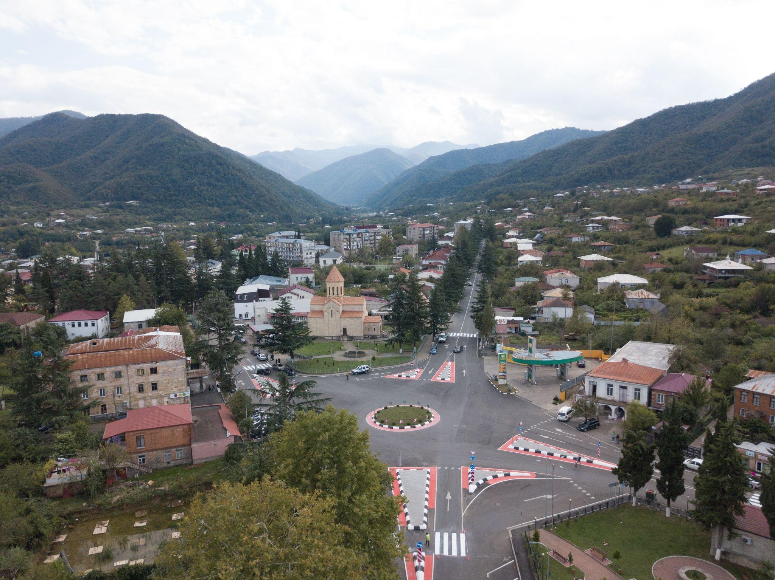
Preface

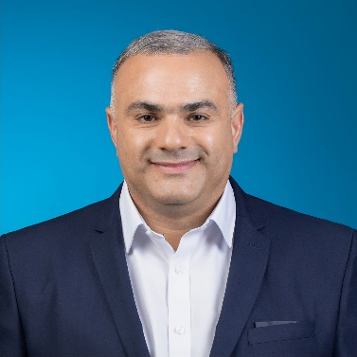
Local economic development is the main priority of the City Hall of Baghdati Municipality. The geographic location of the municipality, abundance of natural resources, two famous climatic and balneological resorts in the area, historical and cultural heritage, climatic conditions, traditional areas of agriculture, investment potential, road infrastructure and available municipal services provide the basis and real opportunities for economic development.
For the economic development of our municipality, in the context of limited financial resources, active dialogue and cooperation of public and private sectors, accurate determination of priorities and needs, and joint planning and implementation of activities are important. Within the framework of the joint initiative of the EU-UN Development Program "Mayors for Economic Growth" in cooperation with the global consulting company " Arup ", a pilot initiative was implemented in Baghdad to develop a new generation economic development plan and methodology. This cooperation gave us the opportunity to understand the development directions of Baghdad in a new way, to take into account innovative planning approaches and the main principles of the European Union Green Agreement.
A local economic development plan developed within the initiative, based on local resources and capabilities, defines the municipality's development vision, priorities and relevant measures. The main part of them will be financed from the budget of the City Hall of Baghdad, and for the implementation of the remaining activities, the local government will actively cooperate with state institutions, the private and civil sectors, and development partners.
I would like to thank the municipality's mayor's office, private and public sector representatives, young people and those who were actively involved in the development of the local economic development plan of the municipality. We hope that the involvement of stakeholders will increase further in the implementation process of the plan. I would like to call on local economic actors to get involved as much as possible in order to make Baghdati municipality a green and attractive place for living, tourism, work and doing business.
[Signature of Mayor]
Regarding the plan, you can contact:
Name: Tina Abuladze
Title: Head of Department of Economic Development, Relations with International and Local Donor Organizations of the City Hall of Baghdati Municipality
Phone: +99595900610
Email: tina.abuladze@baghdati.gov.ge
Website: https://www.baghdati.gov.ge/

- Compliance of the plan with national regulations
According to the "Local Self-Government Code" of the Organic Law of Georgia, the development and implementation of policies at the local level is the competence of the municipality. The legal basis of the economic development document of the municipality is created by the Organic Law of Georgia "Local Self-Government Code" (Article 19, subsection b), according to which the municipal bodies, in the exercise of the municipality's powers, in accordance with the legislation of Georgia, develop, approve and implement relevant programs, strategies, action plans and projects.
According to the Decree N264 of the Government of Georgia of February 15, 2022 "On the Approval of the Municipal Development Planning Manual", municipalities were asked to be guided by the requirements of the manual approved by this decree when developing policy document(s).
According to UN HABITAT, local economic development is a participatory development process that promotes partnerships between different sectors. This concept includes the development-implementation of a specific territorial unit's development strategy and action plan, with the participation of key stakeholders from the public or private sector. This strategy is based on the use of local resources and specific advantages. Its main goal is to strengthen the local territorial unit and promote sustainable development, which means creating decent jobs and stimulating economic activity.
The main principles of developing the local economic development plan fully comply with the methodology approved by the Government of Georgia. These principles are:
- legality
- Data-driven management
- rational management
- continuity
- Complex planning
- Accurate and clear division of responsibilities
- Harmonization with national and regional development
- Unity
- justice
- Gender equality
- sustainability
- Social orientation
- partnership
- Participant complicity and hardship

1. Resume 5
2. Guidelines of Baghdati Municipality 7
2.1 Global principles of development of Baghdati municipality 7
2.2 Local and national economic policies and goals and compliance with Baghdad Municipality 12
3. Assessment of the local situation 16
3.1 Municipal/urban context 17
3.2 Local economy and business activities 23
3.3 infrastructure 34
3.4 Sustainability, environment and biodiversity resilience 40
3.5 living environment 47
3.6. Education and skills 56
3.7. The presence of new and innovative industries 60
3.8. Municipal services 62
4. strategy 68
4.1. Strengths, Weaknesses, Opportunities and Threats 68
4.2. Vision and strategic goals of Baghdati Municipality 70
5. tasks and activities 72
6. Monitoring, evaluation and management of plan implementation 79
6.1. Monitoring and evaluation scheme 79
6.2. The team responsible for the implementation of the plan 82

Resume
The new economic development plan of Baghdad is based on the methodology of the new generation, which was developed within the framework of the joint initiative of the EU-UN Development Program "Mayors for Economic Growth" in cooperation with the global consulting company " Arup ".
The document development process was carried out on the basis of the participatory principle. Civil consultations and population survey results were taken into account. The initiator of the process of developing the document was the mayor of the municipality, who established a planning working group responsible for developing the document. The planning working group ensured high involvement of the civil and private sector in the planning process, with active participation of women and youth.
Habitat 's new urban agenda and the European Union's Green Deal were used as guiding principles .

[Main conclusions of the SWOT analysis]

By 2050, Baghdati Municipality aims to become a thriving and appealing destination for residents, visitors, workers, and businesses alike. Guided by the principles of sustainable development and the EU Green Deal, and leveraging the municipality's economic and cultural heritage, our vision is to foster a conducive environment for the growth of competitive green sectors and the cultivation of future-oriented skills. This will be achieved through the adoption of innovative and eco-friendly approaches, enhancing services and infrastructure, promoting low-emission municipal mobility, and facilitating smart urban renewal.

To achieve this goal, the following priorities and tasks were identified:
priorities | tasks
Advancement of organic viticulture and winemaking as a thriving and competitive sector | Task 1: Enhancing awareness of the municipality's economic potential and promoting investment opportunities  Task 2: Facilitating increased access to finance for economic actors in Baghdati Municipality and fostering the development of tourism products associated with winemaking.  Task 3: Enhancing business support services and upgrading public infrastructure to foster a conducive environment for economic growth.
Cultivating skills aligned with present and future economic demands and introducing cutting-edge approaches through innovation. | Task 4: Enhancing workforce capacity and facilitating alignment with market demands through skills development and effective matching strategies.  Task 5: Expanding access to technologies and fostering the adoption of innovative approaches within the local economy.
Green and smart urban renewal | Task 6: Facilitating the introduction of a low-emission and eco-friendly public transport system to promote green mobility options.  Task 7: Revitalizing and renovating the central areas of the municipality to create vibrant and attractive spaces for residents and visitors.  Task 8: Undertaking energy-efficient renovations of municipal buildings to reduce energy consumption and promote sustainability in the municipality's infrastructure.

[Main findings on financing]

The main part of the measures defined by the plan will be financed from the budget of the City Hall of Baghdad, and for the implementation of the remaining activities, the local government will actively cooperate with state institutions, the private and civil sectors, and development partners.

Guidelines of Baghdati Municipality

Global principles of development of Baghdati municipality

- Empowering municipalities to develop a sustainable and greener economy contributes to the common goals of the Green Deal for the European Union's transformation and the transformation of other countries into modern, resource-efficient and competitive economies, ensuring the following outcomes:
• By 2050, there will be no net emissions of greenhouse gases;
• economic growth achieved from the use of resources;
• No person or place will be left out of this process.
 |  |  | 
Clean air, clean water, healthy soil and biodiversity  - Reducing greenhouse gas emissions by 55% by 2030  - Restoration of forests, soils and wetlands to increase CO2 absorption | Renovated, energy-efficient buildings  - Aim to renew at least 3% of the gross floor area of all public buildings each year  - By 2030, setting the mark of 49% renewable energy in the building | Healthy and affordable food  - Ensure food security in the face of climate change and biodiversity loss  - Reducing the environmental impact of agriculture | Greener and smarter transport  - 90% reduction in transport-related greenhouse gas emissions by 2050  - 5% of EU GDP and employs more than 10 million people  - make an alternative choice
 |  |  | 
Clean energy and the latest clean technology innovation  - Renewables will reach 40% of the energy mix by 2030  - Increase the use of renewable energy in heating and cooling by +1.1% annually until 2030. | Durable products that can be repaired, recycled and reused  - Reducing waste and making sustainable products the norm  - Empowering consumers and public buyers  - Product lifetime | Future-proof jobs and skills training for transition  - Transformation of economies and societies  - The new regulations create new opportunities for innovation and investment in green workplaces | A globally competitive and resilient industry  - Reducing dependence on external energy  - Anticipate extreme climate events and their consequences  - Strengthening the competitiveness of European companies

- The goals of the new urban agenda of UN Habitat , based on the Sustainable Development Goals and their adaptation in the context of urban development:
 | Main dimensions of the new urban agenda | principles
 | Social sustainability | marginalized groups
 | Social sustainability | gender equality
 | Social sustainability | Planning tailored to the needs of migrants, ethnic minorities and people with disabilities
 | Social sustainability | Age-appropriate planning
 | Economic sustainability | Job growth
 | Economic sustainability | Collaborative Policy Design
 | Economic sustainability | A response to automation
 | Economic sustainability | Consideration of low-skilled jobs
 | Economic sustainability | Digital infrastructure
 | Economic sustainability | Available funding opportunities
 | Economic sustainability | Developed and maintained human capital
 | Economic sustainability | Existence of comparative advantage
 | Economic sustainability | A diversified economy
 | Economic sustainability | Strong value chains
 | Economic sustainability | Investments of a basic nature
 | Environmental sustainability | Biodiversity and ecosystem conservation
 | Environmental sustainability | Resilience and adaptation to climate change
 | Environmental sustainability | Climate change mitigation
 | Spatial sustainability | Spatial sustainability and equity
 | Spatial sustainability | Spatial sustainability and urban density

- Sustainable Development Goals
Sustainable economic pathways are linked to the key elements of sustainable urban development and the goals of the post-2015 sustainable development agenda, particularly in goals 8 (decent work and economic growth), 9 (industry, innovation and infrastructure), 10 (reduced inequality), 11 (sustainable cities and Themes) and 12 ( Responsible Consumption and Production), where economic development is mentioned.
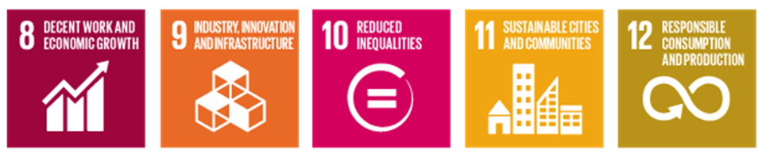

Sustainable local development is also a strong implicit component of goals 1 (no poverty), 2 (zero hunger), 3 (good health and well-being), 4 (quality education), 5 (gender equality), 7 (affordable and clean). Energy), 10 (Reduced Inequality), 13 (Climate Action) and 16 (Peace, Justice and Strong Institutions).
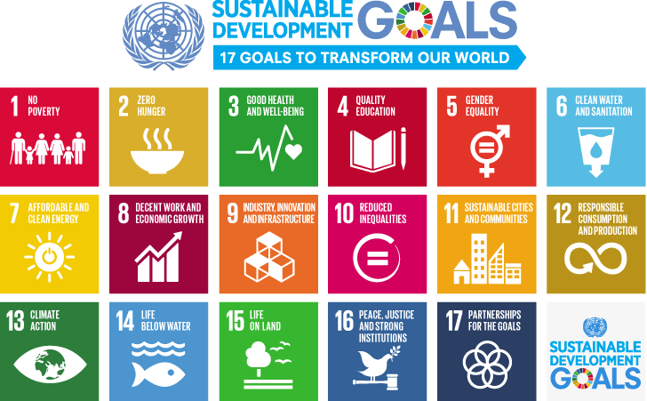

Paris Climate Agreement Goals for 2050 Goals:
• Contribute to limiting growth to 1.5°C
• By 2030:
o Aim to reduce emissions by at least 55% from 1990 levels
o At least 32% share of renewable energy
o At least 32.5% improvement in energy efficiency








3. Digitization goals as defined by the International Energy Agency on empowering cities for a net- zero transition.

Readiness for smart digitalised cities
გააუმჯობესეთ წვდომა ენერგიასთან დაკავშირებულ მონაცემებზე
უზრუნველყოს ადეკვატური დაცვა კიბერუსაფრთხოებისა და მონაცემთა კონფიდენციალურობის რისკებისგან
ციფრული ტექნოლოგიებისადმი ნდობის განმტკიცება
დარწმუნდით, რომ ენერგეტიკული ბაზრები აფასებენ ციფრულად ჩართულ მოქნილობას, რათა მოახდინონ ბიზნეს მოდელების სტიმულირება ჭკვიანი ქალაქების გარშემო
ციფრულ ტექნოლოგიებსა და ინფრასტრუქტურაზე თანაბარი წვდომის უზრუნველყოფა
ციფრული უნარების გაზრდა და სამუშაო ბაზრის ტრანსფორმაციის დაგეგმვა
გარემოზე უარყოფითი ზემოქმედების მინიმუმამდე შემცირება
წაახალისეთ ტექნოლოგიები და ბიზნეს მოდელის ინოვაციები

Local and national economic policies and goals and compliance with Baghdad Municipality

In the process of developing the local economic development plan, the goals and objectives of the existing national and local plans were discussed.
During the selection of policy documents, the possibility of their impact on local economic development was taken into account.

level | sector/  Topic/Focus | Policy/strategic document | term | organization/ agency | main goals | financing
local | economic | Local Economic Development Plan | 2018-2020 | Baghdati Municipality | - raising awareness of the municipality;  - development of skills and abilities of local entrepreneurs;  - Improving the business environment. | Municipal budget
local | social | Social policy document | 2020-2024 | Baghdati Municipality | - Implementation and development of social programs taking into account the needs of the community;  - Institutional development of social and health services to improve the administration of social programs;  - Developing capacities for coordination and cooperation with stakeholders at the local level. | Municipal budget
regional | Economy, social sphere, culture, education, environment | Imereti region development strategy | 2014-2021 | Imereti Regional Advisory Council, Imereti Municipalities | - Imereti - a place for entrepreneurs  - Development of rural settlements and agriculture  - Imereti - the tourist hub of western Georgia  - Interregional, transboundary and international relations | State budget, budgets of municipalities
National | politics,  economic | Association Agreement | 2014 | Government of Georgia | It is provided within the framework of the agreement  - Support for the development of Georgia's economic potential through international cooperation, including  - By approximating legislation with EU legislation.  - It envisages the creation of a deep and comprehensive free trade space. | state budget
National | Climate | 2030 Climate Change Strategy of Georgia | 2030 | government | - By 2030, to reduce greenhouse gas emissions by 5% compared to the baseline scenario projections, promoting the development of low-carbon approaches in the industrial sector by encouraging climate-smart and energy-efficient technologies and services;  - low-carbon development of the agricultural sector by encouraging climate-smart and energy-efficient technologies and services; | state budget
National | economic | "For the construction of the European state" | 2021 - 2024 | Government of Georgia | - post-crisis rapid recovery and development of businesses, including small and medium-sized businesses , which should ensure job creation and the eradication of extreme poverty. | state budget
National | Economy, social sphere, culture, education, environment | Regional Development Program | 2018-2021 | Government of Georgia | - increasing the competitiveness of the country and its regions,  - balanced socio-economic development and  - improvement of living conditions.  - Support for small and medium-sized enterprises, growth-oriented economic sectors and export promotion  - Promotion of human capital development. | state budget
National | Economy, social sphere | Development strategy of highland settlements of Georgia | 2019-2023 | Government of Georgia | - Sustainable development of highland settlements  - Social support of residents in highland settlements  - Availability of services in highland settlements  sustainable development | state budget
National | economic | Small and medium entrepreneurship development strategy of Georgia | 2021-2025 | Government of Georgia | - Legislative refinement, institutional strengthening and improvement of the operating environment for small and medium enterprises;  - promoting the development of small and medium entrepreneurship skills and raising the entrepreneurial culture;  - improving access to finance;  - Promotion of export growth, market access and internationalization of small and medium-sized enterprises;  - Promotion of electronic communications, information technology, innovation, research and development for small and medium enterprises;  - promoting the development of women's entrepreneurship;  - Promotion of green economy development | state budget
National | Economy, agriculture | Agriculture and rural development strategy of Georgia | 2021 - 2027 | Government of Georgia | - diversification/development of economic opportunities in rural areas,  - Improvement of social status and standard of living.
National | tourism | Tourism Strategy of Georgia 2025 | 2025 | Government of Georgia | - Increasing tourism revenues from the current level  - The direct share of the industry in the gross domestic product should be 7.9%;  - Increasing the average amount spent by each visitor from the current 300 USD to 600 USD;  - increasing the average duration of the visit from the existing 3.4 nights to 5 nights;  - the high-paying markets of Western Europe, Asia and North America ;
National | Youth politics | Concept of youth policy of Georgia | 2020–2030 | Government of Georgia | - for youth health care,  - to create favorable conditions for socio-economic well-being, multifaceted development and self-realization;  - ensuring the creation of appropriate conditions for the full participation of young people in public life and democratic processes;  - Perfecting the state youth policy management system at the central and municipal levels | state budget
National | Work and employment | National Strategy of Labor and Settlement Policy of Georgia | 2019-2023 | Government of Georgia | - reducing the mismatch between demand and supply;  - strengthening active labor market policy (ALMP);  - Promoting the involvement of women and vulnerable groups in the labor market with a targeted social and inclusive employment policy;  - improvement of the enforcement system of labor safety and protection of rights at workplaces; improving the management of labor migration;
National | digital communications | National Broadband Networks Development Strategy of Georgia | 2020-2025 | Government of Georgia | - high-speed Internet networks  - To raise the skills of the population to use the Internet and technologies  - Improving the quality and accessibility of the Internet | State budget, private sector
National | waste management | National waste management strategy | 2016-2030 | Government of Georgia, municipalities | - of waste prevention, reuse, recycling and recovery measures,  - Introduction of separation at the source of waste generation, introduction of extended obligation of the producer. | State budget, municipal budget
global | Economy, environmental protection | European Green Initiative | -2050 | European Union |  | EU funding

- Assessment of the local situation
  - Consultations

format | Description
  In person / meetings / events | Engagement Activity 1  Working meeting with local population  16 May 2023  [number of responses/people engaged]
  Digital / Surveys / Campaigns | Engagement Activity 2 - Population survey  The survey was conducted in electronic form  June 2023  [number of responses/people engaged]  […]

Municipal/urban context
Baghdati municipality is located in western Georgia, Imereti region, it borders the center of the region (Kutaisi) and 6 municipalities, four of which are connected by highways of national importance. The municipality consists of 15 administrative territorial units, which include 1 city and 30 villages, one of which has the status of a highland settlement. The administrative center of the municipality is the city of Baghdati, which is 220 km away from the capital of Georgia - Tbilisi (with a driving time of 3 hours and 30 minutes), from the center of the Imereti region, 25 km from the city of Kutaisi (with a driving time of 0.5 hours), from Kutaisi International Airport. 44 km (37 minutes driving time). 19 km (19 minutes) from the nearest railway station. The territory of the municipality is mostly mountainous, 80 - 2600 m above sea level, area - 815 sq. km, among them agricultural fields occupy 82.22 sq. km . 67.5% of the territory of Baghdati is covered with forest. The weather is humid and subtropical. It knows moderately cold winters and relatively hot summers.
adjacent to the central highway of West-East Georgia and on the meridian axis of South-North Georgia (Tetnuld (Mestia, Upper Svaneti)-Kvemo Svaneti-Lechkhumi-Racha-Tskaltubo - Kutaisi - International Airport - Baghdati - Sairme - Zekar pass - Abastumani - Turkish border) on the Kutaisi-Sairme-Abastumani-Turkey customs central highway (completion of construction is planned at the end of 2023).
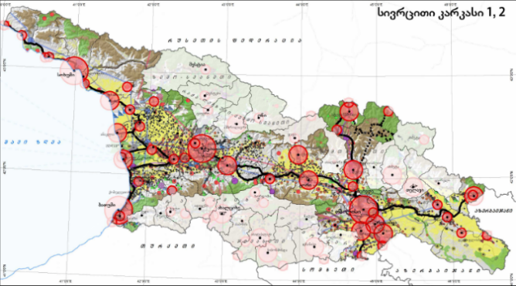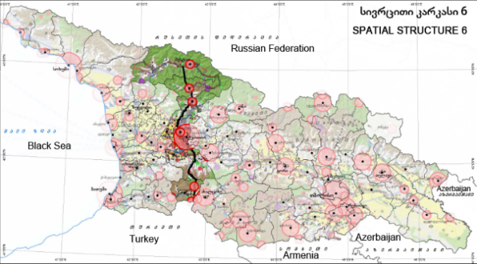The municipality of Baghdati, with the aforementioned meridian axis of settlement , acquires an even more important strategic location.
The meridian axis of north-south Georgia intersects the central axis of settlement, the international highway and the Transcaucasian railway highway, connects Kutaisi (Kopitnar) International Airport and It combines sports-resort and tourist complexes of Hatsvali / Tetnuld, Tskaltubo, Sairmi and Abastumni. In perspective, the mentioned economic base will contribute to the growth of investments in the municipality, the revitalization of the Zekar resort , the emergence of service facilities near the highway , and the economic strengthening of settlements.

Basic data
Location | 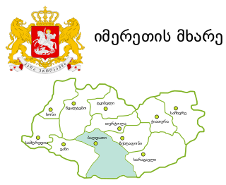
Population | - Total population – 17,600  - Population density - 21.6 inhabitants per square kilometer  - Age statistics - median age 44; 65< 21%  - Gender statistics - female 50.8%, male 49.2%  - Ethnic composition - 99% Georgian  - Persons with disabilities - 1162 (including:  - 0-18 years -73  - With a sharp limitation - 299  - with a significant limitation -660  - -130 with moderately expressed quality  - Number of state pension recipients - 30.8%  - Number of social package recipients - 8.2%
urban/ Rural data | - Population density (excluding forest area): 67 inhabitants per square kilometer;  - Population distribution in urban and rural settlements: urban 16.4%, rural - 83.6%.  - Share of the population living within 20 minutes of daily services (grocery stores, clinics) - 20%
income | - Share of the population living below the poverty line - 8.7%  - The income level of employees in the private sector is 10% lower than the average regional level

Assessing the situation
issue | Strengths, Assets, Capabilities | challenges | The need for investment / or strategic opportunities / and how this opportunity can be exploited | Who can develop this opportunity / who can finance / who can be a partner organization
Location | - Proximity to highways and transport hubs of international importance,  - Proximity to Kutaisi International Airport  - Proximity to 2 stations on the central railway line |  | provides opportunities for business development , including Micro and small business development.  will increase tourist flows | Municipality
Demography | - The median age of the population of Baghdati municipality (44) exceeds the average of the Imereti region (41).  - The share of the population aged 65 and older in the total population is high and amounts to 21%.  - The population density, taking into account the entire territory of the municipality, is 21.6 per square kilometer, and the population density per square kilometer in the populated area is 67 inhabitants. Baghdati in Imereti region is characterized by low density. This has both positive and negative sides. | - rate of population decline both in Baghdati and Imereti region as a whole.  - High level of migration  - Negative balance of births | Improvement of municipal and state programs (demographic promotion).
road infrastructure | - Reconstruction-construction of the Kutaisi - Abastumni highway in the territory of the municipality  - The length of local highways is 159 km, 70% of which have been overhauled. | - Increased traffic will increase CO2 emissions.  - Unsatisfactory state of local roads and district roads | - It will connect western and southern Georgia in the shortest way.  - Sports-resort and tourist complexes of Sairmi and Abastumni and on their base will create a powerful, basic economic cluster , which, together with the Kutaisi International University Campus, through pendulum migration, will employ the population of the surrounding settlements and strengthen their economy.  - Access to markets will be improved, in terms of time and security. | Funded by the state  Municipality
transport | - The current condition of the municipality's road infrastructure facilitates safe and smooth movement in most territorial units of the municipality. | - Absence of municipal public transport  - Irregularity of the transport scheme between municipalities (M3; M2 category).  - High dependence on private vehicles  - The operating schedule of private vehicles is unstable and depends only on profitability | Development of transport policy in the municipality and existence of municipal public transport | Municipality, state, development partners
Climate | - The weather is humid and subtropical  - Moderately cold winters and relatively hot summers  - Average annual temperature on the plain is 14 °C; 9 °C in the mountains  - Precipitation - 1200-1500 mm per year |  | The existing climatic conditions provide an opportunity for the development of diversified agriculture
vulnerable groups | - Existence of state and municipal programs supporting persons with disabilities  - disabled persons registered in the municipality , which is provided by the municipality with a deliberative space.  - Existence of state and municipal programs focused on strengthening families with vulnerable children.  - for the protection and advocacy of children's rights .  - Providing daily free meals to the socially needy population.  . | - Lack of services for people with disabilities  - disability Less accessibility for people with disabilities ( non-adapted infrastructure, lack of sign language interpreter and braille in public spaces )  - disabled and vulnerable children in the municipality . (There is no early childhood development, habilitation -rehabilitation, day care center, speech, behavioral therapy, physiotherapy and other services in the municipality)  - Insufficient level of state and municipal programs focused on strengthening families with vulnerable children.  - Less access to food services for vulnerable groups for villages geographically distant from the center of the municipality.  - Low level of integration and employment of disabled people.  - Absence of social enterprises.  - Low level of employment of mothers with young children. | - for disabled people.  - Ensuring accessibility for disabled people.  - Implementation of long-term services tailored to the needs of disabled and vulnerable children in the municipality : early childhood development, habilitation -rehabilitation, day care center, speech, behavioral therapy, physiotherapy and other services).  - Development and improvement of state and municipal programs focused on strengthening families with vulnerable children.  - Increasing the geographic area of food service use.  - disabled people and creation of workplaces adapted to their abilities.  - Creation of social enterprises | state;  municipality;  Civil society;  Development partners.

Local economy and business activities

In Baghdati municipality, as well as in Imereti region, the indicators of total turnover, created added value and released products are systematically increasing.
The research conducted in order to determine the economic sectors and their development prospects in the municipality of Baghdati, which as a methodology was developed by the European Union (Smart specialization ) Specialization ) uses the strategy, identified competitive economic sectors:
- Agriculture, forestry and fish farming
- Manufacturing industry (related to agriculture)
The survey conducted to identify promising economic sectors additionally identified the following sectors:
- Activities related to tourism - providing accommodation facilities and providing food; Art, entertainment, recreation
- Education (by region)
- Health care and social service activities (by region)

Basic data
Local economy and business activity  Source: National Statistical Service of Georgia | - Number of employees in the business sector (thousands of people): 1.2  Number of employees in the business sector It has been changing in recent years. A significant increase was recorded in 2021. The number of employees in the business sector in Baghdati Municipality in 2014-2021:  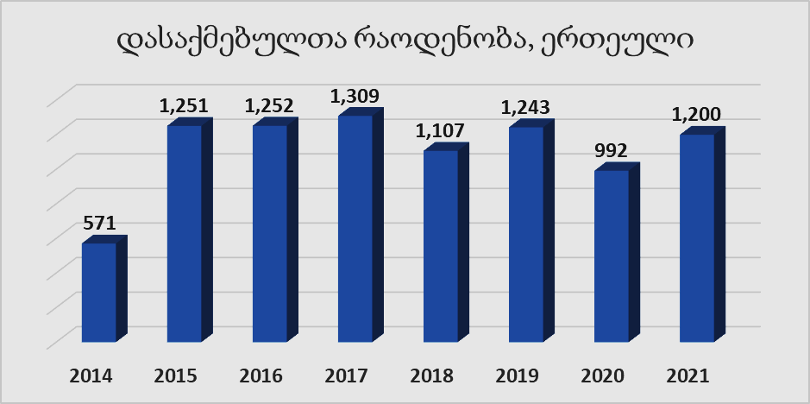  Source: National Statistical Service of Georgia
- turnover is 85.9 million GEL, it is in the top ten in the region
  - The turnover rate is 1.3% of the similar rate in Imereti
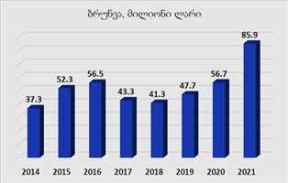
- The added value created in Baghdati is 2.1% of the added value created in Imereti.
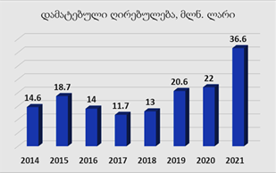
- The rate of production in Baghdati is 1.3% of the production in Imereti.
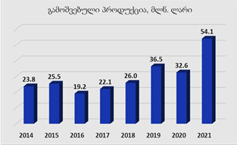
- In 2021, a high growth rate of economic parameters was observed
- The economy created in Baghdati is about 4.5 times behind the country's average rate per inhabitant
- Gross domestic product per inhabitant is about $1,200 (calculated according to various economic indicators)
- Imereti's GDP comes from the agricultural sector, followed by manufacturing, real estate activities, education and trade.
- Free and available spaces for business - 5%
- Number of registered economic entities - 3839
- active economic entities (unit) - 857
  - 19.7% operate in the organizational-legal form of a limited liability company, while
  - 79.8% in the form of an individual entrepreneur.
Active subjects according to the form of ownership | - Operating in Baghdati Municipality Active subjects according to the form of ownership:  - Private local ownership - 93.8%  - Private foreign ownership - 3.4%  - State and municipal property - 2.5%  - Mixed private ownership with local preference - 0.2%  - Mixed private ownership with a foreign majority - 0.1%  Source: National Statistical Service of Georgia
Average salary of hired employees in the business sector | - In 2021, the average salary of hired employees in the business sector was 859 GEL , which is 10% lower than the regional indicator. A similar rate in Imereti is 1046 GEL.  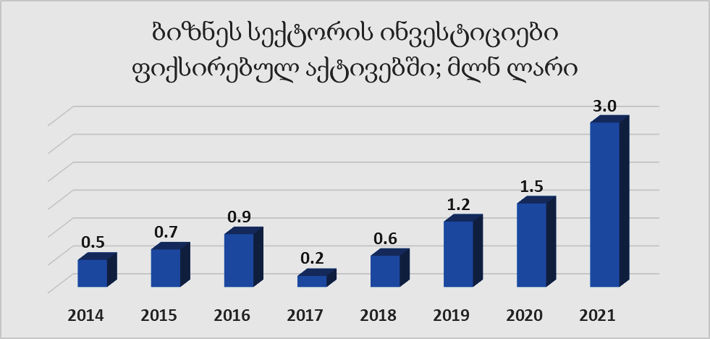  Source: National Statistical Service of Georgia
migration rate | - A high rate of migration and a corresponding decrease in the labor force. The main reason: scarcity of jobs and low pay (compared to the national and regional average)

Assessing the situation
issue | Strengths, Assets, Capabilities | challenges | The need for investment / or strategic opportunities / and how this opportunity can be exploited | Who can develop this opportunity / who can finance / who can be a partner organization
Agriculture | - Viticulture is a traditional and prospectively developing field.  - Beekeeping and local honey form an important part of the municipality's local value chain.  - In recent years, massive cultivation of berry crops (raspberries, blueberries, strawberries) has started in the municipality.  - Primary producers of agricultural products are exempt from taxable income  - The Rural Development Agency has supporting state programs  - agro- cluster - Imereti agro-zone is in the territory of the municipality | - Improper use of natural resources (including land).  - Lack of technological knowledge / innovation  - Low access to finance  - Labor migration  - Lack of statistics by economic sectors  - Lack of mechanization  - Less availability of soil laboratory studies | - The current project for the development of the cluster of greenhouse farms of the state program " Agrozone of Imereti " (220 hectares)  - Proper functioning of the business accelerator is important for local businesses (especially winegrowers). | - of the cluster is planned to be funded by the central government (with the support of development partners)  - State program "Introduce the Future" provides funding opportunities  - The state program allows farmers to own mechanization  - to find financing for equipping and operating the business accelerator in cooperation with development partners.
local industries | - 54 small and 1 medium-sized enterprises operating in the field of industry are represented by wineries, building materials and wood processing industries, furniture enterprises, non-alcoholic beverage bottling plants.  - Compared to 2017, the number of family wineries has increased by 70%. At present, 59 wine cellars are registered in the municipality  - The unique wine made from different varieties of grapes has been a winner at international festivals more than once.  - Within the framework of the "Produce in Georgia" program, there is an opportunity to receive preferential credit and a grant. | - The wine sector has been the most affected among business operators in the municipality due to restrictions and lockdowns caused by the covid 19 pandemic.  - Less availability of laboratory studies  - Lack of technological knowledge/innovation and entrepreneurial skills  - Low access to finance  - Labor migration  - Lack of statistics by economic sectors | - In order to promote the production of bio-wine, it is important to have a suitable laboratory  - In order to increase technological knowledge, it is important to increase the possibility of obtaining relevant knowledge | - Funding for the creation and operation of a wine laboratory on the basis of the business accelerator is planned in cooperation with development partners.  - The state program "Produce in Georgia" provides financing opportunities
tourism | - The world-famous Sairme resort, the domestic-recreational-entertainment infrastructure developed around it, the spa center, the resort's membership of the International Association of Thermal Waters, hotels and service facilities developed for all segments of customers are the main components of the value chain of the municipality's economy.  - Favorable location and climatic conditions  - Diversity of landscape (80-2600 meters above sea level)  - Wine tourism contributes to the growth of tourists.  - Diversity and abundance of cultural heritage and natural-ethnographic monuments ( 49 monuments included in the list of cultural heritage). | - Absence of internal municipal transport  - Inconsistency of intercity transport with the demands of tourists  - Unsatisfactory state of infrastructure with tourist facilities  - Low access to finance in the tourism segment ( due to lack of guarantee conditions and lack of business skills)  - Skilled labor migration and shortage in the sector  - Lack of statistics in the field  - Unattractive state of cultural heritage monuments for tourism, lack of use for economic activity  - Insufficient level of qualifications and skills in the field  - Non-existence of sanitary junctions with tourist facilities of the municipality  - Lack of tourist signs  - Insufficient awareness of the municipality  - Insufficient level/skills in the use of international reservation systems in the accommodation sector  - Lack of activation of tourist objects on google.map  - Lack of camping - picnic and eco-tourism infrastructure  - Low level of use of digital technologies in the field | - Tourist infrastructure improvement  - Increase in the number of hotel rooms  - Increasing awareness of the tourism potential of the municipality at the international and local level  - Marking of tourist routes  - Creation of municipal public transport  - Preservation of cultural heritage sites and promotion of economic activation by turning them into centers of tourist attraction | - access roads and infrastructure to tourist facilities is financed by the local and central authorities in cooperation with development partners.  - The state program "Produce in Georgia" within the Host Georgia component provides financing opportunities for the private sector  - Involvement of municipality, state and development partners to preserve cultural heritage sites and increase tourist attraction
trading | - Analysis of the activity of economically active subjects registered in Baghdati Municipality shows that quantitatively, the field of trade and transport is about 62 percent.  - 48 percent of individual entrepreneurs operate in the field of trade.  - In accordance with Georgian legislation, business registration procedures are simple  - The convenient location of the municipality simplifies the process of transportation of products | - Low purchasing power of the population  - Reduction of the population  - Labor force migration  - Lack of statistics by economic sectors | - Making investments in the trade sector  - Agrarian market functioning | - The main operator in the trade sector is the private sector  - Arrangement of existing public infrastructure near trade facilities is the authority of local authorities
services | - Document circulation in the municipality is carried out in electronic form, the processing time is reduced by 70%.  - The services of the Service Development Agency have been implemented in the municipality and are available  - 80% of the populated area is covered by the municipal waste management service  - Several private hazardous waste management companies operate in the region  - 4 branches of financial organizations provide banking and credit services  - 2 medical facilities, 12 outpatient clinics and 7 dental clinics and one emergency medical service provide medical services | - მშენებლობის ნებართვის გაცემის ელექტრონული სისტემის არარსებობა  - წყაროსთან სეპარირების შესახებ არასაკმარისი ცნობიერება,  - სპეციალური ურნების არასაკმარისი ოდენობა  - ნაგავსაყრელზე ხვდება გამოსაყენებელი ნედლეული.  - მეღვინეობის განვითარებისთვის აჭირო ღვინის ლაბორატორიის მომსახურების არ არსებობა  - სამედიცინო სერვისების არასაკმარისი ხელმისაწვდომობა
investments | - A large amount of free land (800 ha) and buildings (up to 40 units) owned by the municipality and the state allow the implementation of various investment projects.  - The main part of municipal investments (88%) will be directed to the improvement of infrastructure.  - In Baghdati municipality, the volume of investments made in fixed assets in the business sector is small, although an increase will be observed in 2021.  - The location of the municipality is a favorable condition for attracting investments  - The tax code in force in Georgia promotes the implementation of investments | - By 2021, only 2% of the investments made in Imereti region will come from Baghdati Municipality  - Lack of investment visibility of the municipality  - Absence of the general development and development plan of the municipality  - Low access to financial resources for business start-up and expansion/inadequate fundraising skills | - Investing in public infrastructure  - Implementation of private investments according to economic sectors  - Increasing the investment potential and visibility of the municipality | - Local and central government invest in public infrastructure in cooperation with development partners  - The private sector invests in the business sector  - Municipality, state, development partners
Business infrastructure | active business entities are capitalized  connection to the gas supply network is made in accordance with the required performance (except Khan, Zegni and Sakraula territorial units)  Power supply and network connection is done according to business demand and performance | Poor functioning of water supply/ drainage system

The main challenges for local economic development are:
- Improper use of natural resources (including land).
- Low access to financial resources for business start-up and expansion
- A high rate of migration and a corresponding decrease in the labor force. The main reason: scarcity of jobs and low pay (compared to the national and regional average)
- Inadequate indicator of professional education/skills
- Low rate of financial education
- Low access to technology and innovation

infrastructure

The municipality manages and develops the municipal infrastructure (parks, squares, roads, lighting systems, etc. ) within the framework of the powers defined by the Organic Law of Georgia "Local Self-Government Code". Also, in accordance with the country's regional development program, events are planned in the municipality, which are of special importance for the development of Baghdad in the near future.
Despite the fact that infrastructure rehabilitation works are going on intensively and the financing provided in this direction is characterized by increasing dynamics every year, the current situation is still unsatisfactory.
Maintenance of road infrastructure is related to the goal of the Green Deal - green and smart transport. Maintenance of water and wastewater infrastructure is related to - "clean air, clean water, healthy soil and biodiversity" / "healthy and affordable food". The increase in the rate of gasification is related to the goal of "cleaner energy and the latest clean technological innovation".
Basic data
transport | - The total length of national roads is 139 km, of which 85% are capital.  - The length of local roads of the municipality is 431.43 km, including 180 km of paved roads.
Energy | - Electricity is supplied to 100% of the populated area of Methel municipality.  - of the municipality is gasified.
water supply | - The Baghdati service center of the United Water Supply Company of Georgia serves more than 1700 households and 150 legal entities, including Baghdat. Partially supplies only 6 villages.
Digital infrastructure | - The populated part of the territory of the municipality is fully covered by Internet connection, 7 providers operate
other infrastructure | - The property owned by the municipality is up to 20 buildings and structures  - Shops, chain markets, salons, pharmacies, financial institutions, ATMs and payment machines are available for local residents.

Assessing the situation
issue | Strengths, Assets, Capabilities | challenges | The need for investment / or strategic opportunities / and how this opportunity can be exploited | Who can develop this opportunity / who can finance / who can be a partner organization
transport | - The rehabilitation of the section of the Kutaisi-Baghdati-Zekari-Abastumani- Benara road, which connects the Imereti side with the Samtskhe-Javakheti region by the shortest road , is being intensively carried out .  - Over the last five years, capital reconstruction-rehabilitation of up to 40 km of roads of internal national importance took place.  - The road leading from the twenty-five villages of the municipality to the administrative center of twenty-three villages was overhauled during the last ten years.  - 12-15 km of roads of local importance are repaired every year with the funding provided in the budget. road pavement rehabilitation,  - Along with the pavement rehabilitation, new engineering structures (drainage channels, pipe bridges , retaining walls, etc.) belonging to the roads are arranged or the existing ones are repaired. | - 15% of roads of internal state importance need rehabilitation  - 6.2 km leading to the administrative center of two villages. The road surface needs complete rehabilitation.  - Intra-district roads need capital arrangement  - Road safety norms and regulations need to be improved  - Non-existence of municipal public transport  - The private sector provides transportation of passengers, taking into account the profitability of transportation, regular transportation of passengers is not carried out in the municipality.  - There is no system of social benefits for passenger transport in the municipality | - of intra-state and local importance is related to public sector investments. | - The financing of the construction and rehabilitation of roads of intra-state importance is carried out by the central government (Roads Department)  - Construction and rehabilitation of roads of local importance is carried out by the local government.  - In order to obtain financing, local government submits projects to the fund of projects to be implemented in the regions .  - It is possible to negotiate with international financial institutions to finance local and intra-state roads.
Energy | - Electricity is supplied to 100% of the populated area of Methel municipality.  - ¾ of the populated territory of the municipality is gasified.  - During the last 6 years, gasification of 8 large villages and settlements was carried out, 205 km of main network was organized and gasification of the surrounding population was carried out.  - In case of business request, a new trunk network is arranged/ connected in accordance with the required performance.  - Gas supply to Sairmi resort is carried out through a gas transfer station. | - 9 villages in the valley of the Khanissoli River and Sakraula River, where 737 households currently live , without gasification .  - In parallel with the growth of business, the consumption of energy resources increases  - Insignificant rate of use of renewable energy (helio) systems (up to 20 units in total) in the private and municipal sector  - More than 50% of the gasification mains and network are underground networks, of which 62% are defective, and 35% of the overhead network only meets the standards  - The electrical energy supply network is almost completely air-conditioned, the deterioration of climatic and meteorological conditions can lead to interruption of energy supply. | - Additional investments are needed to expand the gasification network  - Additional investments are required for the proper functioning of the electricity supply network  - " SOCAR Georgia" , the central gas supply main in 2 large territorial units of the municipality, Fersati and Tsilikhevi , is being rehabilitated. The work is planned to start in 2023. The rehabilitation of the 80 km long gas main network is planned until 2025. | - Gasification and gas supply is carried out by the private company " SOCAR Georgia".  - Electricity is supplied by the private company "Energo-Pro".  - It is possible to involve the state company in the gasification process
water supply | - The service center of the United Water Supply Company of Georgia, which serves more than 1,700 households and 150 legal entities, supplies water in accordance with the requirements established by the drinking water technical regulations in the territory of the municipality.  - The service area mainly includes St. Baghdatis, out of 25 villages of the municipality, partially supplies only 6 villages.  - The main part of the population of the villages is supplied with water from district springs  - With the financing of the German Development Bank KFW, large-scale rehabilitation of water supply and drainage systems is planned in the municipality of Bagati .  - At this stage, the German company " Fichner " - in cooperation with the United Water Supply Company, is conducting a preliminary design study of the water supply and drainage system.  - Phased implementation of the project is planned for the next 7-10 years. | - The main part of the population of the villages is supplied with water from district springs that do not meet the standards.  - There is no sewage ( sewerage ) system in Baghdati, which is why rivers are polluted with waste water. | - water supply and drainage system is related to large investments | - of the water supply and drainage network in the municipality is mainly carried out by the United Water Supply Company .  - Based on the scale of the project, it is planned to cooperate with the International Financial Institution ((KFW)
Digital infrastructure | - The populated part of the territory of the municipality is fully covered by Internet connection, 7 providers operate | Mobile internet speed is unstable | Broadband development state policy and 2022-2025 action plan | Cooperation of the state, private sector and local self-government
business spaces | - The business accelerator building is equipped with 15 units of production space  - The property owned by the municipality is up to 20 buildings and structures | The need for functional load
Availability of Services | Shops, chain markets, salons, pharmacies, financial institutions, ATMs and payment machines | For villages in the high zone | -

The main challenges for local economic development are:
- ¼ of the populated area of the municipality is not gasified, which hinders the establishment and expansion of small and medium-sized businesses
- Malfunction of water supply infrastructure in rural settlements
- Water system failure
- The need for capital arrangement of intra-district roads
- Growth in energy used in the consumer sector

Sustainability, environment and biodiversity resilience

The sustainable use of natural resources is related to the objectives of the EU Green Deal: "Clean air, clean water, healthy soil and biodiversity" / "Healthy and affordable food", "Cleaner energy and the latest clean technological innovations".

Basic data
Sustainability, environment and biodiversity resilience | - of greenhouse gases - 3857 tons  - Emission of greenhouse gases per inhabitant - 0.22 tons  - Greenhouse gas emissions are generated in seven sectors: power generation and transmission, transportation, buildings, industry, agriculture, waste management, and forestry.  - Municipal buildings and installations have a high share in greenhouse gases  - Total energy consumption - about 3365 MWh  - 31% of total energy consumption comes from buildings, equipment and industrial macro sectors
green spaces | - Squares and leisure parks occupy a rather small space in the territory of Baghdati municipality.  - The municipality actually lives in a green environment, because: 67.5% are forests, 80% are rural settlements, 70% of the city's population lives in their own houses built in backyards, and 30% in apartment buildings.
the waste | - Annual volume of generated household waste - 13660 m3  - The annual amount of generated waste per capita is 37.1 kg.  - Waste disposal service is available in 80% of the populated area, municipal waste is collected by container system  - In the city, containers are emptied daily, in rural settlements - 2-3 times a week.  - Disposal of household waste is carried out at the Kutaisi landfill  - Places are allocated for the disposal of construction waste  - The number of landfills is reduced as much as possible.
natural resources  (forest, rivers, minerals...) | - Forest - 67.5%, surrounds the populated areas of the municipality  - Valuable wood varieties (oak, walnut, kopiti , chestnut, spruce, pine, hemlock, etc.), which are widely used in various industries  - Rivers and tributaries - 5 rivers with 10 tributaries.  - Agricultural land - 8294 ha  - Precious Stone Varieties - The rich quarries of the Lesser Caucasus (Southern Range) provide the opportunity to process such precious stone varieties as tuff, granite and marble.  - Mineral and mineral-thermal waters (Sairme, Nikabeeti , Zekar, Sakraula , Chergeeti )
Means of transportation  (Table #?) | - Truck - 13,500  - passenger (buses and minibuses) - 7,500  - Special purpose - 5,300  - Light - 175,200
Existing HPP(s).
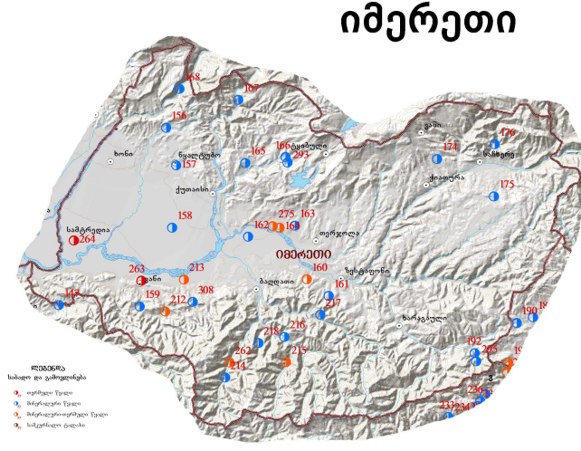

N | resource | Location
214 | mineral water | Sairme
215 | Mineral-thermal water | Zekar
216 | mineral water | Nikabeeti
217 | mineral water | Sacraula
218 | mineral water | Chergeeti
262 | Mineral-thermal water | wilderness

The mineral and mineral-thermal water in Sairme is internationally known and attracts local and foreign vacationers . "Sairme" resort is located in the mountainous zone of the subtropical belt, south of Kutaisi at 950 m above sea level. "Sairme" is the largest resort in Europe. It is the only resort where 4 different healing properties and 1 thermal spring flow out and many diseases can be cured.
Table 4.2. Number of vehicles registered in Imereti region, according to specialization
(by the end of the year, thousand)
 | 2014 | 2015 | 2016 | 2017 | 2018 | 2019 | 2020 | 2021
Cars, total | 130.5 | 141.4 | 152.5 | 161.0 | 168.8 | 176.1 | 187.6 | 201.6
between them:
truck | 11.4 | 12.2 | 12.4 | 12.4 | 12.6 | 12.7 | 13.0 | 13.5
Passenger (buses and minibuses) | 7.0 | 7.1 | 7.1 | 7.2 | 7.3 | 7.4 | 7.4 | 7.5
special purpose | 3.1 | 3.3 | 3.5 | 3.8 | 4.2 | 4.6 | 4.9 | 5.3
light | 109.0 | 118.8 | 129.5 | 137.5 | 144.7 | 151.5 | 162.3 | 175.2

Assessing the situation
issue | Strengths, Assets, Capabilities | challenges | The need for investment / or strategic opportunities / and how this opportunity can be exploited | Who can develop this opportunity / who can finance / who can be a partner organization
natural resources | - Forest 67.5%  - Precious tree species  - 5 rivers with 10 tributaries.  - precious stone  - Mineral and mineral-thermal waters | - Low rate of sustainable use of natural resources | National Forestry Agency Development Strategy and Action Plan 2021-2026
air pollution | - In 2019, the total greenhouse gas emissions in the municipality of Baghdati Municipality were approximately 3857.00 tons of CO2 equivalent.  - the macro-sectors of buildings, equipment/facilities, industry and transport .  - macro -sector emissions of buildings, equipment/facilities and industry in Baghdati Municipality were approximately 2159.92 tons of CO2 equivalent, which is 56.00% of the municipality's total emissions.  - The lowest emissions were recorded in the outdoor lighting sector (77.14 tons of CO2 equivalent) | - According to the countrywide data of 2015, the rate of greenhouse gas emissions in Georgia is 17.6 megatons .  - Transport is the main source of pollution in the municipality . Here we are talking about dependence on fossil fuel energy as well as noise pollution.  - There is a growing trend of dependence on private vehicles. The increased number of light vehicles (61%) in the Imereti region and municipality in 2014-2021 has a negative impact on the environment.
Management of energy resources | - Future measures should consider exploring geothermal and solar energy opportunities in Georgia. Also, exploring additional uses of hydro and wind power and incentives to seek additional investment in renewable energy.  - At this stage, only 20-22% of water resources are used in Georgia. | - Low rate of use of renewable energy | The main direction of the energy policy of the Government of Georgia is to increase the country's energy security and independence, to gradually reduce dependence on imported energy resources through the utilization of local energy resources, diversification of supply sources and routes. Accordingly, the use of renewable energy sources will further strengthen the country's energy security and reduce dependence on imports.
waste management | - "Municipal Waste Management Action Plan 2023-2027".  - Solid waste management, separation, maximum reduction of landfills.  - pilot mode and boxes for separation have been installed. | - 3 villages of the municipality in the mountainous area remain outside of the waste removal service . It is a source of pollution  - sorted waste collection system
Water resources management | - The rivers and their tributaries in the territory of the municipality represent a real potential for the development of small hydroelectric power plants.  - maintenance and operation of irrigation systems are based on existing river resources . | - Seasonally, there is a risk of floods and landslides during heavy rainfall . As a result, agricultural beds and homestead areas are damaged. | In the territory of the municipality, the selection of places where it is necessary to arrange embankments is being intensively carried out.
dehydration |  | - The sewage system in the city of Baghdati is completely amortized  - There are frequent cases of damage to the sewage network.  - Contaminated water coming out of the sewers flows into the Khanistskal River .  - In rural settlements , there is no sewage network at all, in some cases, household sewage systems are connected . On drainage channels that connect to rivers without filtration, which is the main cause of river pollution. | In 2017, KFW funded the study of the water distribution system. Currently, preliminary design works are underway. By 2030, it is planned to arrange the water distribution system of the city of Baghdad, although the sources of real financing have not yet been determined.

living environment

The quality of the living conditions of the population has been dramatically improved in most cases.

This thematic block is related to the objectives of the EU Green Deal: "Renovated, energy-efficient buildings" / "Cleaner energy and the latest clean technological innovations".

Basic data
Accommodation | - 90% of the population of the municipality lives in private houses, and 10% in multi-apartment buildings.  - Most residential buildings built in the last 5-10 years are somewhat compliant with modern energy-saving approaches.  - According to the data of the last general census, the population of the municipality is 10,560 households and  - The average living space per inhabitant is 32.8 ^{m2} .
Housing improvement | - Electricity supply - 99.8% (currently 100% according to Energy Pro data);  - Natural gas -56.8%, and according to the 2022 data of Sokar Gas, the gas supply network currently covers 80% of the populated area of the municipality, to which 7657 subscribers are connected.  - Heating system - 1.8%, according to the 2022 data of SOCAR Georgia Gas, 350 subscribers have installed a central heating system.  - Individual means of heating - 98.9%, of which up to 4,000 SOCAR Georgia gas subscribers use natural gas heaters;  - water supply - 48.3%;  - Hot water systems 25.9. According to SOCAR Georgia Gas, 4,500 subscribers have a natural gas hot water system.  - bath-shower 25.4%;  - Sewerage 48.6% (currently, the problem of drainage is acute in the municipality, the old sewage network is actually out of order, and drainage channels or individually arranged septic tanks , most of which do not meet the standards, serve as drainage channels);  - Flushable toilet 23.7%.
Access to health care | - In the center of the municipality there are emergency medical aid and public health protection centers, which makes the availability of emergency medical services necessary for the creation of a favorable sanitary-epidemiological background in the territory of the municipality.  - 12 primary health care centers operate within the administrative boundaries of villages and communities. However, taking into account the location of the district, the existing number of outpatient clinics cannot provide all residents (territorial) access to primary health care services.  - Outpatient clinics are not equipped with modern equipment and material base.  - In the center of the district there is a stationary type medical institution, where the number of beds is 15 units.  - The maternity block and the children's intensive care unit do not function in the municipality.  - The population should benefit from the state and municipal programs of financing medical services and medicines.
Access to social programs | - In the district center of the municipality, the district department of the Ministry of Labor, Health and Social Protection for IDPs from the occupied territories of Georgia operates, through which the population can benefit from state social services (cash social assistance (living allowance), state pension; targeted state program for the improvement of the demographic situation; household subsidy; social assistance of displaced persons and others;  - Within the social budget of the municipality, citizens benefit from various types of social assistance (financial assistance to families with multiple children, single children, orphans, newborns, disabled persons and socially needy families; assistance to veteran families; provision of housing; assistance to families affected by natural disasters and fires; provision of food services to socially vulnerable families; financing of transportation costs for beneficiaries of the state dialysis program; strengthening of families with children).

Assessing the situation
issue | Strengths, Assets, Capabilities | challenges | Investment need / or strategic opportunity / and how this opportunity can be communicated | Who can take this opportunity forward / Who will fund it / Who can be the partner organization
open spaces | Several squares are arranged in the central area of the municipality, there is one space for outdoor simulators and children's attractions. Developed areas are also arranged in the central places of the municipality . Squares are also arranged in several villages. | High-speed in the existing squares Setting up wi-fi . Increasing the number of outdoor simulators in different places, as well as increasing the number of children's attractions and adding new attractions. Arrangement of squares, outdoor simulators and children's attractions in almost every village | In general, the issue of internetization is raised and initiated by the state. Internetization of central places and all villages should be done. Arrangement of various outdoor entertainment spaces has been started with the support of regional programs as well as municipal and rural programs. Also by financing and co-financing of A/Os. Involvement of private investors is desirable and necessary
Socializing and meeting spaces | - There are 7 libraries operating throughout the municipality, including one central and 6 rural ones.  - There are two museums, V. The Mayakovsky Museum, which is distinguished by the number of visitors, also conducts and hosts salon events. The local knowledge museum is located in the village of In the tourism center in Vartsikhe, where ancient artifacts are preserved.  - Two cultural centers and three youth spaces are also functioning throughout the municipality. | Infrastructural maintenance of the mentioned spaces. Arrangement of small cultural centers, libraries and youth spaces in several villages. | Solving the mentioned challenges is mainly carried out at the expense of the state, within the framework of both municipal and rural programs. Also by financing and co-financing of A/Os.
Art and culture | - About 30 choreographic and folk and fine arts circles of various kinds are functioning in the municipality, the direct beneficiaries of which are 1000 young people.  - There are 47 cultural heritage monuments in the territory of the municipality. About 40 temples (including several cultural heritage monuments). | It is desirable to add and diversify new study circles. Also accessibility for rural residents.  Protection of cultural heritage monuments, care and revitalization of some of them . | Municipal programs and the involvement of private individuals. Their main interest in cultural heritage monuments.
sports | - functions in the municipality in two directions: sports circles and fitness sector. There are 10 types of sports in sports circles, where about 300 children gather.  - There are 19 large and small stadiums and fields, as well as 7 sports halls (of non-standard size) on the territory of the municipality. | Adding new species to sports circles, making them accessible to residents of the village. Purchase of new simulators for the fitness sector. Infrastructural arrangement of large and small stadiums. The main challenge is to build a standard size gym in the municipality. | State programs, municipal programs, rural programs, A/O organizations, private investors.
Housing (available resources and availability) | - In 2022, during the renovation of the central part of the city, 3 multi-storey and multi-apartment buildings were energy-efficiently darkened, thus actually setting a precedent for the complex renovation of multi-storey buildings.  - In order to improve the quality of life and cost efficiency, the population takes into account energy-saving elements, namely the installation of metal-plastic doors and windows and energy-saving lamps during the renovation of residential houses. | - 90% of both types of residential houses are built with whitewash, wood and reinforced concrete in the 60s-90s of the previous century. which are mostly not suitable for modern standards of construction and energy-saving approaches are not taken into account during construction.  - inefficient buildings  - Socially needy population, about 800-1000 families are not able to develop housing, and therefore energy saving elements are less considered in their housing.  - In addition, local developers do not have sufficient knowledge and experience in implementing energy efficiency and smart home directions and high-tech systems.  - At the same time, the municipality has an acute problem of social housing, in the last 5 years there has been an increase in complaints about the damage to residential houses, 30-40 families per year, the homeless population is paid rent by the social program of the municipality.
Attractiveness for residents |  | - Malfunction of water supply infrastructure in rural settlements  - Water system failure  - The need for capital arrangement of intra-district roads
Access to health care | - Operation of emergency aid and public health protection centers.  - 12 primary health care centers operate within the administrative boundaries of villages and communities.  - A stationary medical facility is located in the center of the municipality.  - State and municipal programs for financing medical services and medicines are available to the population | - Considering the layout of the district, the existing number of outpatient clinics cannot ensure (territorial) access to all residents.  - Outpatient clinics are not equipped with modern equipment and material base.  - The maternity unit and the children's intensive care unit do not function in the municipality.  - In the municipality, the maternity block and the children's intensive care unit do not function.  - There is no dialysis center in the municipality (the number of citizens involved in the state dialysis program increases every year)
Local identity/ image/brand | - The brand is associated with the Sairme resort, winemaking, the Mayakovsky house-museum,

Education and skills

The ongoing reform of vocational education and training in the country represents an important opportunity for Baghdati municipality.
Stakeholder views highlight the need for education and skills development for all ages.
- Improving skills and promoting vocational knowledge will encourage the acquisition of new skills among different age groups with insufficient qualifications and low employability. Employment opportunities will increase for lower socio-economic groups, especially those who cannot afford it.
- Informal and professional skills development for young people will support young people to develop specific professional skills, help increase digital and entrepreneurial knowledge and skills. In addition, the growth of youth skills and competences will help to create more volunteer projects and activities
The development of the education system is linked to the goal of the Green Deal - future jobs and skills training for the transition period.
General Information
preschool  Education | - There are 22 schools, where 2540 students are enrolled  - In the last 5 years, the number of students has increased by 6 percent  - 16 kindergartens operate, where 704 children are served by 89 teachers  - In recent years, the number of foster children has decreased in proportion to the decrease in the total population.
Extracurricular education | - 4 higher education institutions (2 state and 2 private) operate in Imereti region.  - All four higher education institutions are located within a radius of 25 kilometers from the center of Baghdad.
Vocational and non-formal education | - There are 9 vocational schools operating in Imereti region.  - College Iberia in Baghdati municipality implements 2 training programs (electricity; accounting)  - In terms of informal education, the youth space " game zone" and the youth club of Baghdati are functioning

Assessing the situation
issue | Strengths, Assets, Capabilities | challenges | Investment need / or strategic opportunity / and how this opportunity can be communicated | Who can take this opportunity forward / Who will fund it / Who can be the partner organization
Education | - dual programs locally with the involvement of civil organizations is also an opportunity. | Equipping the existing professional, formal and non-formal education institutions with the material and technical base as much as possible. Creating more educational structures  Low level of awareness about green development goals | State programs, A/Os, private investors.
high education | - 4 higher education institutions (2 state and 2 private) operate in Imereti region.  - Vocational schools, like higher education institutions, are located within a 25-kilometer radius from the center of Baghdad.
skills |  | - Inadequate levels of workforce qualifications and entrepreneurial skills hinder business investment and productivity.
professional education | - 9 vocational schools operate in the region.  - College "Iberia" operates in Baghdati | - The annual number of students enrolled in vocational schools in the Imereti region is characterized by a decreasing trend, which represents an important challenge for local economic development.  - Lack of training programs (has only 2 programs)  - Inadequate opportunities for professional education and training is an important factor hindering local development  - Low levels of participation in state-run adult training and apprenticeship programs have a negative impact on employment rates  - There is a low rate of recognition of non-formal professional education in the society | Within 10 years, additional learning centers and opportunities on site, non-formal and vocational education collaboration with local value chain and community groups, will increase the level of education and skills of youth and adults, which will have a positive impact on local economic growth and employment.
Local business needs (in terms of education and skills development) | - The development of small and medium entrepreneurship development strategy is being promoted through professional education. | - The presence of elements of informal education and entrepreneurial skills development locally, including elements of green development, their lack of systematicity and collaboration with existing needs and spontaneity  - Insufficient regular opportunities for non-formal education and entrepreneurial skills development of adults and young people is an obstacle to local economic development.
Appropriate infrastructure and equipment | - Underutilized buildings can be used to develop learning and co-working spaces, which will help create integrated services and new centers of attraction.

The presence of new and innovative industries

by introducing innovative methods and approaches, modern high-tech production equipment .
The country's approach to promoting innovative technologies and smart specialization is noteworthy. Since 2014, state programs operating within the country have been promoting the retooling of enterprises and the implementation of innovative ideas.
General Information
The presence of new and innovative industries | - Number of patents and newly created firms  - Number of higher education institutions within an hour's drive  - Number of firms in digital, scientific, research and high-skilled industries  - Development of digital skills provided by the municipality  - Research and development initiatives sponsored by the municipality/region/national government
- Three mineral and drinking water producing companies operating in the municipality are equipped with high-tech equipment, two of which comply with ISO standards.
- 15 local wine producing companies carry out the production process with organic approaches and methods. They are members of the Natural Wine Association and the Association of Organic Farms in Elkana. The member companies are monitored by the experts of the associations. In addition, 3 wine producers are involved in the bio-certification process of food processing company " Kavkassert ".
- With the support of state programs, a cranberry storage-processing enterprise operates in the municipality, in accordance with ISO standards. which exports 90% of the produced products.

Assessing the situation
issue | Strengths, Assets, Capabilities | challenges | Investment need / or strategic opportunity / and how this opportunity can be communicated | Who can take this opportunity forward / Who will fund it / Who can be the partner organization
New technologies and innovations
Existing innovative industries
Appropriate infrastructure (accessible spaces, Internet, etc. )
Skills needed for innovative industries
Municipal support in the direction of innovations
Access to financing

Municipal services
The self-government of the municipality has made revolutionary changes in the last 10 years to improve municipal services.
Improving municipal services is linked to all Green Deal objectives.
General Information
Services and Proceedings | - How many services does the municipality provide to the population? - there are 5 categories of business related services:  - Communal services (outdoor lighting, water supply to rural settlements, street cleaning);  - Municipal waste management;  - Construction permits;  - Privatization of municipal property - leasing;  - Citizen Service Bureau (certificates etc;  - Document circulation and proceedings are carried out on the "one-stop" principle, electronically and in the electronic system of document circulation registered from the Chancellery,  - The budgeting and budgeting process of the municipality is public, recently the municipality has started to implement participatory planning mechanisms, there is effective coordination and cooperation between various municipal services. Information on planning and budgeting is regularly updated and easily accessible to residents.
Services provided to the private sector | to establish partnerships with local economic actors and support initiatives to strengthen the private sector:  - Infrastructural projects of 3 million GEL were implemented to overcome the circumstances hindering the development of the local business sector. Access roads to tourist wineries, rest areas and a business accelerator building were arranged - for the development of business support services.  - The process of contracting with business (executive) and partner organizations is carried out by electronic signature, without on-site announcement and delay.  - The Economic Team of the Municipality Hall provides consulting and referral service to the business sector, providing financing opportunities to 100-150 entrepreneurs annually.  - The municipality conducts tenders through the web-portal of the State Procurement Agency. The activities of the tender commission are transparent and all decisions are uploaded on the agency's website.  - Issuing or privatizing municipal property with the right to use it is carried out through an electronic auction.  - Trading is transparent and participation is anonymous. The winner is announced on the auction website.

Assessing the situation
issue | Strengths, Assets, Capabilities | challenges | Investment need / or strategic opportunity / and how this opportunity can be communicated | Who can take this opportunity forward / Who will fund it / Who can be the partner organization
transparency | - the tender commission are transparent and all decisions are uploaded on the agency's website.  - The Agency's Dispute Resolution Board reviews the complaints received  - The amount of complaints received from the tenders announced by the municipality in the last 3 years is 2.4%, of which 1.2% were partially satisfied, and legal disputes were not initiated in any case.
Regulatory and Institutional Framework (Administrative Issues Facing Business) |  | - For construction permits, applications are received in non-electronic form and the private sector has to present documentation in person, while the process of agreement from various agencies takes time and there are often cases when the start of physical construction works is significantly delayed.  - The legislative framework for issuing building permits does not provide for energy-efficient approaches and obligations.  - However, the municipality does not have a defined policy to reduce emissions in the private sector
Qualifications and Skills |  | - Also in the private sector there is insufficient knowledge about the cost-effectiveness of energy-saving devices and alternative energy sources.
purchases  Procurement requirements | - The municipality conducts tenders through the web-portal of the State Procurement Agency. The activities of the tender commission are transparent and all decisions are uploaded on the agency's website.  - Trading is transparent and participation is anonymous. The winner is announced by the auction website.
Provision of basic services  Provision of basic services | - The implemented electronic management system and electronic document circulation make the provision of services to the population, private sector and public organizations more flexible and operational.  - The processing time has been reduced by 50% in the last 3 years compared to previous years.  - In recent years, during natural events caused by climate change, heavy precipitation, wind and droughts, a temporary disaster management group is created in the municipality, although not a permanent one.  - There is effective coordination between the different services of the municipality, however, in recent years, the unprecedented heavy rainfall during the winter period has created significant obstacles, not only in the municipality, but also in the region.  - % of the territory of the municipality is covered by the waste management service . | - The process of separating the waste at the source has started, but not significantly.  - There are not enough special bins  - At the same time, the awareness of the population about the separation and usefulness of waste is low.  - Accordingly, usable raw materials end up in the landfill.
Property and land owned and available for income generation or private investment | - Periodically, investment resources are identified and investment offers are prepared, however, not sufficiently and without specific goals. | There is no detailed research of investment resources and there is no municipal investment policy and general development plan.

strategy
In this part, Baghdadi's strategy, development vision and main priorities are discussed.

Strengths, Weaknesses, Opportunities and Threats

strong sides | Weaknesses
- Favorable location and climatic conditions  - Abundance of natural resources  - Abundance of water resources (including mineral)  - Diversity of landscape (80-2600 meters above sea level)  - Low emissions per capita  - Location at the intersection of the West-East and North-South transport highways  - Orderly road infrastructure connecting the center of the region and neighboring municipalities  - Proximity to Kutaisi International Airport and railway stations  - Direct connection to the transport hub  - Proximity to free industrial zones  - well-organized basic road infrastructure;  - Supplying most of the population with gas and electricity  - Diversity of agricultural branches  - abundance of family wine cellars and organic wine production;  - Greenhouse cluster "Imereti Agro Zone" on the territory of the municipality  - possibility of production of ecologically clean, organic products;  - Availability of the primary infrastructure required for a business accelerator  - Diversity and abundance of tourist facilities  - The presence of 2 famous climatic and balneological resorts Sairmi and Zekar  - Recreational, recreational and entertainment infrastructure in Sairme resort  - Membership of the International Association of Thermal Cities;  - In recent years, a high rate of economic growth compared to the average rate of the country and region  - Full readiness of the municipality leadership to promote economic development  - Existence of Local Economic Development Plan (LEDP1). | - Insufficient awareness of the municipality.  - Low GDP per capita  - Lack of investment and financial access  - Scarcity of jobs and wages  - migration of local skilled workers;  - Insufficient municipal services  - Lack of public transport  - Inadequate level of entrepreneurial education  - Low access to technology  - Low level of innovation  - Low level of green economy knowledge and skills  - Lack of business services and infrastructure  - Less available agricultural equipment and services  - Less orderly inner district - road and business supporting infrastructure.  - Low level of tourist services (including the qualifications of guides)  - Insufficient and improperly arranged infrastructure for visitors to tourist locations  - Low productivity in animal husbandry  - Low rate of use of renewable energy  - Low wine production capacity  - Non-energy efficient buildings (including public)  - Lack of squares and sports recreation spaces  - The problem of gasification of part of the municipality  - Difficulty in providing cleaning services in 2 villages  - sorted waste collection system  - Lack of statistical information needed for planning
abilities | dangers
- business promotion projects operating in the country;  - the shortest perspective of the South-West transport highway in the municipality;  - Investment policy of the country  - Free agricultural land and infrastructure  - Growing trend of investment in agriculture sector  - Growing demand for agricultural products in the world  - Support of international donor organizations  - Facilitation of implementation of capital investments  - Liberal tax policy and ease of starting a business  - A deep and comprehensive trading space  - European Green Deal  - Innovations in the field of agriculture Supportive state programs  - Formation and development of Imereti Agrozone  - Development of wine accelerator with the support of donor organizations  - Promotion of diversification of tourism throughout the country  - Possibility of development of intermunicipal programs  - State programs for the promotion of professional and non-formal education  - Promotion of renewable energy production at the national and international level  - Promotion of development of organic and bio products in agriculture  - Promotion of green economy development  - Promoting the development of agro and ecotourism  - low-emission transport | - High tendency of migration in the country  - Population aging trend  - Energy shortages for a growing economy  - High dependence on the agricultural sector  - Common pests and diseases of plants and livestock in agriculture  - Low prices for imported agricultural products  - Floating exchange rate  - Aggravation of pandemic processes  - Natural disasters  - seismic activity  - geopolitical threats

The strengths and opportunities of Baghdati Municipality provide a good opportunity to overcome the weaknesses of the municipality's economic development. The joint actions of the local economic actors of the municipality must be directed to the implementation of such measures, which will overcome the weaknesses, taking into account the local strengths, external factors and threats will be taken into account.
Actions should be aimed at overcoming the main challenges that have been identified as a result of the situational analysis.

Vision and strategic goals of Baghdati Municipality
By 2050, Baghdati Municipality will be a green and attractive place to live, travel, work and do business. Taking into account the principles of sustainable development and the European Union Green Agreement, as well as the economic and cultural heritage of the municipality, our vision is to create a favorable environment for the development of competitive green economic sectors and the raising of future-oriented skills, using green and innovative approaches, improving services and infrastructure, as well as introducing low-emission municipal mobility and through smart urban renewal.

strategic goals | Brief justification | Compliance with global/national/regional goals ( EU Green Deal, SDGs…)
Promoting the development of organic viticulture and winemaking as a competitive industry | [Justification based on local context } | The EU Green Deal: Healthy and affordable food  Sustainable Development Goals ( SDGs ):  SDG 8 - Decent work and economic growth  SDG 9 - Industry, innovation and infrastructure
Developing skills tailored to current and future economic needs and introducing innovative approaches |  | The EU Green Deal: on the future customized work places and skills training transition for the period  Sustainable Development Goals ( SDGs ):  SDG 4 - quality education  SDG 9 - Industry, innovation and infrastructure
Green and smart urban renewal of the municipality |  | EU Green Deal:  - Greener and smarter transport  - Renovated, energy-efficient buildings  Sustainable Development Goals ( SDGs ):  SDG 11 - Sustainable cities and communities

tasks and activities
The stated chapter provides the tasks and activities to be performed according to each strategic goal.
goals |  | activities
priorities | tasks | from the budget | attractive
Bio viticulture and Winemaking , as growing and competitive field development promotion  Advancement of organic viticulture and winemaking as a thriving and competitive sector | Task 1: of the municipality economic potential about of familiarity raise and investments attraction Promotion, especially in the direction of viticulture and winemaking  Objective 1 : Enhancing awareness of the municipality's economic potential and promoting investment opportunities , especially in the viticulture and winemaking | - of the municipality economic potential and competitive economic Sectors ( Viticulture and winemaking ) about local and a foreigner business operators To inform ( m . sh . sustainable development principles and green economy direction )  - local and foreign tour operators base Compilation ( of tourism nationally with the agency in coordination )  - local of the cellars of the catalog development Georgian and in English on languages ( info on the product , wine at the tasting and hosting other on services ); coordination Regional with the administration , DMO of Imereti , tourism near the administration , Imereti Working with NGOs  - local touristic potential and product Promote ( emphasis on the cellars and of wine on the way ) informative campaign , festivals participation by way of  - investment Proposals / catalog development Georgian and in English on languages  - interested parties Identification ( coordination Regional with the administration , agency " Atsaramoe in Georgia ")  - of Baghdati investment of the catalog promote media various channels , forums participation and other means  - Bio of viticulture and on winemaking of consciousness raise locally beneficiaries between _ Bioproduction promotion and promotion  - Bio on farming trainings / seminars Conducting local of growers and for winemakers  - Bio on farming working non-governmental local and International organizations an invitation and interest of Baghdati Vineyard - with winemakers with cooperation
 | Task 2: of Baghdati in the municipality economic by activity interested subjects on finances Availability growth _ with winemaking connected touristic products will create promotion  Objective 2 : Facilitating increased access to finance for economic actors in Baghdati Municipality and fostering the development of tourism products associated with winemaking . | - financing existing opportunities about informing growth  - State and non-state financing on programs information distribution of the City Hall Official communication channels  - State support programs ( produce in Georgia ; introduce future and other ) about Advisory - informative meetings and training seminars _ Conduct of applications in preparation Help and etc. )
 | task 3: Business Facilitator of services and public infrastructure improvement  Objective 3: Enhancing business support services and upgrading public infrastructure to foster a conducive environment for economic growth . | - of the City Hall by vulnerable groups economic activities encouragement Financial mechanisms implementation and development  - Write it down services and them to implement Required actions  - of business Facilitator infrastructure improvement  - which infrastructure You will understand and are you planning
existing and in the future economic on needs customized skills development and Innovative approaches implementation  Cultivating skills aligned with present and future economic demands and introducing cutting- edge approaches through innovation . | task 4: Work of force qualification raise and of the market with the requirements approximation promotion  Objective 4: Enhancing workforce capacity and facilitating alignment with market demands through skills development and effective matching strategies . | - locally level work on power of demand and his structure about information permanent Update .  - informative base create in the municipality  - locally private with the sector permanent of dialogue usurpation periodic ( per year twice ) meetings by organization work on power of demand about information receiving purpose  - tourism , viticulture and of winemaking with fields interested persons municipal programs with the help of qualification raising and / or retraining mechanisms implementation  - in the market existing Professional of education of demand identify and respectively State professional with schools communication mechanisms implementation  - employment forums organise and in the forums participation promotion
 | task 5: economic in processes on technologies and Innovative approaches available growth  Objective 5: Expanding access to technologies and fostering the adoption of innovative approaches within the local economy . | - local of wine for manufacturers Modern deficient of services Delivery  - little and average of business Digitization promotion of tourism and village farming in sectors ( municipality Priority sectors )  - municipal of services Digitization ( construction permissions Disbursement of waste management )
of the municipality green and smart urban Update  Green and smart urban renewal | task 6: Low emission and Eco - friendly public of transport system implementation promotion and promotion  Objective 6: Facilitating the introduction of a low-emission and eco-friendly public transport system to promote green mobility options . | - Eco - friendly transportation system development  - inside municipal transportation of demand determine  - transportation needs on satisfaction dialog private with the sector ; accent Eco - friendly on solutions  - Eco - friendly of transport with the help of mobility Encouragement  - Cycling - trails arrangement , sharing system Implementation , relevant infrastructure arrangement and A. _ Sh .  - public of transport infrastructure create  - Stops , informational boards , road regulators and A. _ Sh . arrangement
 | task 7: of the municipality Central districts come alive and Update residents and for visitors alive and attractive spaces will create purpose  Objective 7: Revitalizing and renovating the central areas of the municipality to create vibrant and attractive spaces for residents and visitors . | - tourist with sights and business for activities active near places infrastructure arrangement - arrangement  - road , picnic , camping , parking , shopping _ _ spaces and etc. _ arrangement - arrangement  - public spaces / squares Update and Functional load of society with engagement  - water supply system arrangement
 | Task 8: Municipal buildings energy Effective Update energy consumption reduction and of the municipality infrastructure sustainability promotion purpose  Objective 8: Undertaking energy-efficient renovations of municipal buildings to reduce energy consumption and promotion sustainability in the municipality's infrastructure . | - green economy and Energy - saving of technology of use Encouragement municipal with solutions  - construction permissions when issuing Benefits , locally in fees possible benefits and A. _ Sh . determination energy efficient approaches implementation On the basis of  - appropriate of regulations in determining experts Involvement ( Athea - s with the help of  - International of partners attraction green of the economy and energy Effective approaches for promotion

Monitoring, evaluation and management of plan implementation

Monitoring and evaluation scheme

Priority 1: |  |  | Promoting the development of organic viticulture and winemaking as a competitive industry |  |  | with the Sustainable Development Goals ( SDGs ) and the EU Green Deal:
Task 1.1: |  |  | of the municipality economic potential about of familiarity raise and investments attraction Promotion, especially in the direction of viticulture and winemaking
Task result indicator 1.1.1: |  |  |  |  | basic | target |  |  | source of confirmation
 |  |  |  |  |  | intermediate |  | final
 |  |  |  | year | 2023 | 2025 |  | 2027
 |  |  |  | indicator
activity |  | Activity result indicator |  | source of confirmation | Responsible agency | Partner agency | Performance deadline | Budget [₾} | source of funding
 |  |  |  |  |  |  |  |  | Municipality budget |  |  | other |  | deficit
 |  |  |  |  |  |  |  |  | Amount [₾} |  | Code | Amount [₾} | Organization | deficit
1.1.1 |  |  |  |  | City hall of the municipality | Regp fund
 |  |  |  |  | City hall of the municipality | Regp fund
 |  |  |  |  | City hall of the municipality | Regp fund
Task 1.2:
Task result indicator 1.2.1: |  |  |  |  | basic | target |  |  | source of confirmation
 |  |  |  |  |  | intermediate |  | final
 |  |  |  | year | 2023 | 2025 |  | 2027
 |  |  |  | indicator
activity |  | Activity result indicator |  | source of confirmation | Responsible agency | Partner agency | Performance deadline | Budget [₾} | source of funding
 |  |  |  |  |  |  |  |  | Municipality budget |  |  | other |  | deficit
 |  |  |  |  |  |  |  |  | Amount [₾} |  | Code | Amount [₾} | Organization | deficit
1.2.1 |  |  |  |  | City hall of the municipality |  | 2020

The team responsible for the implementation of the plan

[Describe the process of implementing the plan]

strategic goals | Responsible service of the City Hall | Regularity of coordination meetings | Compliance with the principles of accountability and transparency
Promoting the development of organic viticulture and winemaking as a competitive industry |  | Quarterly | Minutes will be drawn up and published
Developing skills tailored to current and future economic needs and introducing innovative approaches
Green and smart urban renewal of the municipality

Baghdati landmark photo

Additional information municipal of services About is given respectively in subsection 3.8.
Additional information is given respectively in subsection 3.3.

