Integrated District Level CMAM Planning, monitoring, implementation, Community mobilization & Communication with CAB during COVID19 pandemic- 2021-22 in Narmada district
Final Report

INTRODUCTION
Goals to Be Achieved
Mapping of Service Delivery and demand for RMNCH & A; ICDS; School; WASH; Protection Service in the COVID Context and based on the mapping data engage the community in addressing the gaps in the service delivery. Apply the Community-Based Management of Acute Malnutrition among children under 5 years of age to address the problem of malnutrition in the children along with targeted SBCC interventions.
Geographical Coverage
The operational area shall be the entire Narmada district comprising five blocks. The emphasis will be given to all five blocks where all 27 PHCs will be covered.
Taluka | Total PHCs | PHCs to be Covered | Villages
Dediapada | 8 | 8 | 190
Sagbara | 5 | 5 | 97
Nandod | 7 | 7 | 111
Garudeshwar | 4 | 4 | 92
Tilakwada | 3 | 3 | 60
TOTAL | 27 | 27 | 550

Timeframe:
The Project was for a period of 9months from the date of initiation (16th July 2021 to 15th April 2022)
Target Groups:
- Key Influencers are those who influence and inspire the adoption of recommended behaviours in the adolescent population of the area. These influencers are parents; elders of the family; siblings; religious leaders like traditional healers (Bhuvas/Bhagats); Caste boards; PRI members; SHG members; members of the VCPCs, VHNSC, Gram Sanjeevani Samitis, SMCs
- Worked with government officials at the district level; block level and village level including ASHA workers; ANMs; Anganwadi workers; Female Health Workers; Teachers; Ashramshalas; Gram Mitra
Operational Strategy:
- Strengthening Staff and Individual Influencers for support to CAB and SAM related services delivery activities.
- Programme Activities in the Community - Community mobilization activities with Groups of Influencers (community & mandated institutions) on SAM and CAB
- Provide supportive supervision support to different activities on SAM and CAB
- Programme support activities
PROJECT SCOPE:
The monitoring of the project, that was implemented in 27 PHCs in 590 village under 952 Anganwadi centers, was done through the KOBO Toolbox which is a mobile application. The implementation of the community-based Management of Sever Acute Malnutrition (CMAM) was done with supportive supervision of the qualified staff of INRECA throughout the project implementation period.
Methodology Used:
The PHCs Coordinators visit at least two Anganwadi centres (AWC) every day. They collect data at the AWC of children with Severe Acute Malnutrition (SAM) through the KOBO mobile application.
ACHIEVEMENTS:
- A two-day orientation program was organized for staff members. They were given orientation so as to understand what is expected of them in this intervention – their roles and responsibilities.
Some of the responsibilities of the District Project Coordinator was to liaison with officials of different line department at the district and block level; do forward planning for PHC coordinators to work in collaboration with the PHC staff as well as the Key Influencers and also coordinate with the PHC Coordinators for the smooth execution of project activities in accordance with the forward planning; on a monthly basis submission of success stories and voices from the field and best practices of ICDS and PHC. The DPC was also involved in coordination with UNICEF and other agencies for materials and tools needed for executing the intervention. PHC coordinators shared fortnightly reports to the DPC and those were compiled and submitted forward in a pre-designed format.
Along with the DPC the Data manager and Analyzer also contributed in liaisoning with the different line department officials at the district and block level; forward planning for PHC coordinators; on a monthly basis submission of success stories and voices from the field and best practices of ICDS and PHC. They also collected data from the work that happened in the field and analyzed the data and shared the data with the district officials. DMA was also engaged in coordinating with UNICEF and other agencies and compiling and submitting reports submitted by the PHC coordinators in a pre-designed format.
The main responsibilities of the PHC coordinators were to undertake the mapping exercise to identify the gaps in the service delivery for ECD indicators and Child and Maternal Health. They engaged with the community to spread awareness about COVID specific behaviors and the stigma and discrimination attached to it. They addressed the gaps identified and the barrier faced for material health as well as towards responsive parenting while monitoring developmental milestones with the help of key influencers. They applied the CMAM approach so as to enable the community volunteers to identify and initiate treatment for children with acute malnutrition before they became seriously ill. They coordinated with the ICDS and Health teams to identify SAM children and ensure their enrollment with an 8 week follow up and then monthly follow up with pre and post photographs. They also met with traditional healers for motivating them to promote the health and nutrition practices especially for maternal and child health. They did home visits and counseling of families of SUW children identified by AWW or ASHA to bring the children to the normal grade. They were also engaged in the promotion of Take Home Ration (THR) and documentation of different recipes prepared with THR and locally available foods. They followed up with all the SUW children identified with child-wise monthly progress status and submission of success stores. They were also supposed to develop Nutri Garden at PHCs, AWCs, Schools and motivating the community and peer leaders for developing the Nutri gardens. This activity was challenging as there was not enough land available.
- A one-day workshop was jointly organised on 28th September 2021 by UNICEF, TRIFED and the Health Department at the Ayurvedic College in Rajpipla. The aim of the workshop was the COVID-19 vaccination drive prioritizing the forest area dwellers to be fully vaccinated. INRECA participated in this workshop as this is their intervention area to ensure full participation by their beneficiaries in the vaccination drive

- A two-day workshop was organised on 29th and 30th September 2021 by the District Health Society, Narmada and supported by UNICEF for SBCC related to CMA. Participation in the workshop was by ICDS, Health department, UNICEF and INRECA – INRECA participated as it was the partner of UNICEF for conducting the monitoring of CMAM and SAM activities in Narmada district of Gujarat.

- Key influencers were to be identified and they were to be oriented as to what was expected out of them in this intervention.
The tables are given below shows that targets that were achieved in the all 3 quarters.They key influencers identified were the Bhuva Bhagats; SMC members; AWWs; ASHA workers; the PRI members.
Table No. 1: Key Influencer Identified and Targeted to be identified
Key Influencers | Target Achieved in Project period
Bhuva Bhagat | 348
SMC | 602
AWW | 4101
ASHA | 700
PRI | 618
- ASHA Workers; Anganwadi workers; Anganwadi workers; Health Workers; Members of VHNSC; SMC; PRI; VCPC members equipped to take the core message of the intervention forward.
The targets achieved in project period and details aregiven below in Table no. 2

Table No. 2: Key Influencers Equipped to take Core Messages Forward
Key Influencers | Target Achieved in Project period
Anganwadi workers | 5262
ASHA Workers | 700
VHNSC | 156
PRIs | 448
SMC | 618
Youth Group | 212

- Community-Based Management of Acute Malnutrition (CMAM) approach enabling community volunteers to identify and initiate treatment for children with acute malnutrition before they become seriously ill
A total of 550 village volunteers (VV) have been identified in 590 villages in the district and with this 100% of this work has been completed. In the project period 871 SAM children were monitored for their growth and 1032 home visits were done of CMAM enrolled SAM children by the VV as can be seen in the table given below
Table No. 3: Growth Monitoring/Home Visit
Work Details | Target Achieved in project period
Growth Monitoring of SAM children by VV | 871
Home Visit of CMAM enrolled SAM Children by VV | 1032
- Joint Identification of children as SAM and enrolment in CMAM program with FLW of Health and ICDS
The above targets were achieved during the project: A total of 5266children were jointly identified. 56 new SAM children were found during the project who were registered at the Anganwadi but did not benefit from SAM in Anganwadi. Through the efforts of INRECA children have been enrolled in CMAM program and have got the benefit of THR.
When the program was started a total of 3000 SAM children were registered in the district as per the ICDS records of Narmada district. After the implementation of the INRECA-UNICEF Partnered CMAM Program now there are approximately 1100 SAM Children in the district.
- Support the districts in strengthening the referral linkages between field, CMAM and NRC/CMTCs
In the project period250children were admitted to CMTC and NRC. Also 98 children were admitted as coordinators during the project period.
Table No. 4: Strengthening Referral Linkages between CMAM and NRC/CMTC
Work Details | Target Achieved in Q1 ,Q2& Q-3
Children admitted to CMTC and NRC | 250
Children admitted as Coordinators | 98

- Spread messages regarding COVID appropriate behaviour and SAM management – spread awareness that reduces the stigma and discrimination attached to those who are COVID-19 positive
During the project periodtotal 9667 people became aware about COVID-19 and SAM management
Coordination with ICDS and Health team for identification of SAM children and ensuring enrolment in CMAM
In the project period 2917 children were enrolled in CMAM program, the below table shown
Table No. 5: Enrollment in CMAM
Outcomes | Target Achieved in Q1 , Q2,& Q3
Enrolled in CMAM | 2917
- Promotion of Mangal Divas among the community and increasing the community participation.
Table No. 6:Promotion/Participation of Mangal Divas
Outcomes | Target Achieved project period
Mamta Days, Bal Tula Divas, Poshan Sudha Participation | 829
- Meeting with traditional healers for motivating them to promote the health and Nutrition practices especially for Maternal and child
In the first, second and third quarters a total of 348 group meetings were held with traditional healers.
- Home visit and counselling of families of SUW child identified by AWW or ASHA with monthly monitoring with necessary inputs to bring the child in Normal Grade
In the first, second and third quarters a total of 3347home visits and counseling sessions were done with SAM and SUW children of families
- Collect and write Success stories and voices from the field and best practices of ICDS and PHC
During the project period a total 60 success stories were identified and documentedthe target have achieved.
Given below is the success story of a child enrolled in the CMAM Program
Name of Child: Tadvi Mahirkumar Alkeshbhai
Birth Date: 8th April 2021
Gender: male
Enrolled in CMAM Program: 22nd October 2021
Weight: 4.600 kg; Height: 62 cms; Z Score: (-4 SD)
Discharged from CMAM Programme: 18th December 2021
Weight: 5.800 kg; Height 63.4 cm; Z score (-2 SD)
- Promotion of Take Home Ration (THR) and documentation of different recipes prepared with through and Locally available foods through PHC coordinators and village volunteers
Table No. 10: Promotion of THR
Outcomes | Target Achieved  Q1 ,Q2& Q3
Total Mamta Days, Bal Tula Divas, Poshan Sudha Divas | 829
2102 people participated
Through pamphlet and video shared knowledge of different recipes of THR
- Follow up of all SUW children identified with child wise monthly progress status and submission of Success Stories
Table No. 11: Follow up of SUW children
Outcomes | Target Achieved
Total | 24
- Conduct group meetings with each formal and informal institutions (PRI Leaders, Bhuwa/Bhagat, Pani Samiti, Dairy, Watershed Committee, Adolescent Youth Groups) on importance of empowerment of adolescents, nutrition and ending child marriage through PHC coordinators
Table No. 12: Conduction of Group Meetings
Outcomes | Target Achieved in project period
Group meetings Conducted* | 1805
Participation in above meetings | 7220
*PRI, Bhuva, Bhagat, SMC, SHG, Milk Cooperative Societies, Forest Committees, Youth Groups, Village Volunteers (conducted by PHC Coordinators and Village Volunteers)
** Participation by Members, Coordinators and other Community Representatives
In the during the project 1805group meeting were conducted where the participation was of the PRI members; Bhuvas and Bhagats; SMC members; SHG members; Milk Cooperative Society members; Forest Committees; Youth groups; VVs and they were conducted by the PHC coordinators and the Village coordinators. The total participation was 7220 members.

- Support in tracking children who were identified as SAM and enrolled in CMAM
Target Achieve in project period: Total Out 2917 children enrolled in the CMAM programme with ICDS and Health, a total of 1310 children have recovered.
- Success story of the new found hamlet
A new hamlet was identified to be included in the project implementation area by the PHC coordinator Mr. Raysingbhai Vasava. In November 2021 Mr. Vasava had visited Godada village and met with the local leaders and Anganwadi workers and their they shared information about a hamlet named Auta Dungar. This hamlet is 8 km from Godada village and 7 km from Kanapada village. It is hamlet with a total of 24 families. On a subsequent visit the coordinator met the household members of the hamlet. He discussed with them about the benefits they receive from government schemes and was told that they receive grains from the Ration shop but nothing from the Health or the ICDS department.
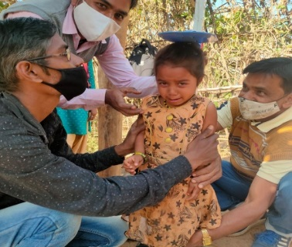
The next month another visit was organized with the DPC to the Auta Dungar hamlet to conduct the household survey. It was found in the survey that the population of the hamlet was 141 with 24 children in the 0-5 years age group. This list was shared with the Taluka Health Officer, Sagbara and the Medical officer of the PHC in Devmogra. The MO of Devmogra was requested to conduct Mamta Divas at the hamlet as two pregnant women and a lactating mother had not got the vaccine. With the efforts of the PHC coordinator Mr. Vasava the Mamta Day was organized on 16th December 2021 at Auta Dungar with the support of the PHC staff of Devmogra – the staff nurse Ms. Sharmisthaben and Mr. Rahulbhai the Multipurpose Health worker vaccinated two pregnant women and they were also given the TT dose and folic acid tables and five children were given the ORI dose, Vitamin Syrup and the Rubela vaccine dose.
Mamta Day Arranged
The CDPO of Sagbara was provided the information about Auta Dungar and a list of the 0-5 year old children was also shared. She was informed that the children were not getting the benefit from THR and other ICDS schemes. The CDPO, Sagbara took action and personally visited the area in January 2022 with UNICEF-CMAM Project Coordinator and other staff of the ICDS department of Sagbara. Screening of children was done on that day and pregnant women; lactating mothers and adolescent girls were provided with THR. The details are given below:
 | Number of Children
Height & Weight Screening | 17
New SAM Children Identified | 3
THR Provided (Total) | 23
Children 5 to 7 years: 17
Adolescent Girls: 4
Pregnant woman: 1
Lactating Mother: 1

- Undertake structured supervision of the CMAM programme, using the KOBO Collect Toolkit
Target Achieve in project period: Total of 5262 Anganwadi centres were visited by the PHC coordinators out of which 4325 Anganwadi centres were monitored through the KOBO Toolkit – a mobile application.
- Support in developing analysis presentation for review meeting
The target was achieved during the project period, a total of 2 developing presentation had completed
- Monthly Monitoring and Planning meeting at INRECA level
Total 10 review meeting had completed during the project period.so that target completed
- Quarterly meeting with District and 5 blocks level health officials
Total 9 review meeting had completed in block during the project period.so that target completed
KEY TO SUCCESS OF CMAM PROGRAM:
- As a result of the partnership between INRECA and UNICEF for the CMAM programme now the Anganwadi are actively participating in screening of the children using proper technique
- During the project period INRECA has strived successfully to bring awareness about the CMAM program at the Anganwadi level but are working towards brining awareness at the community level.
- During the implementation of the CMAM program in the district the SAM children were provided medicine as per the CMAM program guideline but the ratio was very low. INRECA did advocacy about this issue in the review meeting and now the health department is actively involved in the distribution of the medicine to the SAM children who are enrolled in the CMAM program. The INRECA coordinators played a major role in this activity.
OTHER SUCCESS STORIES
Dstrict: Narmada; Block: Garudeshwar; PHC: Jetpur; Village: Kareli
Name of Child: Tadvi Samratkumar Naineshbhai
Gender: Male; Birth Date: 16th December 2020
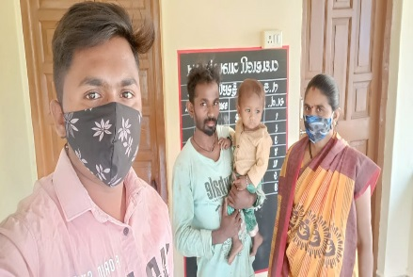
Case Details: On a visit to Kareli village on 7th December 2021 PHC Coordinator Varunbhai Tadvi met the village volunteers and other village leaders and they informed him about a child who was not registered with the Anganwadi worker (AWW). The same day the coordinator visited the home of the child and talked to the parents. They told him that they had not registered their child with the AWW because their home is very far from the Anganwadi centre. Varunbhai met with the Anganwadi worker and got the child registered at the centre. The child was given THR and was weighed and his height was also measured. The child was under Moderate Acute Malnutrition (MAM) category.
SAM child Success Story from Recovered CMAM Program
Enroll in CMAM Program child status:
Name of child in enrolled CMAM Program: Tadvi Mahirkumar Alkeshbhai
Village : Limkhetar Birth Date & Age: 08/04/2021 Sex: Male
PHCs: Jetpur Block:Garudeswar
CMAM Enrolled child status (enroll. 22/10/2021 |  | Progress  CMAM Discharge child status (discharge date.18/12/2021)
Weight: | 4.600 kg. | Weight (Kg) | 5.800
Height: | 62 Cm | Height: (Cm) | 63.4
Z score: | (-4 SD) | Z score: | (-2 sD)
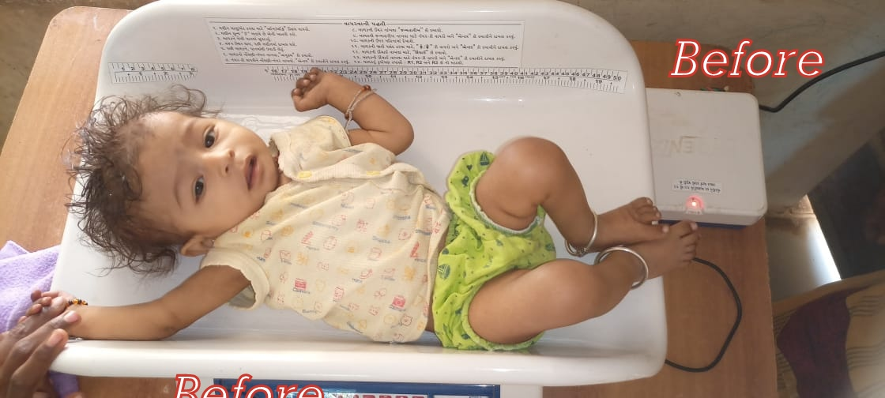 |  | 