Organisation(s): | Ministry of Environment, Forestry and Tourism (MEFT) and UNDP Namibia
Project Title: | Stockholm+50 National Consultations
Document Type: | Feedback Report For The Stockholm +50 Consultation: Private Sector, Academia and CSOs
Venue: | International University of Management (IUM)-Tunana Hall
Date: | 05 May 2022
Revision No: | 001




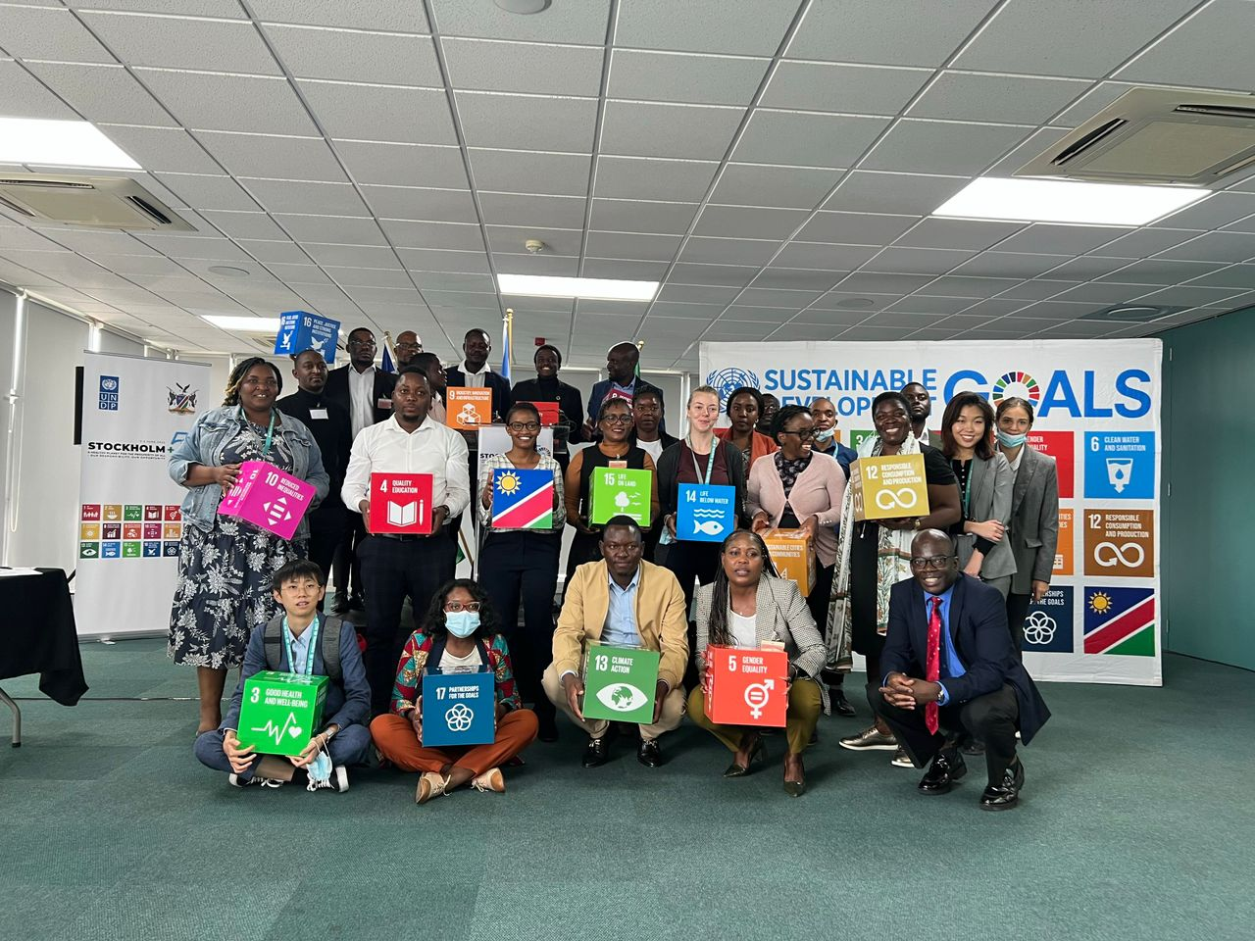

Table of Contents
1. Feedback Report For The Stockholm +50 Consultation: Private Sector, Academia and CSOs 1
1.1. Background 1
1.2. Objectives 1
2. Undertaking Of Launch and Consultative Workshop 2
2.1. Methodology 2
2.2. Meeting Proceedings 2
3. Plenary Discussion 3
3.1. Focus Group Discussions Feedback 4
3.2. Way Forward 8
3.3. Closing Remarks 8
4. Conclusion and Lessons learnt from the consultation 9

- Feedback Report for The Stockholm +50 Consultation: Private Sector, Academia and CSOs
  - Background
The Private Sector, Academia and CSOswere engaged as part of the Stockholm +50 National Consultations on the 5th of May 2022 in Namibia at the International University of Management: Centre for Environmental Studies. The consultation was the first???? of the six national consultations held in Namibia, the consultation report will feed into the national report that will be presented during global discussions to be held at the Stockholm +50 conference which will be held on the 2nd and 3rd of June 2022 in Stockholm Sweden. The Stockholm+50 conference will reinforce the commemoration of the fiftieth anniversary of the creation of the United Nations Environment Programme (UNEP) and address the themes: Reflecting on the urgent need for actions to achieve a healthy planet and prosperity of all; Achieving a sustainable and inclusive recovery from COVID-19 pandemic and; Accelerating the implementation of the environmental dimension of sustainable development in the context of the decade of action.
The stakeholders consisted of the private sector, academia and civic society organisations to ensure that no one is left behind in line with the theme of the Sustainable Development Goals (SDGs).
The purpose of this report is to outline the proceedings of the dedicated consultations with particular focus on the contributions made by the private sector, academia and CSOs. The report prioritises insights gained from participant focus group discussions (leadership dialogues) based on a set of identified questions cascaded by UNDP. In a addition, the report also gives an introspection to lived realities by the different stakeholders, highlighting proposed solutions to climate - related challenges being faced in different sectors of the economy.
The consultation process was inclusive, participatory, and accountable to address all issues raised. To achieve these, leadership dialogues were held, informed by participants to come up with recommendations. The dialogue topics focused on:
- Reflecting on the urgent need for actions to achieve a healthy planet and prosperity of all;
- Achieving a sustainable and inclusive recovery from the COVID-19 pandemic.
- Accelerating the implementation of the environmental dimension of Sustainable Development in the context of the Decade of Action
  - Objectives
The objectives of the national consultations were to stimulate an inclusive whole-of-society and whole-of-government dialogue on the main themes of Stockhom+50 as they relate to each national context. The consultations set to provide in-person and virtual platforms for ideas, insights, and innovation that:
- Build a shared global vision on how to achieve a healthy planet and prosperity for all while accelerating progress on the SDGs and Multilateral Environment Agreements (MEAs) through an inclusive green recovery;
- Offer clear recommendations for government, civil society and private sector on priority actions that can advance national and sectoral policies that address climate change and leverage nature-based solutions. This will build on and inform Nationally Determined Contributions (NDCs), National Biodiversity Strategies and Action Plans (NBSAPs), green economy/green recovery, and SDGs frameworks;
- Amplify the voices of the poor, youth, women, indigenous groups, local communities, and other marginalized groups; and
- Influence national and global debates that consider the views of all stakeholders.
- Undertaking Of Consultative Workshop
  - Methodology
The workshop made use of interactive, collaborative and participatory approaches based on online and in person consultations. It made use of question-and-answer feedback sessions with live streaming on social media handle of UNDP Namibia and MEFT using the zoom platform being broadcasted on the spark blue and YouTube. The workshop made use of presentations, focus group discussions and video interludes to enhance discussions among stakeholders for both the physical and virtual participants as all of them were given an equal chance to contribute. This approach was appropriate as it facilitated acquisition of authentic information of shared realities among participants hence an avenue of co-creation of solutions which will be reflected in overall Namibia consultations. The workshop was conducted in a gender responsive manner giving all individual chance to contribute.
  - Meeting Proceedings

VENUE: IUM: Centre for Environmental Studies

DATE: 05 May 2022

TIME: 02:00 PM (Meeting Agenda in Annex A)

FACILITATORS:
Tendai E. Kasinganeti – National Consultant
Vaino Shigwedha–MEFT
Alfeus Shekunyenge– MEFT
Frieda Lukas – UNDP Namibia

Attendees
Number of Attendees | Males | Females | Youths
31 | 12 | 19 | 15
Percentage | 38% | 62% | 66%

Having a diverse group of participants reflected above, provided diverse consultative insights and gender dimensions to the consultations (meeting attendance register is attached as Annex B).

Welcome and introductions
The meeting started with a national anthem which was sang by all participants. Mr Tendai E. Kasinganeti facilitated the round of introductions and gave a brief background of the Stockholm + Conference which was launched on the 25th of April 2022 at (put right venue) in Windhoek. He highlighted the importance of whole inclusive consultations which make use of disaggregated consultations by sectors so as to capture the various issues that need to be streamlined in a sector specific manner.

Remarks from MEFT
Mr. Alfeus Shekunyenge gave a brief introduction of the Stockholm Convention and how this resulted in the decision host the Stockholm+50 in Sweden. He indicated that stakeholders should take this consultative effort as an important exercise since it will act as a springboard to the realisation of the UNDP’s Decade of Action and to achieve the SDGs in Namibia. Stakeholders were reminded of the achievements by the Government of Namibia in addressing climate change, and he implored the stakeholders to comment and come up with recommendations that can further, improve and transform climate change interventions from all angles of the economy.

Remarks from International university of Management: Centre for Environmental Studies (IUM-CES)
Dr. Sioni Ikela from the International University of Management: Centre for Environmental Studies gave his opening remarks welcoming the stakeholders to the consultative meeting. He highlighted the importance of the Stockhol+50 Consultations and implored stakeholders to be collaborative in addressing climate change impacts, starting with putting heads together to come up with recommendations during the meeting’s focus group discussion session. Special thanks were given to UNDP for considering the newly established IUM Centre for Environmental Studies to host the event, and he pledged the availability of the academia at IUM, NUST, UNAM and other tertiary institutions to conduct collaborative research in the fight against climate change.

- Plenary Discussion

Table 1: Feedback from Leadership Dialogues
ITEM | DESCRIPTION | RESPONSIBLE PERSON
1 | Workshop-Focus Group Discussion  Tendai E. Kasinganeti the UNDP Stakeholder Engagement Consultant shared the objectives of the workshop which were to:  - Help Namibia build-up towards the Stockholm+50 conference which will happen in Sweden in June.  - Raise awareness in Namibia on the environment, biodiversity, ecosystems and climate change issues and allow for a plan of action to be developed.  - Identify and plan how to integrate solutions across climate, biodiversity, climate, green recovery and sustainable development goals related frameworks in Namibia and globally.  - Deliver forward-looking recommendations and commitments for Namibia to accelerate the achievement of SDGs in a green and inclusive manner.  - Explore how identified recommendations can be implemented through sound policies and programmes that are tailor-made to suit Namibia.  Three focus group clusters were identified and leadership dialogues 1,2,3 were discussed as follows:  - Leadership Dialogue 1: Reflecting on the urgent need for actions to achieve a healthy planet and prosperity of all.  - Leadership Dialogue 2: Achieving a sustainable and inclusive recovery from the coronavirus disease (COVID-19) pandemic.  - Leadership Dialogue 3: Accelerating the implementation of the environmental dimension of sustainable development in the context of the decade of action and delivery for sustainable development. | Mr. Tendai Kasinganeti

Figure 1: On-going plenary discussions

  - Focus Group Discussions Feedback
Leadership Dialogue 1: Reflecting on the urgent need for actions to achieve a healthy planet and prosperity of all;

Theme | Mitigation Measures
- How can we restore and regenerate a positive relationship with nature? List 2 or 3 good practices and pathways that you would like to see scaled up to enable a move to a healthy planet? | The group’s response was anchored on education and awareness to come up with a positive relationship with nature.  The group highlighted the need for awareness in the nation on restoration and regeneration. The following good practices were recommended;  - Education to prevent degradation  - Renewable energy sources as a way to minimise forest degradation  - Use of indigenous knowledge systems through grassroots consultations.
- What are the actions that you (your group) would take to scale up the change towards a healthy planet? What policies/structures need to be in place for you to take such action? | The group called for urgent review of all environmental-related legislations and align them such that they are all management under one ministry. This is because there is fragmentation of environmental laws and policies in Namibia, and a responsible organ of state specifically addressing environmental management should be formed. It should be a commission of an agency.  There is need for Local Environmental Action Groups to be formed, and these should be capacitated by UNDP and other organisations. There will also be need to ensure that there is enough expertise to coordinate the Local Environmental Action Groups.
- How could marginalised/vulnerable groups benefit from initiatives and policies designed to restore relationship with nature and mitigate nature risks? How could marginalised and vulnerable groups benefit from policies and initiatives designed to restore a more sustainable and resilient relationship with nature (that mitigates nature risks)? | Local consultations at grassroots levels were identified as the first step in addressing marginalised and vulnerable groups. The fact is that interventions/help should come from their suggestions, such that they are socially acceptable and beneficial to the communities.  Ensuring representation at all levels of planning and development, i.e., local authorities.  Streamlining vulnerable groups, gender and marginalised in all developmental projects should be made mandatory. This will allow for planning and development to address the needs of all Namibians regardless of societal status.
- How can we safeguard the rights of people and nature, including among others, indigenous peoples and local communities, environmental defenders, women, youth, future generations? | The opportunity to know the right of access ton climate and environmental information should be ensured, through awareness campaign. It is clear that MEFT is doing awareness campaigns, but the campaigns are not inclusive. In this regard, there is need to improve communication between UNDP/MEFT/Implementing agencies and stakeholders.
- What are the new or prioritized set of metrics and indicators needed for tracking our progress towards a healthier and more prosperous planet? | - Monitoring and evaluation were identified as a key tool to be implemented to ensure that indicators of successful implementation are considered.  - UNDP should be bold to call action/reforms if projects not being implemented according to its objectives, because there is cutting corners being done. And this affects the delivery of the projects/programmes to the intended beneficiaries.
Leadership Dialogue 2: Achieving a sustainable and inclusive recovery from the coronavirus disease (COVID-19) pandemic:

Theme | Mitigation Measures
- What are the most promising sustainable and inclusive recovery practices currently being applied by public, private and civil society groups at individual, community, city, regional, country level? And how could we scale them up? | The group identified the Conservation Relief, Recovery and Resilient Facility launched by MEFT in response to the threat of Covid-19.  The group also commended the COVID-19 Socio-Economic Impact Assessment on Tourism in Namibia and requested that the document should be taken with serious regard.  There is a need to ensure that nature-based economic activities should be identified and there will be precision of targeted interventions rather than more costly catch all policies.  Increase the geographical distribution of investments from large international organisations including the UNDP and the Environmental Investment Fund in communities through agriculture, conservancies and forest produce value addition. This can help to bolder resilience to the impacts of COVID-19 pandemic.
- What recovery and pre-existing practises need to be changed to ensure an inclusive and sustainable recovery? | Short-term interventions should be done away with, e.g. the N$750.00 and food packages. The government and UNDP should focus on self-help projects for communities. This will mean that they will not continue to rely on the government in the event of another pandemic. In addition, local economic growth can be realised.  The Social Security interventions relieving businesses should also tap into climate finance since some businesses can help to promote adaptation and resilience to climate change.
- How do we ensure that all countries/communities can benefit from opportunities stemming from a sustainable and just transition? | The government should be capacitated in form of financial and technical resources to conduct consultations. In this respect, any form of recommendation for development will be rooted in the communities and there will be a sense of ownership.
- How can we create better performing industries and supply chains for a just transition to more sustainable economies? which sectors are most critical? | Three sectors were identified for prioritisation as follows;  - Agriculture,  - Tourism,  - Energy
- What are some of the commitments and “responsible” principles that need to be made by key industry sectors and by finance and investment institutions? | - There is need to allow applied learning, so that experts can gain experience.  - Industries and businesses should all shift toward sustainability-oriented governance, in this respect Environmental and Social Governance should be adopted at Policy level by the government.  - All financial institutions should have environmental sustainability advisory in form of employees or consultants.
- What are the decent green jobs of the future? What are the new skills needed, what is needed from business? from government? from academia? | - The group identified that Namibia should put, Science, Technology, Engineering, and Mathematics (STEM) at the core of its educational programmes.  - Industries should be mandated to train students, and subsidies should be provided by the government, because mentorship programmes are also expensive.

Leadership Dialogue 3: Accelerating the implementation of the environmental dimension of sustainable development in the context of the decade of action and delivery for sustainable development:

Theme | Mitigation Measures
- What are the biggest challenges we are facing in implementing the commitments to the 2030 Agenda and other environmental commitments (MEAs)?  How do we create an enabling environment for delivery on the ground? | Challenges that were identified by the group were as follows:  - There is a lack of capacity building and knowledge dissemination in the environment dimension.  - Climate change: is resulting in extreme events such as drought and these hamper the realisation of the MEAs goals and targets.  - Population growth: human population is growing at a fast rate and putting pressure on the environment as resources are being exploited and utilized.  - The group highlighted that Namibia is struggling in terms of up-to-date data for planning and development.  The proposed measures recommended by the group gave an indication of some of the interventions that can be adopted to create an enabling environment;  - Improve environmental management institutional arrangements and synergy through creating one roofed ministry for the management of water, forests, environment.  - Create an environmental data centralize data hub  - Capacity building to produce experts that understand the environment and have awareness campaigns  - Avail funds: promote Public-Private Partnership  - Environmental levies should be used for the purpose of addressing environmental impacts of businesses.  - The User Pays Principle should be applied, and resources should be quantified so that monetary value can be attached to them.
- What are the good practices and pathways that you would like to see scaled up to accelerate the implementation of the environmental dimension of Sustainable Development in the context, of the Decade of Action? | - Stakeholder’s involvement/mapping  - Decentralization & awareness campaigns should be rolled out by UNDP and its implementing institutions.  - A guideline manual/ handbook should be developed, highlighting sector-specific good practices.  - The GRN needs to maintain good relationship with development partners.  - Design a curriculum on environment and sustainability for implementation at traditional schools.
- How to transform governance and legal systems that maintain long-term economic stability and ecological and social wellbeing for all? | - There should be more inclusive stakeholders’ consultation when formulating laws and making decisions  - There is need to coordinate and harmonise existing institutions and laws.
- What measures are needed to align public, private and development finance with existing commitments and priorities? | - Climate Budget Tagging for Namibia should be implemented and stakeholders should be sensitised on this.  - Transparency and accountability should be promoted, and this will be achieved through monitoring and evaluation.
- What type of partnerships from the UN and beyond are needed to accelerate a green and sustainable economic transformation that leaves no one behind? | - Genuine open card playground for all community organisations should be availed.  - Flagship programmes should be implemented by UNDP, before transfer of financial support or projects, pilot projects should be done to ensure that the model is replicable and sustainable.
- What capacities and technologies are needed to improve human wellbeing in harmony with nature? | - Awareness Collaborative research and innovation should be promoted.  - A joint environmental and climate research programme implemented by IUM, NUST and UNAM is recommended. This can promote collaborative research and minimise competition for research finance by institutions.

  - Way Forward
The consultations will be ongoing with an online platform for participants to share their concerns and views have the inclusion of all stakeholders. The regional consultations will be ongoing and incorporating more views from the stakeholders
  - Closing Remarks
Mr, Vaino Shigweda from MEFT gave thanks to the participants for giving their sector-related contributions to the discussions. The different organisations in attendance were recommended to continue working together even after the consultative workshop because this was a clear example of how a multi-sectoral action approach against climate change can be adopted and implemented.

- Conclusion and Lessons learnt from the consultation

Discussions between the academia, private sector and CSOs allowed for the identification of key lessons learnt from the consultation. Key issues emanating from the session consisted of the following:
- The progress on sustainability in Namibia was observed to be anchored on education and awareness to come up with a positive relationship with nature.
- The need for awareness on restoration and regeneration was also identified as crucial to help communities with climate action.
- There is a fragmentation of environmental laws and policies in Namibia, and a responsible organ of state specifically addressing environmental management should be formed. It should be a commission or an agency.
- There is a need to ensure that nature-based economic activities should be identified and there will be the precision of targeted interventions rather than more costly catch-all policies.
- Industries and businesses should all shift toward sustainability-oriented governance, in this respect Environmental and Social Governance should be adopted at Policy level by the government.
- A guideline manual/ handbook should be developed, highlighting sector-specific good practices.
- A joint environmental and climate research program implemented by IUM, NUST and UNAM is recommended. This can promote collaborative research and minimise competition for research finance by institutions.

