Organisation(s): | Ministry of Environment, Forestry and Tourism (MEFT) and UNDP Namibia
Project Title: | Stockholm+50 National Consultations
Document Type: | Feedback Report for The Stockholm +50 Consultation: Persons with Disabilities
Venue: | Disability Resource Centre
Date: | 06 May 2022
Revision No: | 001
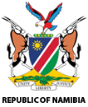

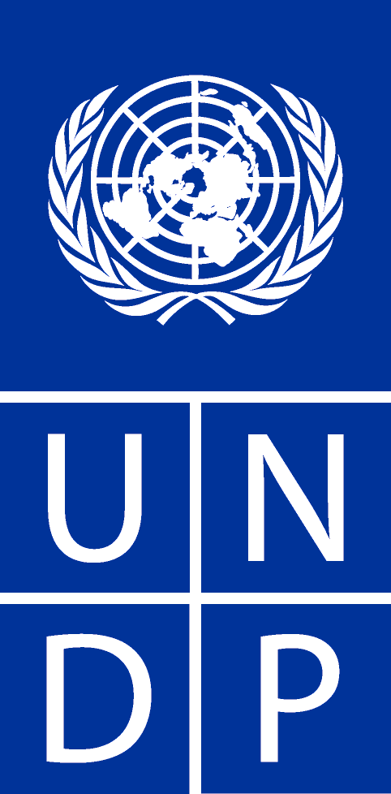

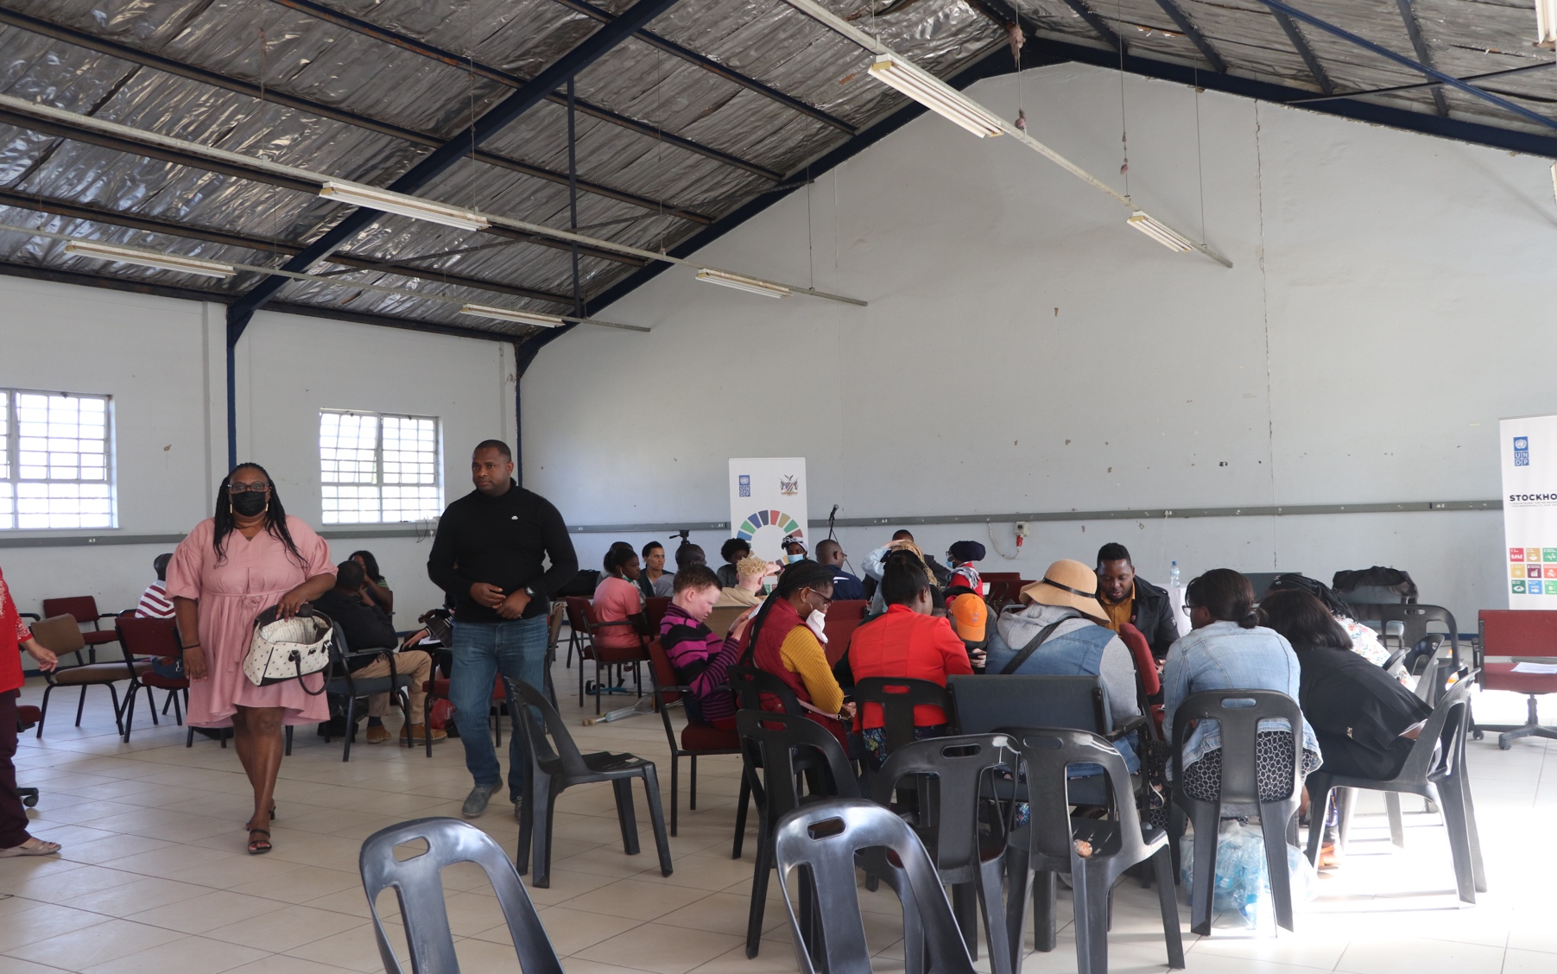

Table of Contents
1. Feedback Report for The Stockholm +50 Consultation: Persons with Disabilities 1
1.1. Background 1
1.2. Objectives 1
2. Undertaking Of Consultative Workshop 2
2.1. Methodology 2
2.2. Meeting Proceedings 2
3. Plenary Discussion 3
3.1. Focus Group Discussions Feedback 4
3.2. Way Forward 8
3.3. Closing Remarks 8
4. Conclusion and Lessons learnt from the consultation 8

- Feedback Report for The Stockholm +50 Consultation: Persons with Disabilities
  - Background
Persons with disabilities were engaged as part of the Stockholm +50 National Consultations on the 6th of May 2022 in Namibia at the Okuryangava Disability Resource Centre. The consultation was the third of the six national consultations held in Namibia, the consultation report will feed into the global discussions to be held at the Stockholm +50 conference which will be held on the 2nd and 3rd of June 2022 in Stockholm Sweden. The Stockholm+50 conference will reinforce the commemoration of the fiftieth anniversary of the creation of the United Nations Environment Programme (UNEP) and address the themes: Reflecting on the urgent need for actions to achieve a healthy planet and prosperity for all; Achieving a sustainable and inclusive recovery from COVID-19 pandemic and; Accelerating the implementation of the environmental dimension of sustainable development in the context of the decade of action.
The stakeholders consisted of different stakeholders representing persons with disability and this ensured that input from this group will be streamlined into the country-derived recommendations to achieve SDGs while ensuring that no one is left behind.
The purpose of this report is to outline the proceedings of the consultation with persons with disabilities. The report prioritises insights gained from participant focus group discussions (leadership dialogues) based on a set of identified questions. In addition, the report also gives an introspection to lived realities by the different stakeholders, highlighting proposed solutions to climate-related challenges being faced in different sectors of the economy.
The consultation process was inclusive, participatory, and accountable to address all issues raised. To achieve these, leadership dialogue was held, informed by member state findings to come up with recommendations. The dialogue topics will be focused on:
- Reflecting on the urgent need for actions to achieve a healthy planet and prosperity of all;
- Achieving a sustainable and inclusive recovery from the COVID-19 pandemic.
- Accelerating the implementation of the environmental dimension of Sustainable Development in the context of the Decade of Action
  - Objectives
The objectives of the consultation was to stimulate an inclusive whole-of-society and whole-of-government dialogue on the main themes of Stockhom+50 as they relate to the Namibian context. The consultations set to provide in-person and virtual platforms for ideas, insights, and innovation that:
- Build a shared global vision on how to achieve a healthy planet and prosperity for all while accelerating progress on the SDGs and Multilateral Environment Agreements (MEAs) through an inclusive green recovery;
- Offer clear recommendations for government, civil society and private sector on priority actions that can advance national and sectoral policies that address climate change and leverage nature-based solutions. This will build on and inform Nationally Determined Contributions (NDCs), National Biodiversity Strategies and Action Plans (NBSAPs), green economy/green recovery, and SDGs frameworks;
- Amplify the voices of the poor, youth, women, indigenous groups, local communities, and other marginalized groups; and
- Influence national and global debates that consider the views of all stakeholders.
- Undertaking Of Consultative Workshop
  - Methodology
The workshop made use of interactive, collaborative and participatory approaches based on online and in person consultations. It made use of question-and-answer feedback sessions with live streaming on the social media handle of UNDP Namibia and MEFT using the zoom platform being broadcasted on Facebook and YouTube. The workshop made use of presentations, focus group discussions and video interludes to enhance discussions among stakeholders for both the physical and virtual participants as all of them were given an equal chance to contribute. This approach was appropriate as it facilitated the acquisition of authentic information of shared realities among participants hence an avenue of co-creation of solutions which will be reflected in overall Namibia consultations. The workshop was conducted in a gender-responsive manner giving all individuals chance to contribute.
  - Meeting Proceedings

VENUE: Okuryangava Disability Resource Centre

DATE: 06 May 2022

TIME: 02:00 PM (Meeting Agenda in Annex A)

FACILITATORS:
Tendai E. Kasinganeti – National Consultant
Vaino Shigwedha–MEFT
Alfeus Shekunyenge– MEFT
Frieda Lukas – UNDP Namibia

Attendees
Number of Attendees | Males | Females | Youths
30 | 10 | 20 | 18
Percentage | 34% | 66% | 60%

Having a diverse group of participants reflected above, provided diverse consultative insights and gender dimensions to the consultations (meeting attendance register is attached as Annex B).
Welcome and introductions
The meeting started with a national anthem which was sung by all participants. Mr Tendai E. Kasinganeti facilitated the round of introductions and gave a brief background of the Stockholm + Conference which was launched on the 25th of April 2022 at UN House in Windhoek. He highlighted the importance of whole inclusive consultations which make use of disaggregated consultations by sectors so as to capture the various issues that need to be streamlined in a sector-specific manner.

Remarks from MEFT
Mr. Alfeus Shekunyenge gave a brief introduction of the Stockholm Convention and how this resulted in the decision host the stockholm+50 in Sweden. He indicated that stakeholders should take this consultative effort as an important exercise since it will act as a springboard to the realisation of the UNDP’s Decade of Action and to achieve the SDGs in Namibia. Stakeholders were reminded of the achievements by the Government of Namibia in addressing climate change, and he implored the stakeholders to comment and come up with recommendations that can further, improve and transform climate change interventions from all angles of the economy.

- Plenary Discussion

Table 1: Feedback from Leadership Dialogues
ITEM | DESCRIPTION | RESPONSIBLE PERSON
1 | Workshop-Focus Group Discussion  Tendai E. Kasinganeti the UNDP Stakeholder Engagement Consultant shared the objectives of the workshop which were to:  - Help Namibia build-up towards the Stockholm+50 conference which will happen in Sweden in June.  - Raise awareness in Namibia on the environment, biodiversity, ecosystems and climate change issues and allow for a plan of action to be developed.  - Identify and plan how to integrate solutions across climate, biodiversity, climate, green recovery and sustainable development goals related frameworks in Namibia and globally.  - Deliver forward-looking recommendations and commitments for Namibia to accelerate the achievement of SDGs in a green and inclusive manner.  - Explore how identified recommendations can be implemented through sound policies and programmes that are tailor-made to suit Namibia.  Three focus group clusters were identified and leadership dialogues 1,2,3 were discussed as follows:  - Leadership Dialogue 1: Reflecting on the urgent need for actions to achieve a healthy planet and prosperity of all.  - Leadership Dialogue 2: Achieving a sustainable and inclusive recovery from the coronavirus disease (COVID-19) pandemic.  - Leadership Dialogue 3: Accelerating the implementation of the environmental dimension of sustainable development in the context of the decade of action and delivery for sustainable development. | Mr. Tendai E. Kasinganeti

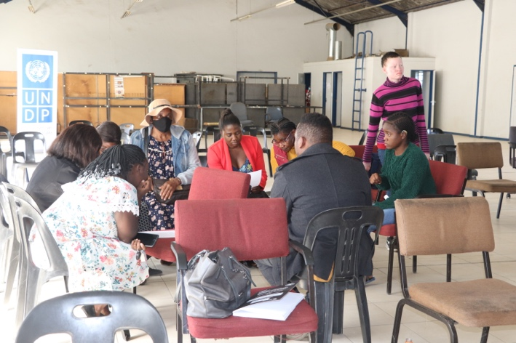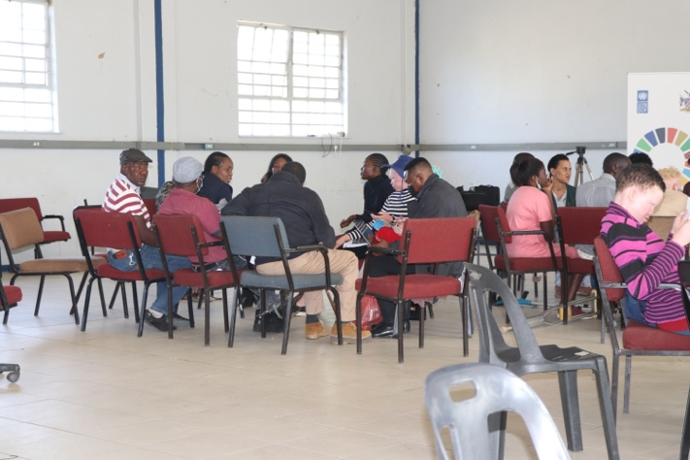
Figure 1: On-going focus group discussions on the leadership dialogue topics

  - Focus Group Discussions Feedback
Leadership Dialogue 1: Reflecting on the urgent need for actions to achieve a healthy planet and prosperity of all;

Theme | Mitigation Measures
- How can we restore and regenerate a positive relationship with nature? List 2 or 3 good practices and pathways that you would like to see scaled up to enable a move to a healthy planet? | Tree planting and renewable energy such as solar and green hydrogen were identified as key aspects that are key to restoration and regeneration of the climate.  Selective harvesting, as a system for implementation in the Kavango and Zambezi regions was suggested. This is because communal lands will continue to need wood, however sustainable practices should be adopted,
- What are the actions that you (your group) would take to scale up the change towards a healthy planet? What policies/structures need to be in place for you to take such action? | The UNDP, MEFT and other NGOs were advised to promote the adoption of renewable energy as a starting point.  The implementation of the Polluter Pays principle should be enforced and stringent fines should be gazetted.  The group identified that communal areas’ carrying capacity is always exceeded due to overgrazing. There is a need to enforce livestock population control programs by promoting agribusiness in all regions of the country. Instead of keeping a large herd, communal farmers should be trained on commercializing their stock.
- Local authorities | There is a need to Increase the benefits natural resources use and beneficiation for communities through community gardens, and factories to process raw materials and create local employment.
- How can we safeguard the rights of people and nature, including among others, indigenous peoples and local communities, environmental defenders, women, youth, future generations? | There is need for the government to adopt a consultative approach when formulating policies to ensure that community rights are protected, and projects being implemented are socially acceptable.
- What are the new or prioritized set of metrics and indicators needed for tracking our progress towards a healthier and more prosperous planet? | The group highlighted that communities in both urban and rural setting are not aware of environmental laws in the country. They recommended that there is a need to scale up awareness and enforcement of the Forest Act and Environment Management Act.
Leadership Dialogue 2: Achieving a sustainable and inclusive recovery from the coronavirus disease (COVID-19) pandemic:

Theme | Mitigation Measures
- What are the most promising sustainable and inclusive recovery practices currently being applied by public, private and civil society groups at individual, community, city, regional, country level? And how could we scale them up? | currently, there are no sustainable programmes that are being implemented, because there is no inclusivity in programmes being implemented.  Persons with disability cannot access finance to self-help projects.
- What recovery and pre-existing practises need to be changed to ensure an inclusive and sustainable recovery? | The group identified the need to develop a universal health care plan for everyone. The health plan should help everyone regardless of being employed, status in society or disability status.  There is a need to strengthen the agricultural system for food security. This is because during the COVID-19 pandemic, the biggest challenge was access to food resources. Because of this, namibia needs to strengthen our local agricultural sector.  The group noted that there is room for improvement on the current health system in Namibia. This this was reflected by the use of temporary health facilities to accommodate patients. There is need for new hospitals, clinics and health research centres.
- How do we ensure that all countries/communities can benefit from opportunities stemming from a sustainable and just transition? | There is a need for Namibia to adopt good practices in terms of adopting sustainable projects implementation for communities. In this respect, international organisations such as UNDP should promote knowledge sharing between Namibia and other countries who have implemented success projects.
- How can we create better performing industries and supply chains for a just transition to more sustainable economies? which sectors are most critical? | The group highlighted that there is a need for Namibia to strengthen value addition in agriculture, because demand and supply is dynamic and there will be surplus and competition from other countries.  Critical sectors of the economy identified are as follows:  - Agriculture  - Health  - Water supply and Sanitation
- What are some of the commitments and “responsible” principles that need to be made by key industry sectors and by finance and investment institutions? | UNDP was requested to help the government with advisory and support to the Government of Namibia to come up with conducive policies and environment for foreign direct investments. The economy of Namibia requires strengthening through investment in different sectors of the economy.  There is a need for the government to look at policies that protects and cushion employees in the event that another pandemic is experienced again.
- What are the decent green jobs of the future? What are the new skills needed, what is needed from business? from government? from academia? | Agriculture: There is need for the promotion of agricultural skills in namibia for livestock, vegetables, grains and agricultural produce processing.  Energy: Green hydrogen is becoming a reality in namibia, and the academia should be take opportunity to generate the much needed skills in the renewable energy sector.

Leadership Dialogue 3: Accelerating the implementation of the environmental dimension of sustainable development in the context of the decade of action and delivery for sustainable development:

Theme | Mitigation Measures
- What are the biggest challenges we are facing in implementing the commitments to the 2030 Agenda and other environmental commitments (MEAs)?  How do we create an enabling environment for delivery on the ground? | There is a lack of communication between the government and its stakeholders when implementing projects.  There is insufficient commitment from the stakeholders to coordinate activities that relate to achieving MEA in Namibia.  To create an enabling environment, there is a need to engage the grassroots communities to ensure that policies are tailor-made to fit the people’s needs.
- What are the good practices and pathways that you would like to see scaled up to accelerate the implementation of the environmental dimension of Sustainable Development in the context, of the Decade of Action? | The group identified there should be free education for all because most people are struggling with student debt, even if they are not employed.  Social grants for the unemployed, disabled and incapacitated should be implemented. The social grants can be in form of self-help projects in agriculture, carpentry, building, mining and fisheries.  Informal settlements were identified to be contributing to land and water pollution due to the unregulated sanitation practices in these areas. Because of this situation, there is an urgent need for health and sanitation intervention in informal settlements. If this is not addressed, there will be the potential to contaminate the environment resulting in irreversible negative impacts.
- How to transform governance and legal systems that maintain long-term economic stability and ecological and social wellbeing for all? | There are laws and policies that address sustainability in Namibia, however, these are not communicated to all stakeholders. The group recommended that there should be training and awareness on environmental laws and policies in Namibia.
- What measures are needed to align public, private and development finance with existing commitments and priorities? | Corruption was identified as a major hindrance to the success of most projects implemented by MEFT and EIF. In this respect, there is an urgent need for corruption-proof systems to be implemented.  The need for accountability at all levels was emphasized. This will ensure that despite government, political, religious or social status, everyone is brought to book when they commit corruption.
- What type of partnerships from the UN and beyond are needed to accelerate a green and sustainable economic transformation that leaves no one behind? | UNDP was commended on the current projects they are implementing in Namibia. The group pointed out that the partnerships should continue through financing, capacity building and advisory.
- What capacities and technologies are needed to improve human wellbeing in harmony with nature? | Human well-being is threatened by pollution and degradation from anthropogenic activities such as mining, agriculture and manufacturing industries. Namibia needs to come up with policies that monitors effluent and air pollution from different operations. The polluter pays principle should be applied according to the level, extent and toxicity of pollution.

  - Way Forward
The consultations will be ongoing with an online platform for participants to share their concerns and views have the inclusion of all stakeholders. The regional consultations will be ongoing and incorporating more views from the stakeholders
  - Closing Remarks
Mr, Vaino Shigweda from MEFT gave thanks to the participants for giving their sector-related contributions to the discussions. The different organisations in attendance were recommended to continue working together even after the consultative workshop because this was a clear example of how a multi-sectoral action approach against climate change can be adopted and implemented.

- Conclusion and Lessons learnt from the consultation

Feedback from the focus group discussions with persons with disability allowed for the identification of key inputs to include into the national synthesis report. Key issues emanating from the session consisted of the following:
- Tree planting and renewable energy such as solar and green hydrogen were identified as key aspects that are key to the restoration and regeneration of the climate.
- There is a need to enforce livestock population control programs by promoting agribusiness in all regions of the country.
- Currently, there are no sustainable programmes that are being implemented because there is no inclusivity in programmes being implemented. Persons with disability are being left out in consultations and provisions for self-help projects.
- The group identified the need to develop a universal health care plan for everyone.
- There is a need to strengthen the agricultural system for food security.
- Green hydrogen is becoming a reality in Namibia, and academia should take the opportunity to generate the much-needed skills in the renewable energy sector.
- The urgent need for health and sanitation intervention in informal settlements was identified and action is needed at local, regional and national levels.
- Namibia needs to come up with policies that monitors effluent and air pollution from different operations. The polluter pays principle should be applied according to the level, extent and toxicity of pollution.

