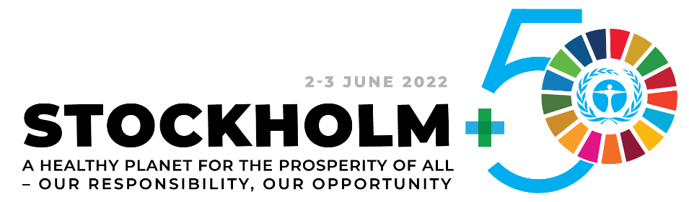

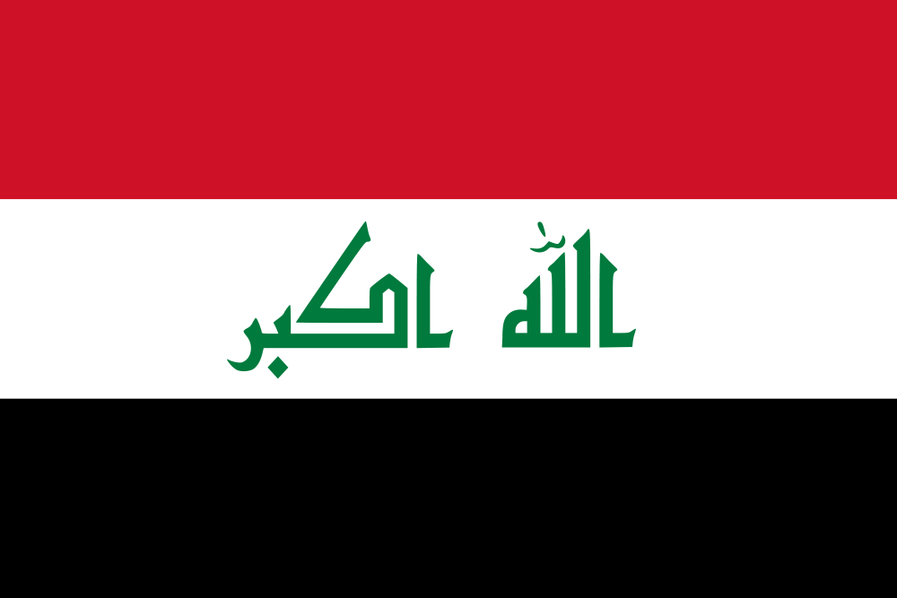

Report on the Stockholm+50 National Consultation
In IRAQ

Draft

Submitted on: 26th May, 2022

Table of Contents

1. National Consultation at a Glance 3
2. Consultation Process including Gender Responsiveness and Inclusivity 6
3. Main Consultation Inputs, Insights and Innovations 9
An overview of the main themes, challenges, opportunities, solutions and recommendations 9
Leadership Dialogue 1. Reflecting on the urgent need for actions to achieve a healthy planet and prosperity of all 11
Leadership Dialogue 2. Achieving a sustainable and inclusive recovery from the coronavirus disease (COVID-19) pandemic 15
Leadership Dialogue 3. Accelerating the implementation of the environmental dimension of sustainable development in the context of the decade of action and delivery for sustainable development 19
Country-specific agenda of the national consultation 25
Highlights from the on-line SparkBlue Consultations 30
4. Consultation Follow-up, Next Steps and Links to National Policies 31
5. Annexes 34

Stockholm +50 National Consultation Report Template
This template is intended to guide National Coordinators to prepare with government and other partners a high-quality Stockholm +50 National Consultation Report.
It contains four main sections and Annexes that standardize the content and quality of the reports across all countries, including the process, recommendations, and next steps.
Instructions:
- Please prepare the report in English
- Consider all types of engagements (in-person meetings, online discussions, etc.) used to produce inputs for the consultation in your responses.
- A first version of the report should be sent within two weeks after the national consultation and no later than 15 May 2022. The final report, with all comments from the reviewers addressed, is expected by 31 May 2022. The final report should then be disseminated widely with all national stakeholders. It will be posted on the SparkBlue website and it will be used to inform a global synthesis report of all the national consultations.
In case of questions, please contact Natalia Olofinskaya (nataly.olofinskaya@undp.org).

National Consultation at a Glance
Please enter the basic information about the consultation.
In-person or hybrid national consultation
Consultation dates (list the dates of all individual events if more than one event was conducted) | 08th May, 2022 - ERBIL  09th May, 2022 - BAGHDAD  12th May 2022 – BASRA
Lead national partner(s) / focal point(s): title and institution | Ministry of Environment
Type(s) of consultation (in-person, virtual, hybrid) | Hybrid
Geographic focus (national, provincial, local) | National and regional (northern and southern Iraq)
Total number of hours in live sessions (provide one cumulative number in case of several events) | 15 hours (excluding tea and lunch breaks)
Live streaming (Yes/No) | No
Link to the recording(s)

Total number of participants | 109

Number of participants by age range
0-18 | None | 19-30 | 10 | 31-50 | 90 | 51-65 | 6 | 66-80 | 4 | 80+ | None

Number of participants by gender
Male | 79 | Female | 30 | Other/prefer not to say

Number of participants from each stakeholder group
Government – National | 5 | Science, Academia | 7
Government - Local | 46 | Foundation, philanthropy | 3
United Nations | 8 | Women and Women Groups | 7
International Financial Institution | 0 | Youth | 5
Bilateral / Foreign Governments | 2 | Local Community
NGO – International |  | Faith-based groups
NGO / CSO – national | 16 | Indigenous Peoples
Private sector (large) | 1 | People with disabilities | 1
Small and Medium Business |  | Other
Consumer Group | 6

Number of participants from each sector
Agriculture & Food | 5 | Forestry | 4 | Media
Cities | 7 | Government | 51 | Tourism
Education | 5 | Green energy | 4 | Traditional Energy
Environment | 45 | ICT |  | Trade & Commerce
Extractives | 3 | Industry | 1 | Transport
Finance & Investment |  | Infrastructure |  | Utilities
Fisheries & Aquaculture | 10 | Health | 5 | Other

Government participation
Office of President / Prime Minister | - | Ministry of Planning / Economy / Finance | -
Parliament | - | Ministry of Environ-t / Nature Resources | Yes
Cabinet of Ministers | - | Ministry of Energy | Yes
Ministry of Foreign Affairs | - | Ministry of Agriculture & Food | Yes
Local Governments | Yes | Line Ministries (Health) | Yes

SparkBlue On-line Consultations
Launch date | -
Consultation length (total number of weeks) | -
Total number of participants | -
Number of thematic discussions supported | -
Total number of comments in the online discussion | -
Link to consultation page | -

Consultation Process including Gender Responsiveness and Inclusivity
Please provide a description of the consultation process and timeline that reflects the whole-of-society and whole-of-government approach used including:
- What preparatory meetings were organized over what time period and when was the main consultation; were they in-person, virtual or a combination, where did they take place?
- Who were the main national and international stakeholders and speakers invited and what sectors/themes/institutions were represented?
- What other national and sector policy consultation processes were involved or referenced including NDCs, NBSAPs, INFFs, SDG Strategies, Green/Blue Economy and Green Recovery Plans, etc.?
- How was the consultation promoted in advance, during and afterward through communications and media?

Please summarize how various stakeholder groups that are not traditionally involved in these processes and may be under vulnerable conditions or marginalized, including women, youth, indigenous peoples, local communities, people with disabilities, and others, were engaged in and contributed to the consultation.

Planning for S+50 consultations started in March 2022. Numerous preparatory meetings were conducted between March and May. These included the following:

    - UNDP Iraq internal meetings: At least five internal meetings were held to discuss the concept of Stockholm+50 consultations and plan for it. Stakeholders were identified and staff allocated for different functions; coordinator, facilitators, communications, monitoring, logistics. Consultation guidelines were reviewed together.

    - UNDP Regional Hub and UNDP HQ focal point: At least three meetings were held with the UNDP global and regional focal points to clarify different aspects; i.e. concept, themes, questions, communications.

    - Meeting with Government: Meetings were held with the Ministry of Environment to discuss the plan for consultations and its implementation. Ministry took the lead in inviting the stakeholders in line with global guidelines ensuring a whole of government and whole of society approach.
    - Meeting with UNEP: Meeting with the UNEP was held to discuss UNEP’s support. UNEP agreed to participate and provide facilitators as well as do presentation on Stockholm +50 concept.

    - Meeting with Sweden: Swedish embassy was briefed about the consultations plan and invited to participate. The embassy agreed to participate. The Charge De Affairs of Swedish Embassy participated in all three consultations and presented on behalf of Sweden.
    - UN PWG#4: The PWG# 4 is a group of UN agencies focusing on environment, energy and climate change work. Members include UNDP, UNICEF, FAO, WFP, IOM and UNEP. The group was briefed about the Stockholm+50 consultations and invited them to join.

Key stakeholders included the federal government ministries, provincial departments, regional government, academia, NGOs, human rights organizations, women and youth NGOs, child rights NGOs, engineering association, private sector, biodiversity specialists, UN and the government of Sweden.

Inputs from numerous other consultative processes were fed into the Stockholm+50 consultations. These included the NDC related consultations to discuss the legal, finance and sub-nationalization aspects of NDC (March 2022), the water diplomacy training in Erbil (30th March – 1st April) and the water dialogue with stakeholders in Southern Iraq (11th May). Most federal ministries and sub-national departments participated in these workshops. The water dialogue in Basra was attended by a wide range of stakeholders including government, civil society, NGOs, academia, private sector, and UN. The consultations discussed climate change, water security, food security and biodiversity, the challenges involved, the current status of progress and the way forward.

Stockholm +50 consultations were covered and documented by UNDP communications team. Information about the consultations was posted on UNDP’s social media platforms (Twitter, Facebook, LinkedIn).
What efforts were made to invite, engage, and ensure effective participation of various marginalized stakeholder groups in the national consultation process (i.e., meetings/settings, materials in local languages, accommodation for people with disabilities, childcare, safe and affordable transportation, connectivity, targeted communications, etc.).
A region wise list of stakeholders from government and other sections of society was prepared to be invited to the consultations. Based on discussions with the Ministry of Environment regarding the need to keep the size of consultation events manageable and ensure effective group work, a short-listed was finalized. Numerous marginalized and vulnerable groups were invited to participate in the consultations, which included different women organizations, youth groups, child rights organizations and farmers associations. All invited organizations participated in the consultations in person and shared their inputs.

Main Consultation Inputs, Insights and Innovations
This is the core of the report, which summarizes the main takeaways of the consultation.

An overview of the main themes, challenges, opportunities, solutions and recommendations
This is a summary of Section 3. Please respond to this question after addressing the other questions under this section.

Key themes and sectors discussed
In addition to the leadership dialogues, key themes in Iraq consultations were water and food security, agriculture, biodiversity, energy, waste management and pollution control in terms of thematic issues. In terms of governance, the discussions related to implementation of laws, funding, private sector participation, coordination among stakeholders, learning about best practices and awareness raising. In terms of social groups, the discussion addressed concerns on women and youth engagement, displaced people recovery, and the need for basic services for marginalized and poor.

Challenges discussed
Key socio-economic challenges for Iraq included; population growth, urbanization, climate change, and civil wars. Key governance challenges were; low awareness, weak implementation of environmental laws, lack of public funds for environmental projects, weak institutional and technical capacities, weak monitoring and information management capacities and poor coordination and policy making mechanisms on environment and sustainable development. Sectoral challenges were also listed regarding weak governance of water, agriculture and urban waste management.

Opportunities discussed
The key opportunities included; i) approval of Iraq’s Nationally Determined Contributions (NDC) as the supreme national policy on climate change, ii) possibility of accessing global climate funds, iii) availability of business models for transition to renewable energy, iv) effectiveness of social media in public awareness raising and v) growing public awareness about environmental risks due to the negative impact of water scarcity, increasing incidence of carcinogenic disease.

Solutions discussed
Increase national funding for environment, access to global green funds for private sector and NGOs, strengthen coordination on environmental management, implement laws, enforce incentives and penalties, engage private sector in environmental projects, engage NGOs and civil society for awareness raising and education, support scientific research on solutions and integrate findings in development projects.

Recommendations suggested - please formulate 5 sharp, concrete and bold recommendations
- Increase financing for environment from national budget, global sources and by encouraging private sector
- Strengthen multidisciplinary coordination by creating multi-sectoral and multi-level coordination forums
- Ensure policy implementation by providing incentives & imposing penalties. Develop institutional capacity for effective implementation, info management & monitoring.
- Support scientific research and innovation to identify practical solutions. Learn from best practices.
- Enhance social protection for the marginalized by subsidizing basic services & empowerment

Summary of the discussions under each Stockholm+50 Leadership Dialogue theme and their guiding questions.

Leadership Dialogue 1. Reflecting on the urgent need for actions to achieve a healthy planet and prosperity of all

- How can we restore and regenerate a positive relationship with nature? List 2 or 3 good practices and pathways that your partners would like to see scaled up to enable a move to a healthy planet?

It was observed that Iraq is facing major challenges with regards to water and food security, sustainable agriculture, biodiversity, pollution control and waste management. Furthermore, Iraq is also prone to civil conflicts and wars which have contributed to environmental degradation in Iraq.
The consultations identified two types of recommendations; i) generic areas of improvement in the public sector and at societal levels, ii) sector specific actions needed by different stakeholders to achieve a healthy planet.
The generic recommendations highlighted the i) the need for improving governance in the country, ii) ensuring implementation of environmental protection laws, iii) data-collection to establish a baseline and reference point for interventions, iv) countrywide awareness raising campaign among all sectors and especially the youth in order to educate them about risks and the need for environmental conservation, and v) application of sustainable development guidelines and standards in development projects.
The sector specific recommendations suggested: i) improved management of water resources including water conservation, ii) introducing modern agricultural methods and irrigation technologies, land reclamation and planting heat and salt-tolerant seeds to reduce the impact of climate change iii) waste recycling and awareness raising about it, iv) and strengthening transboundary cooperation on water resources management with upper riparian countries.
It was also advised that the government shall provide support to NGOs and volunteer groups for green initiatives; i.e. to create and protect green belts/forests, promote environmentally friendly agricultural practices and renewable energy.

- What are the actions that your country/partners would take to scale up the change towards a healthy planet? What policies/structures need to be in place for you to take such action?
The consultations suggested following priorities for the government, NGOs, private sector and academia to scale up change towards a healthy planet.
- Government: Strengthen the strategic role and mandate of environmental authorities and enable them to implement environmental oversight. Ensure compliance by all sectors with the environmental regulations. Set up a Higher Environment Council to enable enforcement of laws across all sectors. Implement a nationwide awareness campaign on environmental challenges and required actions in order to mobilize all concerned stakeholders and social segments.
- Coordination networks and structure between government and non-government stakeholders shall be established, and funding shall be provided for environmental projects.
- Authorities were also encouraged to prevent expansion of urban areas into agricultural lands, and ii) recycle the waste and sewage water.
- NGO: Conduct capacity building and awareness raising of Iraqis from young age.
- Private sector: Adopt best practices and scale-up the role in environmental projects. Support environment friendly agriculture and reduce the GHG emissions, especially in the fuel industry.
- Academic sector: Conduct scientific studies to advise development projects on environmental concerns. Also, the requirement for higher funding for research on environmental issues was emphasized.

- How could marginalized and vulnerable groups benefit from policies and initiatives designed to restore a more sustainable and resilient relationship with nature (that mitigates nature risks)?
The minority, marginalized, remote and indigenous communities shall be supported in dealing with the effects of climate change and to protect natural resources. The importance of empowerment of women and youth was highlighted as priority.
The formulation of policies to take into account the concerns of marginalized groups was emphasized. The need for specific initiatives to target the development of such marginalized groups was identified, especially through access to education and health services. Ensuring food security for the poorest was emphasized. This shall include promoting ecofriendly local businesses and job opportunities.
The need to provide the farmers access to funding for adopting modern solutions, i.e., renewable energy sources was considered important, including through engaging international companies to benefit from their experience.

The displaced people remain a large segment in Iraq and as part of their recovery they shall be supported to engage in agriculture development. This will not only provide them job opportunities but also would boost local food production.

- How can we safeguard the rights of people and nature, including among others, indigenous peoples and local communities, environmental defenders, women, youth, future generations?
The discussions concluded that the implementation of existing laws with regards to protection of the rights of minorities, women and other marginalized groups was important. The integration of needs of marginalized groups into development projects shall be made mandatory, for example in public transportation plans. Marginalized groups shall be offered representation in the decision-making forums at different levels, especially in their local area structures. The need for awareness campaigns was suggested regarding the Human Rights Council’s decision in October 2021 on having a clean, healthy and sustainable environment as a human right.

- What are the new or prioritized set of metrics and indicators needed for tracking our progress towards a healthier and more prosperous planet?
A set of very interesting ideas was suggested in this regard, which included the following:
- % of budget allocated to environmental projects by public and private sectors
- Measuring benefit of projects to people and planet
- Measuring air and water quality, biodiversity and food-security across different social groups, especially the marginalized
Discussions highlighted the lack of experience in Iraq for tracking projects progress and the need for a national database of health, environment, education, agriculture and basic services sectors projects and measuring their impact upon people and planet.

Leadership Dialogue 2. Achieving a sustainable and inclusive recovery from the coronavirus disease (COVID-19) pandemic

- What are the most promising sustainable and inclusive recovery practices currently being applied by public, private and civil society groups at individual, community, city, regional, country level? And how could we scale them up?
The consultations highlighted numerous practices which needed to be sustained and scaled up, such as:
- Continuing the COVID-19 vaccinations
- Upgrading the existing health facilities for COVID-19 response
- Continued awareness raising on the COVID-19 risks, including through social media
- Providing health insurance to the marginalized and lower social segments
- Updating of the COVID-19 recovery plans of the planning ministry
- Implement instructions and regulations from the higher crisis committee (such as decisions related to ensuring that hygiene and health conditions are always met)
- Training of local communities on sanitary measures and encourage them to be vaccinated against diseases
- Continued cooperation with international health agencies such as the WHO to receive updated global criteria of health measures and prevent the spread of global diseases
- Promote e-governance to reduce human interaction and the risk disease exposure in case of pandemics

- What recovery and pre-existing practices need to be changed to ensure an inclusive and sustainable recovery?

Following changes and improvements in pandemic response were recommended.
- Instead of a reactive mode, companies and institutions shall develop preventive plans to tackle the pandemic
- Most of Iraq’s population lacks health insurance. Encourage the population to get health insurance.
- Subsidize health insurance for the poor and marginalized communities especially to cover them in case of pandemic breakouts.
- Adopt flexible, online and work from home options in the public sector to apply them during pandemic periods and ensure safety as well as government continuity
- Develop a plan to ensure food security especially for the remote and marginalized communities during the pandemic outbreaks

- How do we ensure that all countries/communities can benefit from opportunities stemming from a sustainable and just transition?
The recommendations in this regard included:
- Strengthen governmental communication capacity and media outlets to ensure clear message delivery during the pandemic to different social groups
- Education and awareness raising by producing animation videos in different local languages to raise awareness of different ethnic and linguistic groups
- Continue and expand the mobile health care centers to reach out to the remote and most vulnerable groups
- Increase green areas and promote environmental protection to improve health in general and reduce exposure to pollution and communicable disease in congested places
- Conduct periodic third-party monitoring to assess, whether the public services are being accessed equally by all segments of society and to identify bottlenecks in this regard.
- Introduce a regular follow up on health services in the governmental service providing bodies in order to ensure effective implementation and support to communities

- How can we create better performing industries and supply chains for a just transition to more sustainable economies? which sectors are most critical?

N/A

- What are some of the commitments and “responsible” principles that need to be made by key industry sectors and by finance and investment institutions?
The recommendations included the following:
- Government and companies shall adopt prevention as the primary principle, instead of relying on a response-oriented approach
- Health infrastructure shall be expanded to all remote areas and upgraded for effective pandemic response
- Awareness raising is crucial for achieving public compliance to risk mitigation measures
- Health insurance for the toorest and marginalized shall be subsidized
- Public-private partnerships shall be promoted for providing access to health services to all

- What are the decent green jobs of the future? What are the new skills needed, what is needed from business? from government? from academia?
Green jobs of the future would include in sectors such as renewable energy, biodiversity protection, development of green belts and forests, effective water resources management technologies including recycling, treatment, pollution prevention and efficient irrigation technologies, climate resilient agriculture, information management systems on environmental resources, economic planning for green growth, fiscal modelling for green growth, developing monitoring systems for natural resources management among others.
Following skills sets would be required.
- Climate resilient agricultural research
- Green growth economic modelling
- Efficient water resources technologies development, planning and management
- Ecofriendly tourism and transportation systems
- Renewable energy technologies, systems and economic models
Funding needs to be increased for research on innovative approaches and solutions to protect environment, natural resources and mitigate the impact of climate change as well as to adapt to its existing impact.
Best practices shall be shared between the countries and public and private sectors and with the civil society
Awareness raising of the civil society is critical
Profitable business models shall be developed and popularized for the engagement in environmental protection and climate change projects and ventures.

Leadership Dialogue 3. Accelerating the implementation of the environmental dimension of sustainable development in the context of the decade of action and delivery for sustainable development

- What are the biggest challenges we are facing in implementing the commitments to the 2030 Agenda and other environmental commitments (MEAs)? How do we create an enabling environment for delivery on the ground?
The consultations defined challenges at different levels, i.e., societal, governmental and sectoral levels. A brief summary is provided below:
The socio-economic challenges include massive population growth, urbanization, civil conflicts and wars and the lack of awareness among communities and decision makers about environmental threats and the actions that need to be taken. Urbanization was identified as a key source of degradation of agricultural land and increasing environmental pollution, such as air, water and soil pollution. Population growth and urbanization were identified as the sources of greater stress upon environmental resources and their unsustainable exploitation.
The governmental level challenges were identified as, the lack of funding for environmental priorities and to achieve the commitments of Agenda 2030, weak implementation of laws and regulations, weak technical and institutional capacities for ensuring implementation and monitoring, poor management of natural resources, and weak information management systems/databases on environment and natural resources.
The sectoral challenges were identified as i) the impact of climate change, ii) growing water scarcity and poor quality, iii) lack of water recycling capacities and systems, iv) lack of modern and efficient irrigation technologies, and v) weak public health system among others.

- What are the good practices and pathways that you would like to see scaled up to accelerate the implementation of the environmental dimension of Sustainable Development in the context, of the Decade of Action?
A generic list of good practices to promote eco-friendly mechanisms and pathways was suggested as below:
- Develop incentives to encourage participation of private sector and other stakeholders in the environmental conservation and management;
- Apply penalties to prevent environmental degradation and promote the preservation of natural resources, including land, water, air and biodiversity. Private sector polluters and responsible parties shall be made to finance projects for environmental protection and management of natural resources.
- Promote cooperation between public and private sectors for green projects, revision of the educational curricula to integrate information on environmental challenges and environmental management and engaging civil society in consultative processes on development and environment.

Recommendations on technical solutions included the following:
- Expand solar energy and other renewable and clean energies
- Use in-house thermal insulation systems to reduce pressure on the electrical power processing system
- Shift towards eco-friendly cars, promote mass transport and use environmentally friendly public transport
- Shift towards organic agriculture and the use of modern irrigation mechanisms to rationalize consumption
- Recycle liquid and solid waste
- Shift towards environmentally friendly industry

- How to transform governance and legal systems that maintain long-term economic stability and ecological and social wellbeing for all?
The consultations addressed this aspect from the angle of law, improvement in governance and addressing socio-economic concerns. In terms of legislative action, the main recommendation was to ensure the enforcement of existing laws and policies. Also, the updating and or formulation of new laws was suggested with regards to promoting renewable energy, consumer protection, and environmental management.
Transition to E-Governance was recommended to improve governance, as well as the diversification of economy to create green jobs, provide employment for youth and to end poverty. Providing health and social security to all groups, and promoting peace and harmony were other recommendations.
Institutional systems and capacities need to be built for monitoring environmental conditions, supervision of the implementation of policies and ensuring compliance to environmental laws and standards by the different stakeholders, including the private sector, local communities.

Information management systems on environment and climate change need to be developed to record baselines in databases and monitor them through field surveys and scientific studies and take action for their protection.

Environmental Impact Assessments (EIAs) are an important instrument to ensure compliance by the private sector, however the capacity needs to be developed to verify the findings of EIAs and ensure compliance to the findings.

- What measures are needed to align public, private and development finance with existing commitments and priorities?
This is an area where Iraq is lagging-behind and generally Iraq has a tough operating environment for the private sector with cumbersome registration and taxation processes. Numerous interesting recommendations emerged from the national consultations on how to strengthen the participation of private sector in environmental conservation efforts. The recommendations related to the need for creating an enabling environment for private sector, offering incentives, removing restrictions and bringing in legal reform, as well as capacity building. Here is a summary list:
- Revise the investment law to encourage investments in environmental projects by creating an enabling environment for investing entities. It shall include developing mechanisms for public private partnerships by formation of mixed sector companies or signing partnership contracts for specific projects.
- Reduce taxes on environmentally friendly companies and projects to encourage investment in such projects
- Develop an Investment Authority to attract international private sector companies with experience in environmentally friendly projects. For example, Kurdistan region already has a Environment Protection and Investment Board (EPIB).
- Encourage green baking and introduce environmentally friendly technologies in the agriculture and industry sectors
- Build capacity of the private sector of Iraq and NGOs and create mechanisms in order for the private sector to access international environment funding.

- What type of partnerships from the UN and beyond are needed to accelerate a green and sustainable economic transformation that leaves no one behind?

Multistakeholder coordination forums shall be established to discuss environmental and climate change challenges and identify solutions and define responsibilities. This means taking an all of society approach, where government, private sector, civil society, academia, NGOs, development partners and others regularly meet to share information, make decisions and ensure compliance. This can be done through creating Joint councils at different levels. Such partnerships could facilitate transfer of knowledge on environmentally friendly investment projects. The need for technical, financial and legal support to such joint mechanisms was identified.

Tax exemption for ecofriendly projects was recommended. The need to remove bureaucratic bottlenecks to such joint projects was underscored.

The need for partnerships and cooperation with the countries in the region was highlighted to learn from success stories and specially to promote cooperation on transboundary water resources management.

6. What capacities and technologies are needed to improve human wellbeing in harmony with nature, including digital technologies?
Consultations suggested the need for creating higher education opportunities and scholarships in environmental management, increasing the capacity of government personnel on modern environmentally friendly solutions and technologies, engaging the media to raise awareness and creating national and international platforms to introduce new technologies.
Furthermore, a wide range of sectoral priorities for capacity building were identified as below:
- Energy: Introduce technologies to improve efficiency in the energy sector, stop the waste of gas through flare and use it for electricity generation and shift towards renewable energy
- Water: Improve efficiency in water resources management through water recycling, treatment and efficient irrigation technologies
- Disaster Prevention: Strengthen early warning systems and remote sensing for preventing environmental disasters, especially in the agriculture sector
- Agriculture: Protect the cultivable land from erosion and takeover by industrial or housing interests. Restore the damaged soil with ecofriendly interventions and technologies. Encourage organic-based agriculture
- Greenbelts and waste management: Transform dumping spaces into green areas and stop destruction of green belts. Improve waste segregation and recycling capacities
- Transport: Develop public transport and gradually shift towards hybrid and electric cars

Country-specific agenda of the national consultation

A summary of the discussions relevant to country-specific themes including links to NDCs, NAPS, NBSAPS, and other national/sectoral frameworks: challenges, opportunities, solutions, recommendations.
The focus of country specific discussions was upon ensuring access to water, food-security and protection of biodiversity.

Ensuring access to clean drinking water for all in Iraq
- While, highlighting the right to water for all, consultations pointed out the need for i) allocating sufficient funds for water resources management, ii) improving water supply infrastructure and maintaining it iii) eliminating misuse of water, iv) establishing water reservoirs/wells in the water scarce areas, v) and negotiating with upper riparian countries on the water flows to Iraq from the Tigris and Euphrates.

- Since massive inequalities exist in the share and quality of water available to different governorates, fair distribution of water shall be ensured by defining needs, establishing quotas and enforcing laws and regulation. Water scarcity shall be addressed by promoting responsible consumption practices, reducing water waste by introducing efficient irrigation technologies, promoting rainwater harvesting through creating local reservoirs, construction of dams and lakes, and adopting water recycling. Water losses shall be reduced by introducing water rationing and promoting green house agriculture practices. Furthermore, water leakage and inefficient use shall be prevented by i) developing legislation, ii) enforcing existing laws to prevent water pollution, iii) raising social awareness regarding water scarcity and responsible consumption, iv) ensuring rehabilitation and maintenance of water treatment plants and infrastructure, and v) restricting land transformation from rural to urban through activating related legislations.

- Legislation and its implementation are critical to prevent water pollution which shall involve a regimen of penalties and taxes by activating existing laws and developing new laws as needed. A national integrated water management strategy shall be developed. Awareness raising is required about national water quality indices and their implementation. A monitoring system shall be established for effective maintenance of water treatment plants and water purification plants. Water recycling, including both the urban sewage, and medical and industrial shall be prioritized, which remains a constant challenge especially in the southern Iraq, which suffers from high levels of water pollution.

- Southern Iraq faces severe water salinity, which is a consequence of the reduced river flows from upstream countries, as well as the flows within Iraq between north and south, which means that insufficient water is available for feeding the sea of Gulf, and therefore it leads to intrusion of sea water into the primary source of water the Shat Al-Arab. This also causes salination in the agricultural areas of Southern Iraq due to under land seepage of sea water and the lack of recharging of sea with fresh waters. Sufficient quantities of water must flow into the sea to arrest this trend. Also, salt-tolerant farming and plantations practices shall be introduced.

Achieving food-security in a climate change context in Iraq
- Environmental factors negatively affecting food security in Iraq involve: growing water scarcity, the impact of climate change and resulting changes in rainfall patterns, as well as reduction in rainfall, rising temperatures, and soil degradation due to water and air pollution. The socio-economic factors having an impact upon food security range from population growth, migration of farming communities to urban areas, conversion of agriculture land into urban residential complexes and industrial areas, wars and civil conflicts resulting in destruction of agricultural land and the effect of war remnants. Weak governance in agriculture sector affects the food security adversely, including: lack of incentives of farmers, poor water resources management, use of outmoded irrigation technologies, weak early warning systems for environmental hazards, lack of education of farmers about dealing with climate change and environmental hazards and weak agricultural extension services.

- Children, women, elderly, poor, women headed households remain the most vulnerable to food insecurity risks. Geographically residents of informal/illegal settlements, remote areas, disputed territories, areas under military operations and controlled by non-state actors and marshlands were identified as the most vulnerable.

- Dependency upon imported food shall be reduced by supporting local production, innovation in agriculture practices, investment on agricultural research, adaptation of modern irrigation, planting and harvesting technologies, efficient irrigation systems, subsidies for famers, and establishment of effective extension services is crucial. Better storage facilities need to be established and farmers shall be provided with subsidized seeds, fertilizers, pesticides, machinery and tools etc.

- Effective marketing support and services to local farmers are essential, which can be provided by developing markets in local areas and improving access infrastructure (roads, transport) to existing markets. Local farmers need to be provided good price for their products and higher tax shall be applied on imported food items, in order to increase competitiveness of locally produced food items. The impact of environmental hazards on agriculture such as droughts and changes in rainfall seasonality shall be reduced by introducing drought and heat resilient crop and plant varieties to local farmers. They shall be educated about dealing with the climatic changes and advised on planting options under changed scenarios and seasons, such as in the case of delayed rains, or early rains or lower than rains or higher than average rains etc.
- Long-term planning for ensuring food security for all social segments is a must. Federal and Kurdistan region governments shall prepare plans for developing agriculture, and food industries. The role of private sector shall be strengthened in revival of agriculture sector. The government shall facilitate the active participation of private sector and provide necessary support. Partnerships with private sector shall be created to provide jobs for new graduates and farmers.
- Social welfare networks for most vulnerable segments shall be strengthened and financial allocations for such programmes shall be increased. Also, the amount provided to individual beneficiaries and quality of ration products, especially in vulnerable areas, shall be improved. School feeding programmes shall be introduced/restored, especially in poorer, remote and most vulnerable areas. A system for monitoring food security and malnutrition in the remote and vulnerable areas shall be introduced. Reconciliation and peace building in the conflict affected areas is a must so that the displaced people could return to their areas and resume farming. Incentives and support will need to be provided to these farmers. Health insurance law shall be activated, and most vulnerable social segments shall be provided with insurance services. Ignored and marginalized segments of the population such as rural women, displaced persons shall be supported to engage in agricultural activities.

Protecting biodiversity from the effects of climate change
Increase in temperature, reduced rainfall, growing water scarcity and desertification as well as deforestation have significant impact upon biodiversity in Iraq. In addition to climate change, also socio-economic drivers like population growth, internal displacement of people due to civil conflict, lack of employment opportunities, is leading to greater exploitation of environmental resources or their neglect, thereby contribution to loss of biodiversity in the southern and northern Iraq. Rise in the price of animals and plant products also serves as an incentive for over exploitation of the natural resources and therefore their depletion. Many such communities are resorting to illegal hunting and poaching practices. Growing water pollution and salinity are other factors behind the damage to historical Iraqi marshland areas for example, which are an important biodiversity area.
The migration and breeding seasons of certain bird species are changing. The other impact of climate change and socio-economic factors upon biodiversity includes extinction or near extension of certain species, which in return affect the ecological chain adversely and the ecosystem services.
Protection of biodiversity in Iraq requires action at various levels, including the following;

International Commitments: Iraq needs to meet its commitments to international conventions such as CBD, CMS. SITES, RAMSAR, and review their items and cooperation with UNEP, UNDP and UNESCO needs to be strengthened.

Legislation and protected areas: Legislation for biodiversity conservation is crucial to prevent illegal hunting, deforestation and urbanizations. To ensure the implementation of laws, effective monitoring systems shall be created to preserve the National Protected Areas (NPAs) and Key Biodiversity Areas (KBAs) and the endangered species in these areas.

Monitoring systems: Establishment of monitoring systems and capacities to prevent harm to biodiversity from businesses, encroachment and local communities is crucial. This includes the development and maintenance of databases on biodiversity, endangered species, medicinal plants, heritage sites (such as the marshlands). These databases shall be supported with regular field-based surveys and land surveys to monitor the situation and update the information. Academia, civil society, youth and ministry of environment’s capacity can be developed for hosting such databases and their regular updating through field surveys. Environmental police shall be created to penalize the offenders, poachers, illegal hunters and occupiers of biodiversity hotspot areas.

Rare species and endangered species: Conservation of rare and endangered species require artificial breeding sanctuaries to increase their number and release into the wild.

Fresh water supply: Ensuring sufficient water supply to biodiversity areas is crucial to maintain natural resources and preserve species. This can be done by recycling of water and or harvesting rainwater as well as irrigation by ground water wherever possible.

Awareness: Enhancing awareness of general population, and local communities on biological conservation is crucial in order to reduce unwanted interference and harmful activities, such as unnecessary exploitation through hunting and poaching and cutting or burning of green belts etc.

Civil society engagement and networking: Encourage the participation of NGOs and civil society organizations in biodiversity protection. Stakeholder networks shall be established to discuss environmental challenges and identify and implement solutions

Industry: The role of industry, especially oil industry needs serious reflection. The private sector companies shall be obligated to provide funding for protection of biodiversity and stop damage to nature. In case harm is done by such companies they must pay penalties and invest on projects to restore and maintain natural habitats and biodiversity areas.

EIAs: Environmental Impact Assessments (EIAs) are a critical tool to measure prevent environmental losses due to business and industry interventions. The Government shall have capacity for effective verification of the EIAs submitted to it. In case of false or poorly done EIAs, the government must penalize the offenders and they shall be made to pay for environmental preservation and remediation.

Ecotourism: the promotion of eco-tourism can be an important incentive to encourage environmental conservation and protection of biodiversity, since this will be an important tool for awareness raising of communities on the importance of environment and biodiversity to their livelihoods. Also, this can help raise awareness of the tourists about the value of natural resources and ecosystems.

What were the priorities, needs, key messages and solutions raised by women, youth, indigenous peoples, local communities, people with disabilities, and other stakeholder groups under vulnerable conditions or marginalized?
Describe in 3,000-4,000 characters including spaces
Three key concerns and recommendations were raised by the women, youth and other civil society groups, which included the following:

- Improve the provision of basic services to the marginalized groups, especially education, health (including health insurance), food security and water security. The suggestion included subsidization of the basic services for the poor and marginalized
- Increase inclusiveness of the civil society in decision making on environmental and sustainable development, through establishing multi-stakeholder forums especially at the local levels
- Facilitate women and youth empowerment through their proactive engagement and providing funding to their organizations for environmental management
- Strengthen the role of civil society organizations and NGOs in awareness raising on environmental risks and in management of ecofriendly environmental services, such as eco-tourism.
- Prevent encroachment by industrial, oil and housing interests upon the agricultural land and its transformation into urban residential settlements

How did various stakeholder groups in your country express their expectations from the Stockholm+50 international meeting? What changes do they expect in the international environmental cooperation, policies, and investment frameworks as a follow up to the Stockholm+50? How do they think that Stockholm+50 can help your country better position itself for advancing integrated solutions across national climate, biodiversity, green recovery, sectoral, and SDG policy frameworks?

Key recommendations concerned to the expectations from the international community were as following:
- Facilitate access to global climate finance especially for civil society organizations, NGOs, and youth and women groups.
- Ensure that developed counties meet their commitments to support COVID-19 recovery in the developing countries by addressing its social and economic impacts.
- Support Micro, Small and Medium Enterprises (MSMEs) to implement environmentally friendly projects in food production, agriculture and expansion of green belts by engaging NGOs and private sector.
- Share best practices on environmental management and climate change. Educate countries about the business models for private sector involvement in environmental projects.
- Play a role in promoting cooperation between riparian countries to jointly address challenges of climate change and river basin management.

Highlights from the on-line SparkBlue Consultations
Summarize the key types of comments, recommendations and findings relevant to the Stockholm+50 Leadership Dialogues themes.

Leadership Dialogue 1. Reflecting on the urgent need for actions to achieve a healthy planet and prosperity of all
Describe in 1,500-3,000 characters including spaces

Leadership Dialogue 2. Achieving a sustainable and inclusive recovery from the coronavirus disease (COVID-19) pandemic
Describe in 1,500-3,000 characters including spaces

Leadership Dialogue 3. Accelerating the implementation of the environmental dimension of sustainable development in the context of the decade of action and delivery for sustainable development
Describe in 1,500-3,000 characters including spaces

Consultation Follow-up, Next Steps and Links to National Policies

Possible follow-up and next steps including the design and implementation of socially inclusive and gender-responsive national and sectoral polices, NDCs, NBSAPs, INFFs, SDG Strategies, Green/Blue Economy and Green Recovery Plans, etc..

In the coming months, Iraq is rolling out a number of processes, with regards to environmental management and climate change adaptation and mitigation. These include:

  - Formulation of the national NAMA for Iraq and the NAMA project
  - Formulation of the Energy Transition Framework
  - Multisectoral water analysis of Iraq
  - Development of the National Climate Vulnerability Report
  - Revision of the National Environmental Strategy and Action Plan
  - Revision of the National Biodiversity Strategy and Action Plan
  - NDC implementation workshops

Iraq will also produce a national multidisciplinary water resources analysis and carryout activities on stakeholder awareness raising about the findings of this analysis. Furthermore, a national climate vulnerability report will be produced to educate decision makers and stakeholders about the vulnerability of Iraq.

Multistakeholder coordination opportunities will be created, for example by involving the ministries, private sector, civil society and NGOs, academia, media in the consultative process on the formulation of different policies and strategies listed above.

Capacity building activities will be undertaken to improve compliance to environmental policies and laws by all stakeholders. This would include development of information management systems, databases, training in technical skills and education in environmental and climate change science for officials and youth.

Actions will be taken to improve Iraq’s access to global climate finance with the help of United Nations organizations and bilateral and multilateral international development partners, including through the NDC Partnership, Global Climate Fund (GCF), GEF and others.

Iraq will participate in global environmental and climate change fora to learn best practices and apply them in country.

How has coordination with other national/subnational processes benefited/been improved?
Iraq approved its NDC in October 2021 and since early 2022, it embarked upon a process of NDC implementation planning. In this regards, three workshops were held with focus on the following subjects:

- Sub-national implementation of the NDC
- NDC and legal aspects
- NDC and finance

The priority areas of the NDC are closely associated to the priorities of the Stockholm +50. Most of the government ministries and sub-national departments were engaged in the NDC workshops and they had already identified different suggestions which related to the Leadership Dialogue 1 and Leadership Dialogue 3, while many of the recommendations of the NDC workshops addressed subjects of water security, food security and protection of biodiversity.

The stakeholders therefore drawing upon the recommendations and priorities from the NDC workshops, suggested their integration into the Stockholm+ 50 consultations.

Iraq had also held a workshop on Water Diplomacy with regards to the need for negotiations with the upper riparian countries due to the significantly reducing water flows in the Tigris and Euphrates rivers. During the workshop, the need for improvement of water governance was highlighted as a priority, because while the transboundary cooperation was a daunting task and could take longer, Iraq could focus on effectively managing the water resources available to it.

How will stakeholder dialogue on these topics be maintained and continued? What platforms or mechanisms are in place for stakeholders to provide their feedback and follow up recommendations, including the use of virtual dialogues and digital technologies?

In 2022 and 2023, Iraq would be undergoing a number of strategy planning exercises, which include the following:

- Formulation of the national NAMA for Iraq and the NAMA project
- Formulation of the Energy Transition Framework
- Multisectoral water analysis of Iraq
- Development of the National Climate Vulnerability Report
- Revision of the National Environmental Strategy and Action Plan
- Revision of the National Biodiversity Strategy and Action Plan
- NDC implementation workshops

It has been suggested that the consultative activities around the above policies and strategies provide sufficient opportunities to engage different stakeholders (government and society) in the process of establishing national priorities and integrate the recommendations from the Stockholm+50 consultations in the different policies and strategies.

Furthermore, the United Nations Priority Working Group #4 on Environment, Energy and Climate Change (PWG#4) would also offer regular opportunities to discuss the recommendations from the Stockholm+50 consultations. The agencies can then consider the relevant integration of relevant recommendations into their programming support.

What other initiatives have been triggered/inspired/informed by the National Consultation?
N/A

Annexes

Please attach here:
- Agenda(s) of the national consultation
- List of participants disaggregated by stakeholder group, public/private/civil society, national/international
- More detailed minutes/transcripts of the consultation(s)
- Power point presentations, flowcharts, or any other graphics
- Consultation photos, video(s)
- Summary of traditional and social media coverage with links
- Any other communication materials or assets you prepared in support of the consultations which can include:
- materials/assets that were used to promote the consultations in advance;
- materials/assets that communicated the event and progress of the consultations themselves such as recordings or summaries;
- materials/assets that share the findings, conclusions, insights from the consultations.

Annex I - Agenda (s) of the national consultation

Stockholm +50 National Consultations Iraq
AGENDA

TIME | SUBJECT | SPEAKER/FACILITATOR
OPENING SESSION
0900-0910 | Opening Remarks | Ministry of Environment
0910-0920 | Introduction to Stockholm +50 | Sweden
0920-0930 | Stockholm +50 and reflections of 50 Years of Environmental Action in Iraq | UNEP
0930-1000 | Iraq’s Environmental and Climate Change commitments | UNDP
STOCKHOLM+50 DIALOGUE THEMES
1000-1130 | Actions to achieve a healthy planet and prosperity of all | Parallel Group 1
1000-1130 | Ensuring sustainable and inclusive recovery from COVID-19 | Parallel Group 2
1000-1130 | Accelerating the implementation of environmental Dimension of Sustainble Development in Iraq | Parallel Group 3
1130-1300 | Group Presentations and Plenary Discussion | Workshop Facilitator
LUNCH
PRIORITY NATIONAL THEMES AND STOCKHOLM +50 PRIORITIES
1400-1530 | Priority 1: Ensuring access to clean drinking water for all in Iraq | Group 1
1400-1530 | Priority 2: Achieving food-security in a climate change context in Iraq | Group 2
1400-1530 | Priority 3: Protecting biodiversity from the effects of climate change | Group 3
1530-1630 | Group Presentations | Workshop Facilitator
1630 | Closing remarks | Ministry of Environment/UNDP

Annex II: List of Participants

Sunday, 08th May 2022
ERBIL

# | Name | Sex | Stakeholder group/ institution/ Sector | National/ International
1 | Mohammed Mahmood | Man | Environment Protection and Investment Board/ Division of Waste management/ public sector – KRG | National
2 | Niyan Kamran | Woman | Environment Protection and Investment Board/ Division of radiation protection/ public sector – KRG | National
3 | Khalid Ibrahim | Man | Environment Protection and Investment Board / public sector - KRG | National
4 | Handren Ragnib | Man | Environment Protection and Investment Board / public sector - KRG | National
5 | Dilon Salim | Man | Environment Protection and Investment Board / public sector - KRG | National
6 | Mohanad Eyub | Man | Environment Protection and Investment Board / public sector - KRG | National
7 | Dildar Abdulahh | Man | Environment Protection and Investment Board / public sector - KRG | National
8 | Solin Ali | Woman | Environment Protection and Investment Board / public sector - KRG | National
9 | Hersh Sadr | Man | Environment Protection and Investment Board / public sector – KRG | National
10 | Haval Ahmed | Man | Environment Protection and Investment Board / public sector – KRG | National
11 | Diyar Yaseen | Man | Environment Protection and Investment Board / public sector – KRG | National
12 | Mohanad Othman | Man | Environment Protection and Investment Board / public sector – KRG | National
13 | Dilmon Hayder | Man | Environment Protection and Investment Board / public sector – KRG | National
14 | Parwar Galib | Man | Environment Protection and Investment Board / public sector – KRG | National
15 | Nuha Hana | Woman | Environment Protection and Investment Board / public sector – KRG | National
16 | Abdullah Yaseen | Man | Environment Protection and Investment Board / public sector - KRG | National
17 | Beena Helko | Woman | Ministry of Health/ Public sector - KRG | National
18 | Sardar Kareem | Man | Ministry of Planning/ public sector - KRG | National
19 | Neam Nabeel Hashim | Woman | Ministry of Environment/ Public sector – federal | National
20 | Ahmed Radhy | Man | Ministry of Environment/ Public sector – federal | National
21 | Mohammed Abbas | Man | Ministry of Environment/ Public sector – federal | National
22 | Ban Abood | Woman | Ministry of Planning/ Public sector – federal | National
23 | Yousif Moayed | Man | Ministry of Environment/ Public sector – federal | National
24 | Shahlaa Abbas | Woman | Investment board/ Public sector | National
25 | Siraj Mohammed | Man | University of Salahaldeen/ Public sector – Federal | National
26 | Rozghar Mohsin | Man | Head of NGO – Private Sector | National
27 | Parez Dazy | Woman | NGO | National
28 | Susan Al-Banaa | Woman | Climate change expert | National
29 | Omar Fadhil Al-Sheikhly | Man | Biodiversity expert | National
30 | Zubair Murshed | Man | UNDP | International
31 | Mohammed Al-Attar | Man | UNDP | National
32 | Mustafa A. Ali | Man | UNDP | National
33 | Zein Hamdan | Man | UNDP | International
34 | Qais Al-Yasiri | Man | UNEP | National
35 | Miraq Aljbouri | Man | UNEP | National
36 | Sabine Sakr | Woman | UNEP | International
37 | Kristian Olsson Selerud | Man | Sweden Embassy in Iraq | International
38 | dvard Thorfinn George | Man | Sweden Embassy in Iraq | International

Monday, 09th May 2022
BAGHDAD

# | Name | Sex | Stakeholder group/ institution/ Sector | National/ International
1 | Shimaa Midher | Woman | Ministry of Electricity | National
2 | Entdhar Fahad | Woman | General Secretariat for the Council of Ministers/ women empowerment department – Federal | National
3 | Ahmed Radhy | Man | Ministry of Environment - Federal | National
4 | Muneer Abbas | Man | Ministry of Environment - Federal | National
5 | Raghad Asad | Woman | Ministry of Environment - Federal | National
6 | Maysoon Sattar | Woman | Ministry of Environment - Federal | National
7 | Ghufran Dheyab | Woman | Ministry of Water Resources – Federal | National
8 | Omar Mohsin | Man | Engineering Association for Development & Environment | National
9 | Radwan Khalifa | Man | Senior consultant on environment and agriculture | National
10 | Ahmed Al-Ibrahimi | Man | Public Aid Organization (PAO) - NGO | National
11 | Taleb Jabar | Man | Yes, we can - NGO | National
12 | Nadia Ali | Woman | Yes we can – NGO | National
13 | Fatin Abdullah | Woman | Children Brilliance Organization - NGO | National
14 | Wahran Nieam | Man | Peace and social cohesion organization - NGO | National
16 | Ghasaq Mohee | Woman | NGO | National
17 | Amani Altimimi | Woman | Dean of Environment and Renewable Energy college/ University of Technology | National
18 | Omar Fadhil | Man | Biodiversity expert | National
19 | Susan Al-Banaa | Woman | Climate change expert | National
20 | Qais Al-Yasiri | Man | UNEP | National
21 | Miraq Aljbouri | Man | UNEP | National
22 | Zubair Murshed | Man | UNDP | International
23 | Ibrahim Al-Taey | Man | UNDP | National
24 | Mohammed Al-Attar | Man | UNDP | National
25 | Ali Al-Muwali | Man | UNDP | National
26 | Mustafa A. Ali | Man | UNDP | National
27 | Kristian Olsson Selerud | Man | Sweden Embassy in Iraq | International
28 | Edvard Thorfinn George | Man | Sweden Embassy in Iraq | International

Thursday, 12th May 2022
BASRA
# | Name | Sex | Stakeholder group/ institution/ Sector | National/ International
1 | Amer Jabar | Man | Al-Muthanna governorate/ agriculture department | National
2 | Sumaia Ahmed | Woman | Center of Restoration of Iraqi Marshes and Wetlands Management | National
3 | Salam Sa’ad | Man | Center of Restoration of Iraqi Marshes and Wetlands Management | National
4 | Adnan Abdullah | Man | Center of Restoration of Iraqi Marshes and Wetlands Management | National
5 | Yusra Hasan | Woman | Basrah Governorate/ Department of planning | National
6 | Maytham Jawad | Man | Misan Governor office for environmental affairs | National
7 | Layth Abdulzahra | Man | Directorate of Thiqar environmental department | National
8 | Mohammed Radi | Man | Misan governorate/ Environmental department | National
9 | Yousif Swadi | Man | Al-Muthanna governorate/ agriculture department | National
10 | Yousif Swadi | Man | Al-Muthanna governorate/ Environmental department | National
11 | Basem Mohammed | Man | Misan governorate/ agriculture department | National
12 | Kareem Hani | Man | Thiqar governorate/ agriculture department | National
13 | Hayder Said | Man | Thiqar governor advisor on environmental issues | National
14 | Abdulwahab Wahaeeb | Man | Al-Muthanna Governorate Assistant for agriculture and water resources | National
15 | Mohammed AbdulZahra | Man | Director of Environmental department in Basrah - Federal | National
16 | Mohammed Abbas | Man | International environmental relationships department/ MoEn – Federal | National
17 | Ahmed Radhy | Man | International environmental relationships department/ MoEn – Federal | National
18 | Ameer Mohammed | Man | International environmental relationships department/ MoEn – Federal | National
19 | Yousif Moayed | Man | Head of international environmental relationships department/ MoEn - Federal | National
20 | Nadwa Hilal | Woman | Basrah University | National
21 | Ali Salman | Man | Muthanna University | National
22 | Manar Majed | Woman | Thiqar University | National
23 | Hayder Abdul-Jaleel | Man | NGO | National
24 | Aqeel jarallah | Man | NGO | National
25 | Hasan Jamal-Aldeen | Man | NGO | National
26 | Fadwa Tu’ama | Woman | Ozone Organization – NGO | National
27 | Nidhl Jabur | Woman | Albasrah governorate center | National
29 | Hasan Al-Hajaj | Man | Qudrat organization – NGO | National
30 | Awatif Almuatafa | Woman | Altaquwa organization for women and children - NGO | National
31 | Alham Naser | Woman | Women culture union in Basrah – NGO | National
32 | Mohammed Mazen | Man | Alsuroor organization - NGO | National
33 | Hussain Adnan | Man | Sawa for human rights -NGO | National
34 | Sahar Qasim | Woman | Bina’a Alinsan for human development - NGO | National
35 | Thaer Ali | Man | Ana Basri organization - NGO | National
36 | Hussain Faleh | Man | Businessmen union | National
37 | Susan Al-Banaa | Woman | Climate change expert | National
38 | Omar Fadhil Al-Sheikhly | Man | Biodiversity expert | National
39 | Zubair Murshed | Man | UNDP | International
40 | Mohammed Al-Attar | Man | UNDP | National
41 | Ali Al-Muwali | Man | UNDP | National
42 | Mustafa A. Ali | Man | UNDP | National
43 | Mohammed Al-Bahbahanee | Man | UNDP | National
44 | Kristian Olsson Selerud | Man | Sweden Embassy in Iraq | International
45 | Edvard Thorfinn George | Man | Sweden Embassy in Iraq | International

Annex III - Consultations Photos
Erbil:
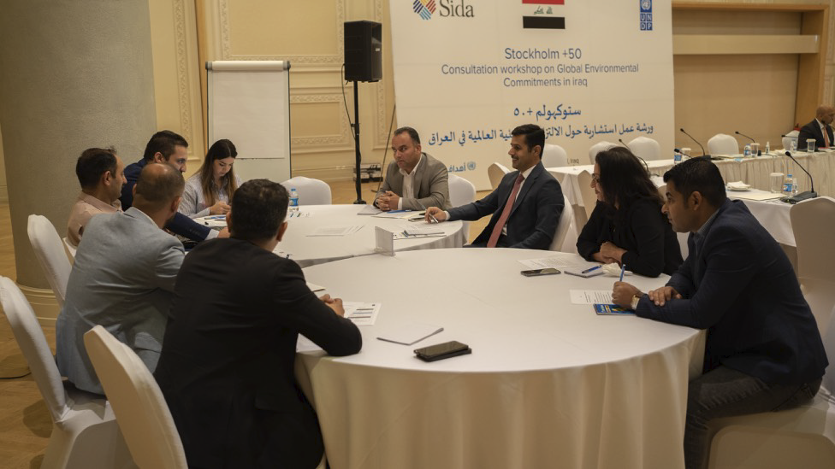

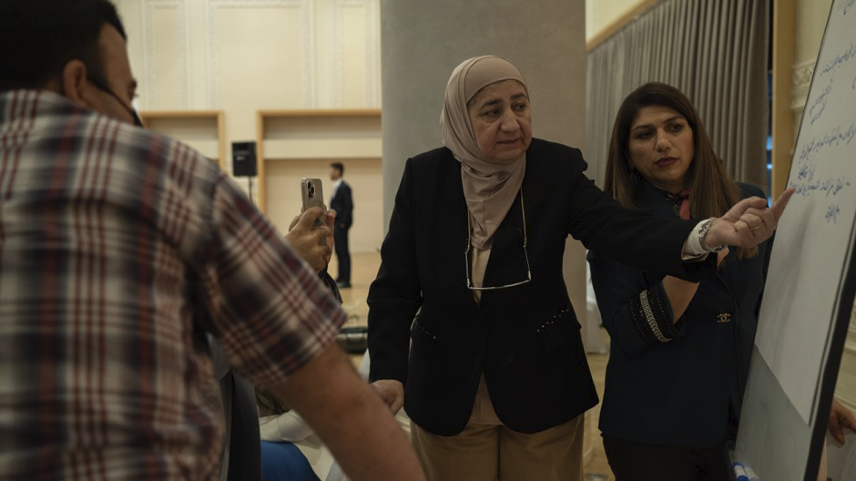

Baghdad:

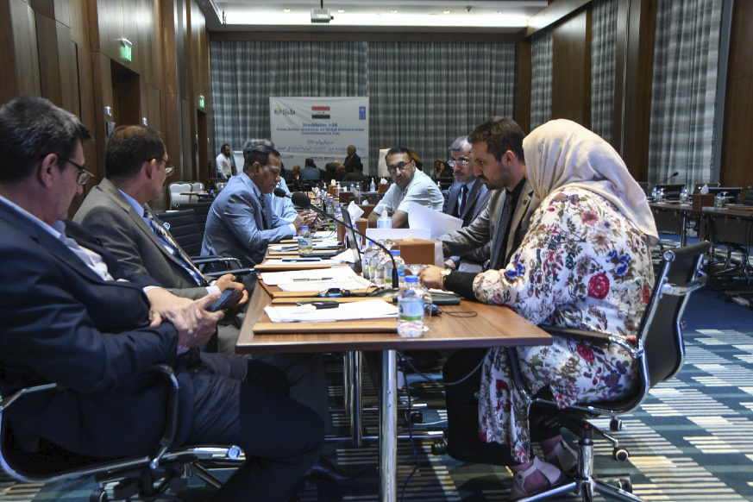

Basra:

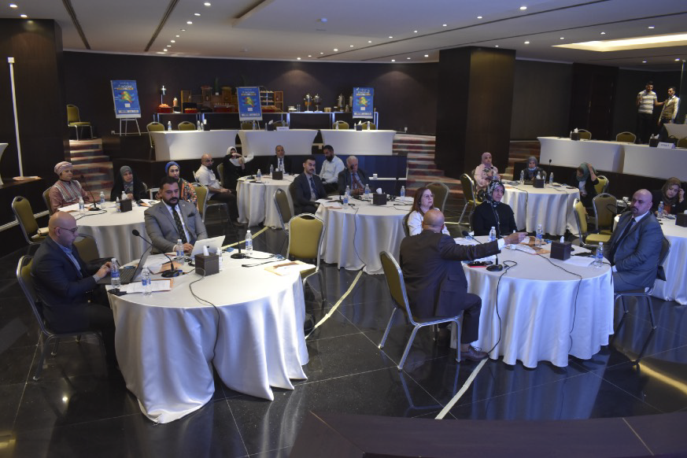

Annex IV: Powerpoints

Review of Environmental and Climate Change- UNDP
https://www.sparkblue.org/content/iraq-environmental-and-climate-change-policies

Stockholm+50 Overview - UNEP
https://www.sparkblue.org/content/presentation-stockholm50-overview-unep

Annex V - Social Media coverage:
More photos, presentations and social media coverage on SparkBlue: https://www.sparkblue.org/stockholm50/consultation-iraq

