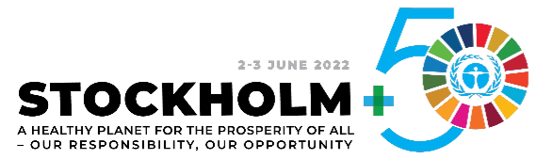

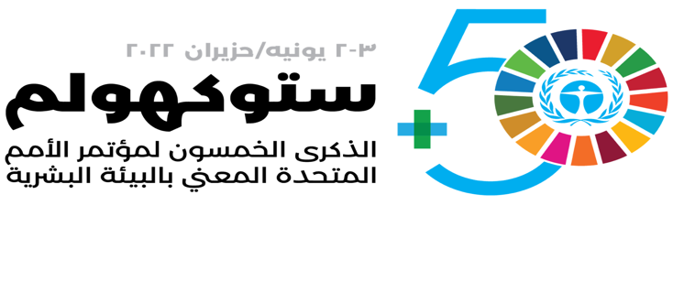

Sudan’s communication and outreach strategy for Stockholm+50

Stockholm +50
- The “Stockholm+50: a healthy planet for the prosperity of all – our responsibility, our opportunity” is an international meeting to be convened by the UN General Assembly in Stockholm on 2 and 3 June 2022 to commemorate the 50 years since the convening of the UN Conference on the Human Environment
- The main aim of Stockholm+50 (S+50) is to help accelerate the implementation of the Sustainable Development Goals (SDGs) during the Decade of Action including through a sustainable recovery from the COVID-19 pandemic.
- The S+50 international meeting is hosted by the Government of Sweden with support from the Government of Kenya.
- Stockholm+50 calls for an inclusive approach that reflects the diversity of voices and perspectives from a wide range of stakeholder groups (local governments and communities, civil society, women, academia, youth, private sector, people with disabilities, others)
- The S+50 will be preceded by extensive national consultations to provide platforms for sharing experiences and contributing ideas, innovations, and insights, to stimulate inclusive whole-of-society dialogue on the main themes of the meeting, as they relate to the national context, in order to build a shared vision and offer recommendations on priority actions
- Outcomes of the national consultations will inform the S+50 international meeting through national reports and a global synthesis report capturing key findings, recommendations, data, media coverage, and links to national policy frameworks

Sudan’s communication strategy and outreach plans
Communication and outreach activities will aim to raise awareness and mobilize interest in, and support to the cause and objectives of the S+50 meeting. Using various tools (see below) the communication activities will target a wide range of audiences at the federal, state, and local levels. Outreach and visibility promotion activities will be initiated from the Pre-S+50 preparations, to continue during launching and facilitation of the national consultations, and through post-S+50 meetings to achieve the following specific objectives:
- Communicate the S+50 meeting goals, objectives and outcomes
- Advance dissemination of information about the national consultations to ensure awareness and allow adequate preparation of stakeholder groups to effectively engage in the process
- Stimulate interest and contribution to the national consultations process
- Disseminate results and recommendations of the national consultations
- Follow up feedbacks and promotion post S+50
- Acknowledge the roles of UNDP, UNEP, and the governments of Sweden and Kenya in supporting the S+50 meeting and associated initiatives

2.1 Communication activities
- Design and publish branding material (logo usage, banners, templates for media releases, social media, rollups, stationery, etc.) during the preparation stage to convey overall goals of the S+50 meeting. Those will communicate information and key messages under the three leadership dialogues (LDs):
- LD1: Urgent actions to achieve a healthy planet and prosperity for all
- LD2: Sustainable and inclusive recovery from the COVID-19 pandemic
- LD3: Accelerating implementation of the environmental dimension of sustainable development - the decade of action and delivery
- Articulate and disseminate objectives and key messages of the national consultations. The Sudan country team (UNCT) plans to organize 3 thematic national dialogues, local consultations at 4 states, and a final national validation workshop covering the following national environmental priority challenges under the S+50 three LDs themes:
  - Actions on the triple planetary crises (climate, nature, pollution) and their impacts on the people and ecosystems in Sudan under LD1, addressing:
  - Threats to the functional integrity of ecosystems and biodiversity
  - Pollution from use of mercury in artisanal gold mining and environmental risks of pollution from plastics
  - Drivers of desertification and land degradation through the national REDD+ strategy
- Effective containment of the spread of the Covid-19 pandemic and prevention of its re-emergence (LD2)
- Improving the resilience to climate change among highly vulnerable communities and access to low-emission energy for development (LD3)
- The gender dimension across all the above
- Prepare and release post-consultation deliverables (final report messages and results) through social media posts (local media broadcast, online)
- Disseminate to regional and international partners through SparkBlue
- All communication and outreach activities will be implemented by the UNCT and coordinated by UNDP and UNEP. Communication activities will make use of existing dialogue institutions, forums and committees that are convened at the federal and state levels (NDCs, NBSAPs, SDG, other standing committees). The strategy will also consider co-convening or co-organizing a consultation with key national partners to promote national ownership and accountability.

2.2 Target audiences
- All stakeholder groups directly and indirectly affected by themes taken up at the various national dialogues to be conducted (civil society organizations, local communities, research and academia, private sector/business associations, federal and state government agencies, youth and women organizations, people with disabilities, others)
- Mass media/journalists to serve as dissemination agents for wider outreach
- The general public

Communication tools
The following main tools will be applied at the different stages of the S+50 cycle of Consultations and meetings as described above:
- Arrangement of in-person consultations/meetings
- Development of multimedia content and arrange for media coverage
  - National and social media to serve as a platform for engaging journalists and mass media for TV coverages of the consultations/meetings
- Video content/photos captured in the location of the national consultations
- Video content/recordings capturing:
  - During consultations highlights and key interventions
  - interviews with participating key stakeholders
  - Interviews with UNCT members
- Stories about the challenges, risks, and successful initiatives
- Blogs and press releases about the national in-person consultation
- Utilize the support of professional communications consultant services
- Corporate UNDP website and social media
- Websites and social media of the Stockholm+50 partner organizations
- UNDP's digital platform, SparkBlue, for hosting interactive online consultations, live streaming, and discussions alongside development partners and stakeholder groups

